PRESS RELEASE April 16th, 2021
Quantron AG exchanges ideas on innovations with EU Member of Parliament Markus Ferber
Last Tuesday, April 14, Markus Ferber, Member of the European Parliament, invited to the Lunch Talk. Participants were representatives of innovative companies from the administrative district of Bavarian Swabia, including Volker Seitz from the e-mobility specialist Quantron AG. Due to the current pandemic, the meeting took place as a video conference.
The exchange was themed: "Digital, innovative and still lost in the EU jungle". MEP Ferber opened the expert exchange with an insight into the work and decision-making processes in the European Parliament as well as the cooperation with the European Commission. The main part of the expert talk was a lively exchange of information between the participating company representatives and Ferber as well as Peter Martin from the European Commission, who also attended the conference.
Picture (preview):
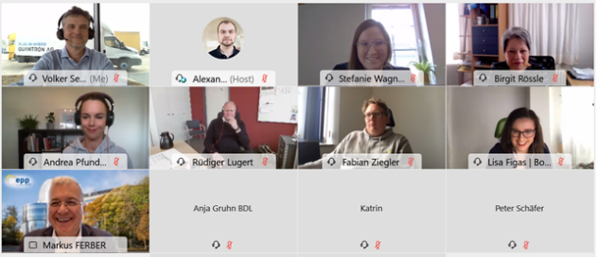
Caption
Volker Seitz (Quantron AG) in digital conversation with MEP Markus Ferber

About Quantron AG
Quantron AG is a system provider of clean battery and hydrogen-powered e-mobility for commercial vehicles such as trucks, buses and vans. In addition to new electric vehicles, the wide range of services offered by the innovation forge includes the electrification of used and existing vehicles, the creation of individual overall concepts including the appropriate charging infrastructure as well as rental, financing and leasing offers and driver training. Quantron also sells batteries and integrated customised electrification concepts to manufacturers of commercial vehicles, machinery and intralogistics vehicles. The German company from Augsburg in Bavaria is a pioneer and innovation driver for e-mobility in passenger, transport and freight traffic. It has a network of 700 service partners and the comprehensive knowledge of qualified experts in the fields of power electronics and battery technology, through its cooperation with CATL, the world's largest battery producer. Quantron AG, as a high-tech spin-off of the renowned Haller GmbH, combines 138 years of commercial vehicle experience with state-of-the-art e-mobility know-how.

You can find more information at www.quantron.net
Visit the Quantron AG on its social media channels on LinkedIn and YouTube.

Your contact:
Volker Seitz, CCO Quantron AG, press@quantron.net, +49 (0) 821 78 98 40 86

