PRESS RELEASE April 29th, 2021
Quantron AG presents the environmentally friendly all-rounder Q-ELION in two variants
- The e-mobility specialist offers the all-electric Q-ELION as an equipment carrier (M series) and as a van (T-series)
- Q-ELION: excellent price-performance ratio
The all-electric Q-ELION impresses with a wide range of applications and a compact design. As a sales partner of the Austrian manufacturer MUP technologies GmbH, Quantron AG offers the vehicle in two series: as an equipment carrier in the M-series and as a transporter in the T-series. Both are in registration class N1 with a maximum permissible gross weight of up to 3.5 tons. This means that the only requirement for driving a Q-ELION is a Class B driver's license.
The Q-ELION from QUANTRON is the ideal tool for modern municipalities and transport services that rely on environmentally friendly and effective operation. The emission-free Q-ELION is characterized by the installation of high-quality, partially maintenance-free components. Operating costs are significantly lower compared with a diesel vehicle in the same class. Both series of the Q-ELION can be used flexibly thanks to a wide range of attachments and can also negotiate narrow alleys and sidewalks thanks to their compact size of just 1.60 meters in width.
T-series: optimal transporter for municipalities, delivery services, factory logistics and garden centers The T-series of the Q-ELION is used by municipalities, delivery services or garden centers. The e-vehicle is also ideal for in-house transport operations and logistics centers. The van impresses with the combination of its compact design and a high payload of up to 1.4 tons. Further plus points are the range of up to 205 kilometers and a top speed of 65 km/h, which means that city highways can also be used to shorten journey times.
M-series: the all-rounder for municipalities, building yards and service providers
The M-series of the Q-ELION is also designed for extensive use in a wide range of work areas, such as building yards or municipal service providers. With a top speed of 65 km/h, it offers individual equipment options. For example, it can be equipped with a watering arm and water tank or a mower for green maintenance. The maneuverable equipment carrier with a range of up to 255 kilometers is also suitable for cleaning work or road maintenance.
"With MUP technologies, we have a valuable partner for electric commercial vehicles and implement carriers at our side," says Christoph Wede (Head of Sales BU Truck & Bus EMEA at Quantron AG). "The all-electric Q-ELION is not only pleasantly quiet on the road, but also sends an important signal for a more environmentally conscious future thanks to its emission-free drive."
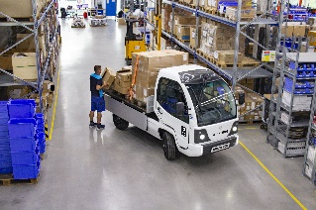
Pictures (preview):
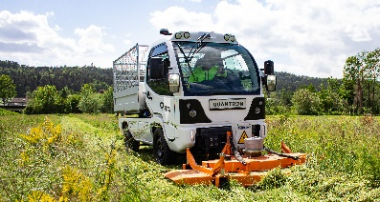
You can find the original photos in low and high resolution here: Press releases from QUANTRON AG (https://www.quantron.net/en/q-news/pr-berichte/)
Caption
The Q-ELION from QUANTRON. As M-series for municipalities. As T-series for transport tasks

About QUANTRON AG
Quantron AG is a system provider of clean battery and hydrogen-powered e-mobility for commercial vehicles such as trucks, buses and vans. In addition to new electric vehicles, the wide range of services offered by the innovation forge includes the electrification of used and existing vehicles, the creation of individual overall concepts including the appropriate charging infrastructure as well as rental, financing and leasing offers and driver training. Quantron AG also sells batteries and integrated customised electrification concepts to manufacturers of commercial vehicles, machinery and intralogistics vehicles. The German company from Augsburg in Bavaria is a pioneer and innovation driver for e-mobility in passenger, transport and freight traffic. It has a network of 700 service partners and the comprehensive knowledge of qualified experts in the fields of power electronics and battery technology, through its cooperation with CATL, the world's largest battery producer. Quantron AG, as a high-tech spin-off of the renowned Haller GmbH, combines 138 years of commercial vehicle experience with state-of-the-art e-mobility know-how.

You can find more information at www.quantron.net
Visit the Quantron AG on its social media channels on LinkedIn and YouTube.

Your contact:
Volker Seitz, CCO Quantron AG, press@quantron.net, +49 (0) 821 78 98 40 86

