PRESS RELEASE May 11th, 2021
QUANTRON Academy: the new e-mobility training centre for truck and bus specialists

The e-mobility specialist Quantron AG is expanding its wide range of services with the QUANTRON Academy, a competence centre for customised training and further education for safe and efficient work on electric vehicles. The wide range of courses offered by the QUANTRON Academy includes driver training as well as various workshops and seminars such as "Diagnosis and measurement on electric commercial vehicles and electric buses". During the events, the content is not only presented in theory, but is also clearly demonstrated on QUANTRON E vehicles. The venue is the main building of Quantron AG in Augsburg.
In April, the first QUANTRON Academy classroom training course on "Safe working on trucks and buses with high-voltage systems" was held with speaker Deniz Kartal (Evalus GmbH). The content of the three-day course was the certified attainment of training level HV-2. The event took place in strict compliance with the applicable Corona measures, including a Corona test obligation for all participants. In addition, the training area was spatially completely separated from the Quantron staff.
"As a holistic system provider, Quantron AG not only offers e-vehicles, but also numerous services such as advice on financing and leasing options or charging infrastructures tailored to customers' needs," says Claudio Matà, Head of Aftersales EMEA at Quantron AG and organiser of the QUANTRON Academy. "The technical training provided by the QUANTRON Academy complements QUANTRON's comprehensive range of services with an additional, high-quality service offering for our customers."
For more information on the training offered by the Quantron Academy, please visit https://www.quantron.net/quantron-academy/.

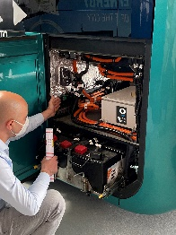
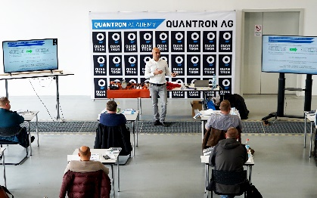
Pictures (preview):

You can find the original photos in low and high resolution here: Press releases from Quantron AG (https://www.quantron.net/en/q-news/pr-berichte/)
Caption
The Quantron Academy, QUANTRON's new training centre

About Quantron AG
Quantron AG is a system provider of clean battery and hydrogen-powered e-mobility for commercial vehicles such as trucks, buses and vans. In addition to new electric vehicles, the wide range of services offered by the innovation forge includes the electrification of used and existing vehicles, the creation of individual overall concepts including the appropriate charging infrastructure as well as rental, financing and leasing offers and driver training. Quantron AG also sells batteries and integrated customised electrification concepts to manufacturers of commercial vehicles, machinery and intralogistics vehicles. The German company from Augsburg in Bavaria is a pioneer and innovation driver for e-mobility in passenger, transport and freight traffic. It has a network of 700 service partners and the comprehensive knowledge of qualified experts in the fields of power electronics and battery technology, through its cooperation with CATL, the world's largest battery producer. Quantron AG, as a high-tech spin-off of the renowned Haller GmbH, combines 138 years of commercial vehicle experience with state-of-the-art e-mobility know-how.

You can find more information at www.quantron.net
Visit the Quantron AG on its social media channels on LinkedIn and YouTube.

Your contact:
Volker Seitz, CCO Quantron AG, press@quantron.net, +49 (0) 821 78 98 40 86

