PRESS RELEASE May 5th, 2021
Quantron AG participates in 1st German Road Safety Conference and joins the Road Safety Pact
On 04 May 2021, the first National Road Safety Conference took place under the leadership of Andreas Scheuer, Germany‘s Federal Minister of Transport and Digital Infrastructure. Quantron AG was also represented among the approximately 400 participants. With its participation, the e-mobility company reaffirmed its commitment to increasing road safety in Germany and Europe.
The digital event was held under the motto: "Safe mobility - everyone bears responsibility, everyone participates". Among other things, the "Pact for Road Safety" was presented, a strategy for road safety work in Germany for the next few years that involves the whole of society. The goal of this new pact is an accident-free "Vision Zero". At the conference, participants were presented with specific measures for increasing road safety in twelve fields of action, which were drafted last year in consultation with a wide range of road safety stakeholders in line with the intentions of the German government.
Safety in everyday road traffic, but also when working on vehicles, is a high priority at Quantron AG. With the QUANTRON Academy, an offer was therefore created to pass on their expertise in the safe handling of electric vehicles in the form of seminars and workshops.
"The topic of safety when dealing with electric commercial vehicles and especially safety in use as well as the use and application of electric mobility with new safety features is a top priority for Quantron AG and all its products," explains Reiner Dellori, Head of Product Management at Quantron AG. "We therefore support the new Pact for Road Safety of the German Ministry of Transport."

Picture (preview):
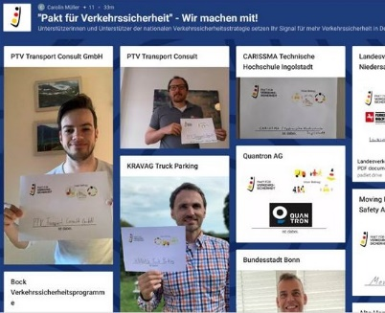
You can find the original photo here: Press releases from Quantron AG (https://www.quantron.net/en/q-news/pr-berichte/)
Caption
Quantron AG supports the new "Pact for Road Safety" of the German Ministry of Transport

About Quantron AG
Quantron AG is a system provider of clean battery and hydrogen-powered e-mobility for commercial vehicles such as trucks, buses and vans. In addition to new electric vehicles, the wide range of services offered by the innovation forge includes the electrification of used and existing vehicles, the creation of individual overall concepts including the appropriate charging infrastructure as well as rental, financing and leasing offers and driver training. Quantron AG also sells batteries and integrated customised electrification concepts to manufacturers of commercial vehicles, machinery and intralogistics vehicles. The German company from Augsburg in Bavaria is a pioneer and innovation driver for e-mobility in passenger, transport and freight traffic. It has a network of 700 service partners and the comprehensive knowledge of qualified experts in the fields of power electronics and battery technology, through its cooperation with CATL, the world's largest battery producer. Quantron AG, as a high-tech spin-off of the renowned Haller GmbH, combines 138 years of commercial vehicle experience with state-of-the-art e-mobility know-how.

You can find more information at www.quantron.net
Visit the Quantron AG on its social media channels on LinkedIn and YouTube.

Your contact:
Volker Seitz, CCO Quantron AG, press@quantron.net, +49 (0) 821 78 98 40 86

