PRESS RELEASE May 21th, 2021
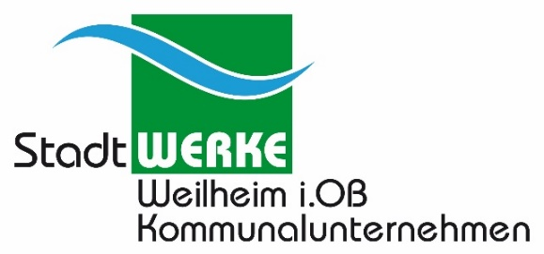
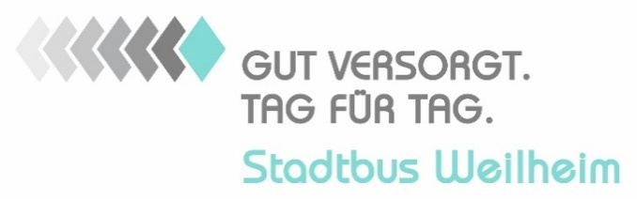

"City bus 2022" - Public transport becomes more environmentally friendly and attractive
The German municipal enterprise Stadtwerke Weilheim i.OB KU acquires five Karsan Atak Electric e-midibuses from Quantron AG Augsburg/Gersthofen
Public transport in Weilheim, Germany, is to become more modern, more environmentally friendly, more user-friendly and, combined with low prices, much more attractive for more user groups and passengers. Stadtwerke Weilheim had presented its "City bus 2022" concept several times, and the city council then passed the basic resolution on November 19th 2020: from January 1st 2022, Stadtwerke Weilheim will be in charge of operating the city bus.
"Our preparations for this are in full swing," says Peter Müller, head of Stadtwerke Weilheim: "An important point of our 'City bus 2022' concept is that we want to operate public transport in Weilheim in a more environmentally friendly way, not just a theoretical example, but a practical example of more climate protection.
According to the concept, the current diesel buses will be replaced by battery-electric midi buses. For the procurement of the five new battery-electric midi buses, they had issued a Europe-wide invitation to tender at the end of February 2021: "After the end of the bidding and clarification of several detailed questions, the best bidder, the company Quantron AG in Augsburg/Gersthofen, was awarded the contract for the delivery of five Karsan Atak Electric buses at the end of April", informs head of Stadtwerke Peter Müller. He signed the corresponding contract together with Andreas Haller, CEO of Quantron AG, on May 11th 2021 at the new headquarters of the supplier of modern electric commercial vehicles in Augsburg/Gersthofen.
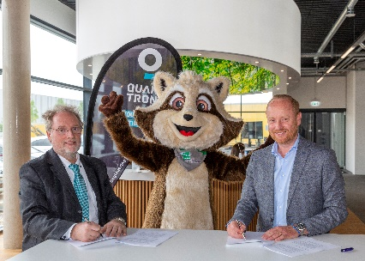
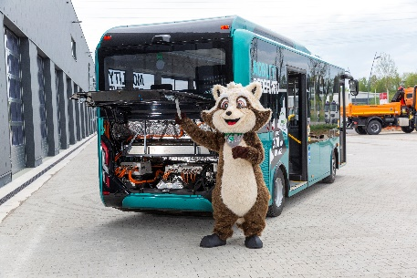
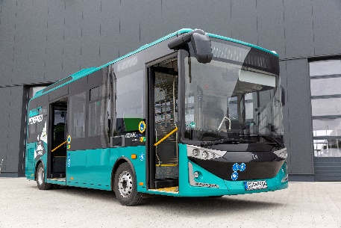
Picture (preview):

You can find the original photo in low and high resolution here: Press releases from Quantron AG (https://www.quantron.net/en/q-news/pr-berichte/)
Caption
Photo 1: The contract was signed on site in Augsburg/Gersthofen on May 11th 2021. Peter Müller, CEO of Stadtwerke Weilheim i.OB KU; Stadtwerke mascot Wilhelm and Andreas Haller, CEO of Quantron AG, Augsburg/Gersthofen.

Photo 2: Wilhelm the mascot of Stadtwerke Weilheim with the new e-bus Karsan Atak Electric

Photo 3: The all-electric QUANTRON midibus Karsan Atak Electric

About Quantron AG
Quantron AG is a system provider of clean battery and hydrogen-powered e-mobility for commercial vehicles such as trucks, buses and vans. In addition to new electric vehicles, the wide range of services offered by the innovation forge includes the electrification of used and existing vehicles, the creation of individual overall concepts including the appropriate charging infrastructure as well as rental, financing and leasing offers and driver training. Quantron AG also sells batteries and integrated customised electrification concepts to manufacturers of commercial vehicles, machinery and intralogistics vehicles. The German company from Augsburg in Bavaria is a pioneer and innovation driver for e-mobility in passenger, transport and freight traffic. It has a network of 700 service partners and the comprehensive knowledge of qualified experts in the fields of power electronics and battery technology, through its cooperation with CATL, the world's largest battery producer. Quantron AG, as a high-tech spin-off of the renowned Haller GmbH, combines 138 years of commercial vehicle experience with state-of-the-art e-mobility know-how.

You can find more information at www.quantron.net
Visit the Quantron AG on its social media channels on LinkedIn and YouTube.

Contact Quantron AG
Volker Seitz, CCO Quantron AG, press@quantron.net, +49 (0) 821 78 98 40 86
Contact Stadtwerke Weilheim i.OB Kommunalunternehmen und Energie GmbH - SWE
Peter Müller, Board and Managing Director
Stadtwerkestraße 1
82362 Weilheim i.OB.
Tel.: 0881 / 94 20-900
Mail: mueller@stawm.de

