PRESS RELEASE May 18th, 2021
New: plug-in hybrid van from QUANTRON
The electric Q-Light van from Quantron AG is now also available as a plug-in hybrid in the van variant. In addition, the Q-Light Hybrid is now also available with automatic transmission.
The Q-Light Hybrid combines the high driving range and drive power of a combustion engine with the possibility of covering distances flexibly in emission-free electric mode, e. g. in green environmental zones. The purely electric range is up to 70 km at a top speed of 80 km/h. This makes the Q-Light Hybrid ideal for sustainable transport services in daily urban traffic. The environmentally friendly van also masters gradients and strong accelerations under heavy load with ease. Depending on the size, the battery is fully charged within just 3.5-5 hours. Additional energy can also be generated while driving via the electric motor, which significantly extends the vehicle's electric range.
As a further plus point, the Q-Light Hybrid is almost silent on the road in emission-free electric mode, making it particularly pleasant for residents and employees in and around the vehicle. The vehicle can therefore also be used in urban logistics processes during daytime and nighttime hours. This means that deliveries can also be made outside peak traffic hours, which helps to equalise traffic.
QUANTRON offers the vans in various sizes between 3.5 and 7 t gross vehicle weight. The payload is up to 3,400 kg, depending on the version. The Q-Light Hybrid is available with both manual and Hi Matic automatic transmissions.
The e-mobility specialist QUANTRON not only offers vans as new vehicles, but also undertakes the conversion of used and existing vehicles. The German Federal Ministry of Transport and Digital Infrastructure has announced that it will support such electrification of vehicles with a grant of up to 80 % of the costs from July 2021.

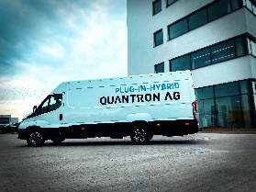
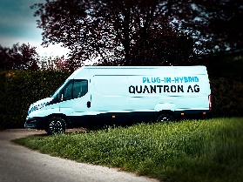
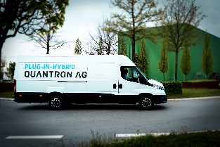
Pictures (preview):

You can find the original photos in low and high resolution here: Press releases from Quantron AG (https://www.quantron.net/en/q-news/pr-berichte/)
Caption
The new Q-Light Hybrid van from QUANTRON

Vehicle data Q-Light Hybrid van
Permissible total weight | 3500 – 7000 kg
Payload | 650 – 3400 kg
Wheelbase | 3750 – 5100 mm
Power | 120 kW
Torque | 1150 Nm
Top speed (EV) | 80 km/h
Range (EV) | 50 – 70 km
Battery capacity | 20 – 29 kWh
Charging time | 3,5-5 h
Charging capacity | 6,6 kW

About Quantron AG
Quantron AG is a system provider of clean battery and hydrogen-powered e-mobility for commercial vehicles such as trucks, buses and vans. In addition to new electric vehicles, the wide range of services offered by the innovation forge includes the electrification of used and existing vehicles, the creation of individual overall concepts including the appropriate charging infrastructure as well as rental, financing and leasing offers and driver training. Quantron AG also sells batteries and integrated customised electrification concepts to manufacturers of commercial vehicles, machinery and intralogistics vehicles. The German company from Augsburg in Bavaria is a pioneer and innovation driver for e-mobility in passenger, transport and freight traffic. It has a network of 700 service partners and the comprehensive knowledge of qualified experts in the fields of power electronics and battery technology, through its cooperation with CATL, the world's largest battery producer. Quantron AG, as a high-tech spin-off of the renowned Haller GmbH, combines 138 years of commercial vehicle experience with state-of-the-art e-mobility know-how.

You can find more information at www.quantron.net
Visit the Quantron AG on its social media channels on LinkedIn and YouTube.

Your contact:
Volker Seitz, CCO Quantron AG, press@quantron.net, +49 (0) 821 78 98 40 86

