PRESS RELEASE June 24th, 2021
Quantron AG expands its international production network and appoints Dr. Uwe Hansult as COO
Quantron AG‘s team is being expanded with the addition of further renowned executives: Dr. Uwe Hansult will join the e-mobility company as Chief Operating Officer (COO) in July.
Dr. Hansult, who holds a doctorate in mechanical engineering, draws on more than 20 years of experience in production management at leading companies in the commercial vehicle industry, such as MAN and Krone. Furthermore, he is also a member of the Industrial Advisory Board of the Cluster of Excellence "Internet of Production - IOP" at RWTH Aachen University.
Given the background of the current and future changes to be expected in the international procurement market, Dr Hansult will be responsible for the expansion of Quantron AG's international production network. He will also be responsible for securing the supply chain and sourcing as well as safeguarding production capacity.
Andreas Haller, CEO of Quantron AG: "We are expanding our production network in order to be able to process large international orders with unit numbers in the four and five-digit range on schedule. I am very pleased that Dr. Uwe Hansult is expanding our company management with his experience and competence."

Picture (preview):
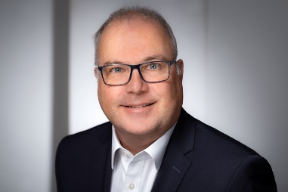

You can find the original photo here: Press releases from Quantron AG (https://www.quantron.net/en/q-news/pr-berichte/)
Caption
Dr. Uwe Hansult, COO of Quantron AG

About Quantron AG
Quantron AG is a system provider of clean battery and hydrogen-powered e-mobility for commercial vehicles such as trucks, buses and vans. In addition to new electric vehicles, the wide range of services offered by the innovation forge includes the electrification of used and existing vehicles, the creation of individual overall concepts including the appropriate charging infrastructure as well as rental, financing and leasing offers and driver training. Quantron AG also sells batteries and integrated customised electrification concepts to manufacturers of commercial vehicles, machinery and intralogistics vehicles. The German company from Augsburg in Bavaria is a pioneer and innovation driver for e-mobility in passenger, transport and freight traffic. It has a network of 700 service partners and the comprehensive knowledge of qualified experts in the fields of power electronics and battery technology, through its cooperation with CATL, the world's largest battery producer. Quantron AG, as a high-tech spin-off of the renowned Haller GmbH, combines 138 years of commercial vehicle experience with state-of-the-art e-mobility know-how.

You can find more information at www.quantron.net
Visit the Quantron AG on its social media channels on LinkedIn and YouTube.

Your contact:
Volker Seitz, CCO Quantron AG, press@quantron.net, +49 (0) 821 78 98 40 86

