PRESS RELEASE June 17th, 2021
Quantron AG wins German Innovation Award 2021 in the "E-Mobility" category
Quantron AG has received the German Innovation Award in the "E-Mobility" category. Every year, the award honors innovative companies that stand for sustainable and user-oriented projects and methods with future potential.
This year, for the fourth time, forward-thinking companies in cross-industry categories were prized with the German Innovation Award. Quantron AG impressed the jury with its comprehensive services as well as its wide range of environmentally friendly electric, hybrid and fuel cell solutions for commercial vehicles from under 3.49 to 44 tons. To save the CO2 emissions of a new vehicle production, Quantron AG focuses on the resource-saving conversion of used and existing vehicles.
Andreas Haller, founder and CEO of Quantron AG: "I am very pleased that we are among this year's winners of the German Innovation Award and would like to thank the selection committee. With our sustainable q-repowering approach, we are making an important contribution to a greener future. The award confirms the highly innovative character of our concept."

Picture (preview):
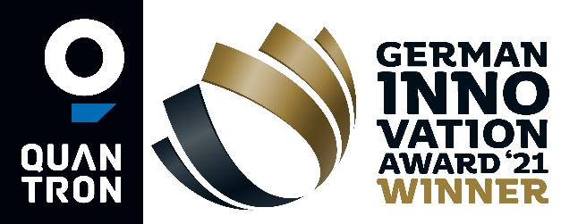
You can find the original photo in low and high resolution here: Press releases from Quantron AG (https://www.quantron.net/en/q-news/pr-berichte/)
Caption
Quantron AG is winner of the German Innovation Award 2021 in the "E-Mobility" category

About Quantron AG
Quantron AG is a system provider of clean battery and hydrogen-powered e-mobility for commercial vehicles such as trucks, buses and vans. In addition to new electric vehicles, the wide range of services offered by the innovation forge includes the electrification of used and existing vehicles, the creation of individual overall concepts including the appropriate charging infrastructure as well as rental, financing and leasing offers and driver training. Quantron AG also sells batteries and integrated customised electrification concepts to manufacturers of commercial vehicles, machinery and intralogistics vehicles. The German company from Augsburg in Bavaria is a pioneer and innovation driver for e-mobility in passenger, transport and freight traffic. It has a network of 700 service partners and the comprehensive knowledge of qualified experts in the fields of power electronics and battery technology, through its cooperation with CATL, the world's largest battery producer. Quantron AG, as a high-tech spin-off of the renowned Haller GmbH, combines 138 years of commercial vehicle experience with state-of-the-art e-mobility know-how.

You can find more information at www.quantron.net
Visit the Quantron AG on its social media channels on LinkedIn and YouTube.

Your contact:
Volker Seitz, CCO Quantron AG, press@quantron.net, +49 (0) 821 78 98 40 86

