PRESS RELEASE August, 4th 2021
A new global player: Quantron AG strengthens its global presence via a share swap with Ev Dynamics
Quantron AG and Ev Dynamics join forces and become mutual shareholders. Quantron is a systems provider of battery and hydrogen-powered e-mobility for commercial vehicles such as trucks, buses and vans, with a focus on the electrification of commercial vehicles. Ev Dynamics is a European-Asian consortium of companies specializing in electric and hydrogen-based mobility.
Together, Quantron AG and Ev Dynamics will develop sourcing and supply chain opportunities for EV components. In addition, the Ev Dynamics team will support Quantron AG in retrofits and technical developments. Together, QUANTRON and Ev Dynamics will have a production capacity of over 10,000 vehicles per year. Upon completion of the share exchange, Ev Dynamics will have approximately 14% of Quantron AG's share capital. The majority shareholder of Quantron AG continues to be Andreas Haller.
Andreas Haller, founder and CEO of Quantron AG: “Quantron and Ev Dynamics will jointly launch BEV and FCEV vehicles. Quantron is developing the products based on our many years of expertise in Germany and Europe. Production will be carried out by Ev Dynamics. Ev Dynamics will thus play an important role in our global growth strategy. The two companies will evaluate strategic partnerships with fuel cell technology companies. The share swap is another milestone in the strategic growth of the two companies.”
Miguel Valldecabres Polop, CEO of Ev Dynamics: "Quantron is an ideal fit for our group of EV-focused companies. Quantron has long-standing EV expertise for commercial vehicles and has excellent market access in Europe. Ev Dynamics will become one of QUANTRON's manufacturing facilities.

Picture (preview):
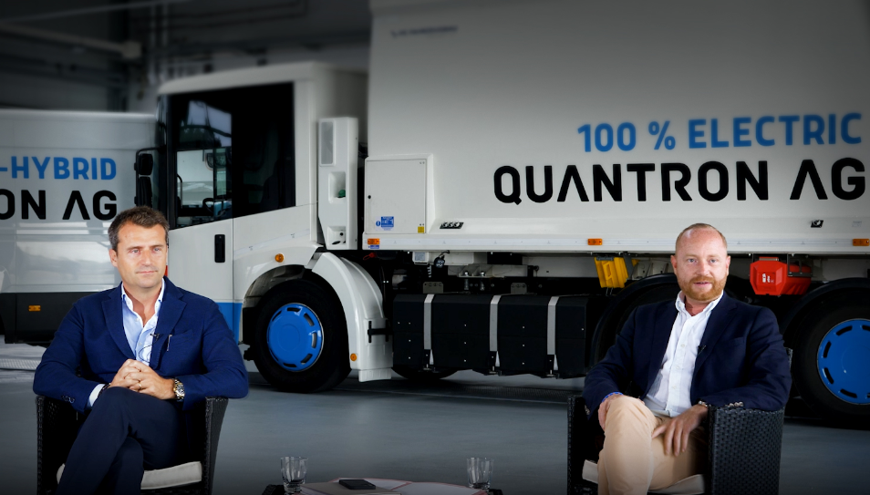
You can find the original photo in low and high resolution here: Press releases from Quantron AG (https://www.quantron.net/en/q-news/pr-berichte/)
Caption
Miguel Valldecabres Polop, CEO of Ev Dynamics (left) and Andreas Haller, member of the board and founder of Quantron (right) believe that the share swap is another milestone in the strategic growth of the two companies.

A video of the interview with Miguel Valldecabres Polop and Andreas Haller about the corporate cooperation can be found on the YouTube channel of Quantron AG.
Short version: https://youtu.be/92Xevbp-B10
Long version: https://youtu.be/Ocz4TscZSbk

About Quantron AG
Quantron AG is a system provider of clean battery and hydrogen-powered e-mobility for commercial vehicles such as trucks, buses and vans. In addition to new electric vehicles, the wide range of services offered by the innovation forge includes the electrification of used and existing vehicles, the creation of individual overall concepts including the appropriate charging infrastructure as well as rental, financing and leasing offers and driver training. Quantron AG also sells batteries and integrated customised electrification concepts to manufacturers of commercial vehicles, machinery and intralogistics vehicles. The German company from Augsburg in Bavaria is a pioneer and innovation driver for e-mobility in passenger, transport and freight traffic. It has a network of 700 service partners and the comprehensive knowledge of qualified experts in the fields of power electronics and battery technology, through its cooperation with CATL, the world's largest battery producer. Quantron AG, as a high-tech spin-off of the renowned Haller GmbH, combines 138 years of commercial vehicle experience with state-of-the-art e-mobility know-how.

You can find more information at www.quantron.net
Visit the Quantron AG on its social media channels on LinkedIn and YouTube.

About Ev Dynamics (Holdings) Limited (HK: 476)
Ev Dynamics (Holdings) Limited is a pioneer and major player in the Chinese market for battery and fuel cell electric commercial vehicles. Formerly known as China Dynamics (Holdings) Limited, the company is a provider of integrated powertrain and logistics solutions for a wide range of applications. The group has a manufacturing facility in Chongqing and a distribution network in China, Hong Kong, Asia Pacific and South America.
For more information, please visit www.evdynamics.com

Your contact:
Volker Seitz, CCO Quantron AG, press@quantron.net, +49 (0) 821 78 98 40 86

