PRESS RELEASE September 13th, 2021
World Premiere: QUANTRON launches electric 12-metre bus
- Available as both BEV and FCEV
- Attractive price level of the QUANTRON BEV-Buses: on a par with conventional diesel buses
- Proven technology - thousands of buses already in use
- Batteries from CATL, fuel cells from Ballard Power

E-mobility specialist Quantron AG is launching its own QUANTRON vehicle, the electric QUANTRON 12 m low-floor bus, at the end of this year. The city bus will be offered in two versions: In the BEV variant, the vehicle can be ordered as early as the end of 2021, as an FCEV from spring 2022. Unique: the emission-free BEV-bus is in a similar price range to conventional diesel buses.

The vehicle is offered in close cooperation with QUANTRON investor and strategic partner Ev Dynamics, a European-Asian consortium of companies specialising in electric and hydrogen-based mobility. Both the batteries (CATL) and the fuel cells (Ballard Power) come from the world's leading manufacturers of the respective technologies.

Miguel Valldecabres Polop, CEO of Ev Dynamics, explains: "Several thousand buses have already been produced. These have been operating successfully in Asia for years."

With fully electric drive, the bus achieves a maximum output of 250 kW. The range is up to 280 km, making the vehicle ideal for daily urban use. The charging power is up to 80 kW with a battery capacity of up to 422 kWh. The battery is charged via a European standard plug CCS 2 within 3 to 6 hours depending on the battery size. This means for example, that the city bus is fully operational after overnight charging. The battery system is adapted to the respective operational requirements and is compatible with various charging solutions. The bus has a capacity for up to 95 passengers. The equipment for optimum passenger and driver comfort as well as the interior and exterior design are available in a wide range of specifications and style to meet individual customer requirements.

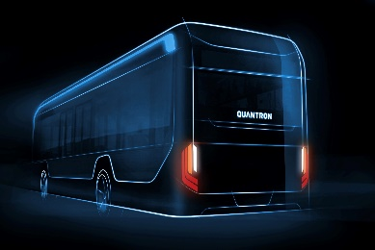
Picture (preview):
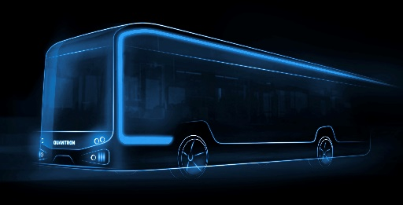
You can find the original pictures here: Press releases from Quantron AG (https://www.quantron.net/en/q-news/pr-berichte/)
Caption
The new 12 metre bus from QUANTRON will be available as BEV and FCEV.

Vehicle data QUANTRON 12 metre low-floor bus BEV*

Permissible total weight | 19500 kg
Maximum power | 250 kW
Maximum torque | 3400 Nm
Range | 160-280 km
Battery capacity | 242/281/363/422 kWh
Charging time | 3-6 hours
Maximum charging power | 80 kW
Passenger capacity | 71- 95

* All specifications are based on the current status August 2021. QUANTRON reserves the right to change the technical features and specifications of its products without prior notice.

About Quantron AG
Quantron AG is a system provider of clean battery and hydrogen-powered e-mobility for commercial vehicles such as trucks, buses and vans. In addition to new electric vehicles, the wide range of services offered by the innovation forge includes the electrification of used and existing vehicles, the creation of individual overall concepts including the appropriate charging infrastructure as well as rental, financing and leasing offers and driver training. Quantron AG also sells batteries and integrated customized electrification concepts to manufacturers of commercial vehicles, machinery, and intralogistics vehicles. The German company from Augsburg in Bavaria is a pioneer and innovation driver for e-mobility in passenger, transport and freight traffic. It has a network of 700 service partners and the comprehensive knowledge of qualified experts in the fields of power electronics and battery technology, through its cooperation with CATL, the world's largest battery producer. Quantron AG, as a high-tech spin-off of the renowned Haller GmbH, combines 138 years of commercial vehicle experience with state-of-the-art e-mobility know-how.
Every day, Quantron AG researches e-vehicles and zero-emission drive technologies to make them even more efficient and economical, thus making a significant contribution to sustainable, environmentally friendly passenger and freight transport.

You can find more information at www.quantron.net
Visit the Quantron AG on its social media channels on LinkedIn and YouTube.

Your contact:
Volker Seitz, CCO Quantron AG, press@quantron.net, +49 (0) 821 78 98 40 86

