PRESS RELEASE September 30th, 2021
Unique in Europe: QUANTRON presents fuel cell transporter as part of its hydrogen offensive
- The Q-Light FCEV is unique in Europe as an H2 vehicle in the 3.5-4.2 t range.
- Ranges of up to 500 km can be achieved.
- QUANTRON relies on a proven and safe drive technology.
- The transporter is available with different body variants and can be used in a variety of ways.
Vehicles fuelled with green hydrogen protect the environment, are quiet on the road and convince with a long range. Ideal for sustainable companies that want to rely on emission-free goods transport for the long haul. In addition to fully electric commercial vehicles, Quantron AG also offers mobility solutions with hydrogen fuel cell systems. Their latest product in this segment is the Q-Light FCEV van.
At NUFAM, the leading trade fair for the commercial vehicle industry, QUANTRON presents the Q-Light to a trade audience for the first time. As a hydrogen fuel cell transporter in the 3.5 to 4.2 tonne range, it is unique in Europe. The vehicle is offered in cooperation with QUANTRON partner and fuel cell expert AE Driven Solutions. It is based on a reliable and proven powertrain technology that is already in use in over 400 vehicles throughout Europe. All components of the Q-Light FCEV comply with European safety standards.
The payload of the Q-Light FCEV is analogous to that of a comparable diesel vehicle. The refuelling time can also be compared to that of a diesel vehicle. The Q-Light FCEV can be driven flexibly in electric or fuel cell mode. The battery capacity is 37 kWh and, like the 15 kW fuel cell used, has a long service life. The waste heat from the fuel cell can also be used to heat the interior, for example, so that additional electricity can be saved.
QUANTRON supports its customers in finding the ideal vehicle for their individual requirements. Thanks to its wide range of superstructures, the Q-Light FCEV can be used flexibly in different areas of application, for example in the logistics industry or as a delivery vehicle. Thanks to its quiet and emission-free drive, the transporter can also be used during the day and at night. Depending on requirements, the vehicle can be equipped with up to four hydrogen tanks and thus achieve a range of up to 500 km. In the future, the power of the fuel cell will also be scalable, so that the vehicle can be offered in different versions, such as a 7.2 t variant.

Picture preview:
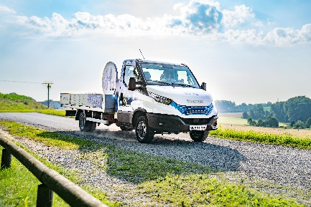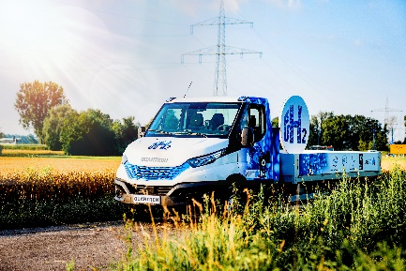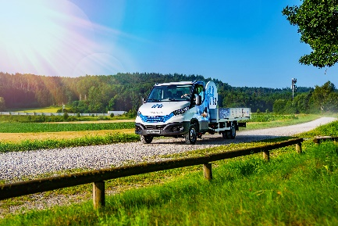

You can find the original pictures here: Press releases from Quantron AG (https://www.quantron.net/en/q-news/pr-berichte/)
Caption
The new Q-Light FCEV from QUANTRON.

Product Video:
A product video of the Q-Light FCEV can be found on the YouTube channel of Quantron AG.
Short version: https://youtu.be/aE9mIlUsqGg
Long version: https://youtu.be/uOn4Q5V8BJ4

Vehicle data Q-Light FCEV
Gross vehicle weight | 4.2 t
Power e-mode | 100 kW (136 PS)
Maximum torque e-mode | 1150 Nm
Top speed | 90 km/h
Hydrogen per tank | Approx. 2.1 kg
Range (2 tanks / 4 tanks) | 300 km / 500 km
Fuel cell power | 15 kW
Battery capacity | 37 kWh
Charging capacity | 6,6 kW
Battery charging cycles | 3.000

About Quantron AG
Quantron AG is a system provider of clean battery and hydrogen-powered e-mobility for commercial vehicles such as trucks, buses and vans. In addition to new electric vehicles, the wide range of services offered by the innovation forge includes the electrification of used and existing vehicles, the creation of individual overall concepts including the appropriate charging infrastructure as well as rental, financing and leasing offers and driver training. Quantron AG also sells batteries and integrated customized electrification concepts to manufacturers of commercial vehicles, machinery, and intralogistics vehicles. The German company from Augsburg in Bavaria is a pioneer and innovation driver for e-mobility in passenger, transport and freight traffic. It has a network of 700 service partners and the comprehensive knowledge of qualified experts in the fields of power electronics and battery technology, through its cooperation with CATL, the world's largest battery producer. Quantron AG, as a high-tech spin-off of the renowned Haller GmbH, combines 138 years of commercial vehicle experience with state-of-the-art e-mobility know-how.
Every day, Quantron AG researches e-vehicles and zero-emission drive technologies to make them even more efficient and economical, thus making a significant contribution to sustainable, environmentally friendly passenger and freight transport.

You can find more information at www.quantron.net
Visit the Quantron AG on its social media channels on LinkedIn and YouTube.

Your contact:
Volker Seitz, CCO Quantron AG, press@quantron.net, +49 (0) 821 78 98 40 86

