PRESS RELEASE November 26th, 2021
QUANTRON expands its management team with leading experts from the e-mobility and commercial vehicle industry
- Quantron AG targets a leading position in Europe in Zero Emission Transportation market and starts a talent recruitment offensive
- After signing strategic partnerships with Ballard Power and various other strategic partners – Quantron beefs up his competence team with top industry experts and EV pioneers
- Great new joiners: Alexander Stucke as Head of Tender Management & Product Management Bus, Martin Lischka as Head of Corporate & Product Strategy, Dr. Uwe Hansult as COO, Jochen Bauer as Head of EE & Digital Products and Dieter Fath as Member of the Board of Directors for QUANTRON in Switzerland.

Quantron AG, leading system provider of battery- and hydrogen-powered e-mobility, is on course for global growth. The company is being supported on this path by five new senior specialists: Alexander Stucke, Martin Lischka, Dr. Uwe Hansult, Jochen Bauer and Dieter Fath.

Alexander Stucke is taking on the role of Head of Tender Management Bus and Product Management Bus at Quantron AG. He brings his many years of global industry experience from previous positions at the world's leading bus manufacturers Mercedes-Benz, IVECO and MAN to the Augsburg-based e-mobility specialists.
As Head of Corporate & Product Strategy, Martin Lischka will further expand Quantron AG's global e-mobility strategy and product portfolio. A key focus will be on the area of Design & Vision. Previously, Lischka worked for several years in the electric vehicle sector at AUDI AG and the Volkswagen Group, as well as Automobili Pininfarina among others.
Dr. Uwe Hansult will fill the position of COO (Chief Operating Officer). Hansult, who holds a doctorate in mechanical engineering, has more than 20 years of experience in production management at leading commercial vehicle companies such as MAN and Krone and will be responsible for the expansion of Quantron AG's international production network, among other things.
Jochen Bauer will be responsible for expanding the Digital Ecosystem as Head of EE & Digital Products. His wealth of experience includes positions at well-known companies such as Porsche AG and AUDI AG.
As a member of the Board of Directors for QUANTRON in Switzerland, Dieter Fath complements the team. Previously, he was COO of Futuricum of Designwerk Products AG.
Michael Perschke, CEO and Member of the Board of Quantron AG: "The new colleagues enrich Quantron AG with a valuable mix of both commercial vehicles and e-mobility. With our strong Q-Team, we are setting out on a course towards the OEM of emission-free and thus sustainable commercial vehicles."
Picture (preview):
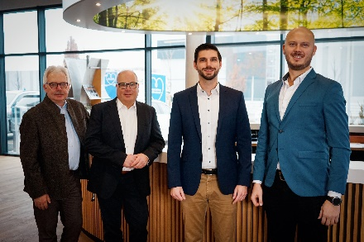
You can find the original photo in low and high resolution here: Press releases from Quantron AG (https://www.quantron.net/en/q-news/pr-berichte/)
Caption
New to the Quantron team: Alexander Stucke, Dr. Uwe Hansult, Jochen Bauer and Martin Lischka (l. to r.). Not pictured: Dieter Fath.

About Quantron AG
Quantron AG is a system provider of clean battery and hydrogen-powered e-mobility for commercial vehicles such as trucks, buses and vans. In addition to new electric vehicles, the wide range of services offered by the innovation forge includes the electrification of used and existing vehicles, the creation of individual overall concepts including the appropriate charging infrastructure as well as rental, financing and leasing offers and driver training. Quantron AG also sells batteries and integrated customised electrification concepts to manufacturers of commercial vehicles, machinery and intralogistics vehicles. The German company from Augsburg in Bavaria is a pioneer and innovation driver for e-mobility in passenger, transport and freight traffic. It has a network of 700 service partners and the comprehensive knowledge of qualified experts in the fields of power electronics and battery technology, through its cooperation with CATL, the world's largest battery producer. Quantron AG, as a high-tech spin-off of the renowned Haller GmbH, combines 138 years of commercial vehicle experience with state-of-the-art e-mobility know-how.

You can find more information at www.quantron.net
Visit the Quantron AG on its social media channels on LinkedIn and YouTube.

Your contact:
Volker Seitz, CCO Quantron AG, press@quantron.net, +49 (0) 821 78 98 40 86

