PRESS RELEASE November 11th, 2021
Quantron AG gains a top e-mobility professional as CTO
- Electromobility expert René-Christopher Wollmann will accelerate development into leading manufacturer of battery-electric and fuel-cell-electric commercial vehicles

On its way to becoming a manufacturer of zero-emission commercial vehicles, e-mobility specialist Quantron AG is expanding and accelerating its development by setting up a top development team. As of this month, the management team has been joined by René-Christopher Wollmann as CTO (Chief Technology Officer). Wollmann assumes overall responsibility at QUANTRON for commercial vehicle and component developments and the expansion of hydrogen development with partner Ballard Power.

Wollmann, who has a degree in electrical engineering, draws on an extensive knowledge and experience in the electric mobility industry. He worked at Mercedes-AMG for around ten years. Among other things, he held leadership positions in the all-electric SLS AMG electric drive sports car project and headed the high-tech ONE hypercar project - the first production sports car with a hybrid drive system with an integrated Formula 1 engine. Most recently, Wollmann was head of electric sports cars at a high-tech e-mobility startup, where he was responsible for a fully electric hypercar with 1,900 hp.

Andreas Haller, CEO of Quantron AG: “René Wollmann's expertise combines e-mobility with dynamics. He is thus an ideal fit for QUANTRON and our goals and values.”

René-Christopher Wollmann: “The incredible agility and speed of the experienced QUANTRON team paired with the visions and goals of Quantron AG offers me and the team the opportunity to quickly generate customer-oriented sustainability with impact. An unprecedented opportunity for me for a beneficial, real measurable and global CO2 impact!”

Michael Perschke, CEO of Quantron AG: “René is a perfect fit for Quantron AG. I have already worked with him successfully and trustfully in the past. His strengths such as expertise, speed of implementation, pragmatism and social skills are a perfect fit for an agile innovator like Quantron AG.”
Under the new CTO, Quantron AG will integrate additional industry talent to further expand its BEV capabilities and launch its own products. Together with its strategic partner, the world's leading fuel cell company Ballard Power, Quantron AG is building a competence team for heavy-duty FCEV truck development.
Picture (preview):
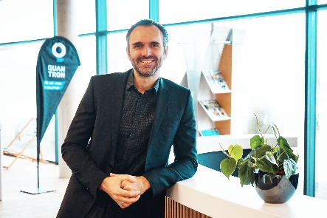
You can find the original photo in low and high resolution here: Press releases from Quantron AG (https://www.quantron.net/en/q-news/pr-berichte/)
Caption
René-Christopher Wollmann, CTO of Quantron AG

About Quantron AG
Quantron AG is a system provider of clean battery and hydrogen-powered e-mobility for commercial vehicles such as trucks, buses and vans. In addition to new electric vehicles, the wide range of services offered by the innovation forge includes the electrification of used and existing vehicles, the creation of individual overall concepts including the appropriate charging infrastructure as well as rental, financing and leasing offers and driver training. Quantron AG also sells batteries and integrated customised electrification concepts to manufacturers of commercial vehicles, machinery and intralogistics vehicles. The German company from Augsburg in Bavaria is a pioneer and innovation driver for e-mobility in passenger, transport and freight traffic. It has a network of 700 service partners and the comprehensive knowledge of qualified experts in the fields of power electronics and battery technology, through its cooperation with CATL, the world's largest battery producer. Quantron AG, as a high-tech spin-off of the renowned Haller GmbH, combines 138 years of commercial vehicle experience with state-of-the-art e-mobility know-how.

You can find more information at www.quantron.net
Visit the Quantron AG on its social media channels on LinkedIn and YouTube.

Your contact:
Volker Seitz, CCO Quantron AG, press@quantron.net, +49 (0) 821 78 98 40 86

