PRESS RELEASE 28 January 2022
QUANTRON accelerates decarbonisation in goods and passenger transport
- Prof. Dr.-Ing. Raimund Klinkner, Chairman of the Executive Committee of the German Transport Forum (DVF): “Quantron AG is converting diesel-powered commercial vehicles to realise emission-free drive technologies. This facilitates a faster conversion of truck and bus traffic to climate-neutral drive systems.”
- Quantron AG welcomes plans by the new Minister of Transport of the Federal Republic of Germany, Volker Wissing, to transform freight and passenger transport and successfully offers zero-emission commercial vehicles as well as related services.
- QUANTRON has been a member of the German Transport Forum since January 2022
With the appointment of the new Transport Minister Volker Wissing, FDP, the Federal Government is steering a clear course towards achieving climate neutrality. Wissing emphasised in the ZDF Morgenmagazin TV show that the transport sector has to make a major contribution to climate neutrality. As a pioneer and innovation driver for e-mobility in passenger, transport and freight transport, Quantron AG provides the emission-free trucks, buses and vans required for this.
In order to decarbonise freight transport as quickly as possible, Quantron AG is converting existing and used vehicles from diesel technology to emission-free electric drives. This gives them a second, now environmentally-friendly service life, so to speak, and thus makes a fundamental contribution to climate protection and resource management in the transport sector.
Prof. Dr.-Ing. Raimund Klinkner, Chairman of the Executive Committee of the German Transport Forum (DVF), acknowledged this commitment at a joint press conference at the end of last year. "Quantron AG's repowering approach of converting diesel-powered commercial vehicles to emission-free drive technologies allows truck and bus transportation to be switched over to climate-neutral drives more quickly". "Time is an essential factor for the climate balance," explains Klinkner, which is why, in view of the ambitious climate targets of the new federal government, "the focus must not only be placed on new vehicles but also on existing fleets." For the Chairman of the Executive Committee of the German Transport Forum "a 'refit' of existing vehicle fleets is a very sensible measure."
The fact that QUANTRON is on the right track is shown by the company's recent award of the "European Transport Prize for Sustainability 2022".
QUANTRON has been a member of the German Transport Forum (DVF) since January 2022.

Picture (preview):
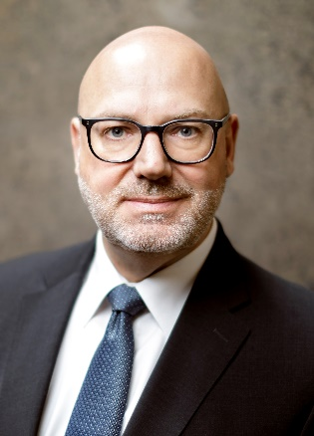
You can find the original photo in low and high resolution here: Press releases from Quantron AG (https://www.quantron.net/en/q-news/press-releases/)
Caption
Prof. Dr.-Ing. Raimund Klinkner, Chairman of the Executive Committee of the German Transport Forum (DVF)

About Quantron AG
Quantron AG is a system provider of clean battery and hydrogen-powered e-mobility for commercial vehicles such as trucks, buses and vans. In addition to new electric vehicles, the wide range of services offered by the innovation forge includes the electrification of used and existing vehicles, the creation of individual overall concepts including the appropriate charging infrastructure as well as rental, financing and leasing offers and driver training. Quantron AG also sells batteries and integrated customised electrification concepts to manufacturers of commercial vehicles, machinery and intralogistics vehicles. The German company from Augsburg in Bavaria is a pioneer and innovation driver for e-mobility in passenger, transport and freight traffic. It has a network of 700 service partners and the comprehensive knowledge of qualified experts in the fields of power electronics and battery technology, through its cooperation with CATL, the world's largest battery producer. Quantron AG, as a high-tech spin-off of the renowned Haller GmbH, combines 138 years of commercial vehicle experience with state-of-the-art e-mobility know-how.

You can find more information at www.quantron.net
Visit the Quantron AG on its social media channels on LinkedIn and YouTube.

Your contact:
Volker Seitz, CCO Quantron AG, press@quantron.net, +49 (0) 821 78 98 40 86

