PRESS RELEASE January 25th, 2022
QUANTRON hosts the online premiere of its all-electric 12m city bus
- Premiere: The 12 m BEV bus will be presented online on February 16th from 10 am (CET).
- Access to the online event: event.quantron.net or via www.quantron.net
- The QUANTRON bus uses proven and safe technology
- Cost-efficient zero-emission alternative: The price will be below the market price for comparable BEV buses

E-mobility specialist Quantron AG is launching its own all-electric city bus. The vehicle will be showcased worldwide as part of an online presentation. Bus operators, bus fans and the general public will be able to follow the event on February 16 at 10 am (CET) at event.quantron.net live.
The zero-emission city bus is initially available as a BEV version with a price that is below the current price level for comparable BEV buses. In this way, Quantron AG seeks to enable environmentally friendly passenger transport and offer a cost-effective alternative to conventional diesel buses. The FCEV version of the 12 m vehicle with fuel cells from Ballard Power Systems is already under development.
The 12 m bus relies on proven and safe technology and LiFePo4 batteries from the world's leading manufacturer CATL. The charging power is up to 150 kW with a battery capacity of up to 422 kWh. With a range range of up to 360 km according to E-SORT 2, the bus meets the requirements to cover daily city operation with an overnight charging time of 3 to 5 hours. Various equipment options will be available to suit individual customer requirements.

Picture (preview):
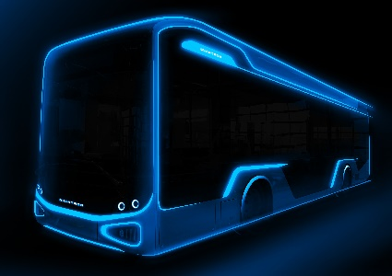
You can find the original photo in low and high resolution here: Press releases from Quantron AG (https://www.quantron.net/en/q-news/press-releases/)
Caption
The all-electric 12m city bus from QUANTRON

About Quantron AG
Quantron AG is a system provider of clean battery and hydrogen-powered e-mobility for commercial vehicles such as trucks, buses and vans. In addition to new electric vehicles, the wide range of services offered by the innovation forge includes the electrification of used and existing vehicles, the creation of individual overall concepts including the appropriate charging infrastructure as well as rental, financing and leasing offers and driver training. Quantron AG also sells batteries and integrated customised electrification concepts to manufacturers of commercial vehicles, machinery and intralogistics vehicles. The German company from Augsburg in Bavaria is a pioneer and innovation driver for e-mobility in passenger, transport and freight traffic. It has a network of 700 service partners and the comprehensive knowledge of qualified experts in the fields of power electronics and battery technology, through its cooperation with CATL, the world's largest battery producer. Quantron AG, as a high-tech spin-off of the renowned Haller GmbH, combines 138 years of commercial vehicle experience with state-of-the-art e-mobility know-how.

You can find more information at www.quantron.net
Visit the Quantron AG on its social media channels on LinkedIn and YouTube.

Your contact:
Volker Seitz, CCO Quantron AG, press@quantron.net, +49 (0) 821 78 98 40 86

