PRESS RELEASE January 7th, 2022
Quantron AG awarded a high ESG rating along and ranked “very sustainable”
- Sustainability report: Quantron AG has an excellent ESG rating and is a very sustainable business
- Strong environmental management, high sustainability impact and top marks earned in other criteria.

The renowned Asset Impact analysis institute has awarded Quantron AG the rating “very sustainable”. For this, the company was subjected to a comprehensive auditing process.

Quantron AG was able to convince the judges in all categories including evaluation points such as Sustainability Impact, Transformation Capability and Sustainable Developments Goals. In the heavyweight category “Sustainability ESG: Ecological, Social, Governance” QUANTRON's strong environmental management, tasked with the aim of reducing emissions and material consumption, was considered to be particularly positive.

The official conclusion of the evaluation is: “Quantron makes an important contribution to reaching the climate targets set by the European Green Deal and the Paris agreements. The company's core business is focused on retrofitting and upgrading towards a green mobility transition. Moreover, the company is ambitious in minimizing environmental and social risks. In terms of ESG criteria, the company is partly solid and partly well positioned.“

Picture (preview):
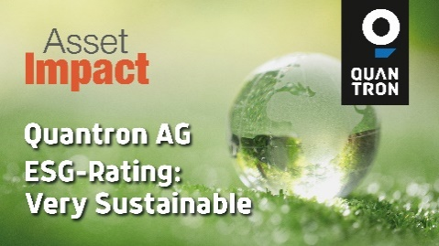
You can find the original photo in low and high resolution here: Press releases from Quantron AG (https://www.quantron.net/en/q-news/pr-berichte/)
Caption
Quantron AG has received a "very sustainable" rating from the Asset Impact analysis institute

About Quantron AG
Quantron AG is a system provider of clean battery and hydrogen-powered e-mobility for commercial vehicles such as trucks, buses and vans. In addition to new electric vehicles, the wide range of services offered by the innovation forge includes the electrification of used and existing vehicles, the creation of individual overall concepts including the appropriate charging infrastructure as well as rental, financing and leasing offers and driver training. Quantron AG also sells batteries and integrated customised electrification concepts to manufacturers of commercial vehicles, machinery and intralogistics vehicles. The German company from Augsburg in Bavaria is a pioneer and innovation driver for e-mobility in passenger, transport and freight traffic. It has a network of 700 service partners and the comprehensive knowledge of qualified experts in the fields of power electronics and battery technology, through its cooperation with CATL, the world's largest battery producer. Quantron AG, as a high-tech spin-off of the renowned Haller GmbH, combines 138 years of commercial vehicle experience with state-of-the-art e-mobility know-how.

You can find more information at www.quantron.net
Visit the Quantron AG on its social media channels on LinkedIn and YouTube.

Your contact:
Volker Seitz, CCO Quantron AG, press@quantron.net, +49 (0) 821 78 98 40 86

