STRING Megaregion reveals plans to pioneer the green transition of road transport
Local and regional governments in Germany, Denmark, Sweden, and Norway together with six private companies has applied for EU/CEF funding to support a connected network of hydrogen fuelling stations from Hamburg to Oslo.
The alternatives to fossil fuels are already here, and hydrogen fuel cell technology is a bright green hope for a seamless zero-emission revolution in road transport. STRING members are now planning to invest in the fuelling network that will make it all possible.
A hydrogen vehicle refuels in 5-12 minutes, making it possible to transport goods and people without the logistical challenges of charging battery-operated alternatives. Moreover, hydrogen vehicles are silent and their only by-product is water. However, to make hydrogen fuels a reliable alternative to petrol and diesel, we have to make it available. By supporting the introduction of hydrogen vehicles through the establishment of fuelling infrastructure, local governments provide the opportunity to put an end to the era of fossil fuels, and eliminate hazardous particle pollution and CO2 emission from the transport sector.

To solve the issue of fuelling infrastructure, STRING members and six private companies have initiated a cross-border public/private partnership to invest in a series of hydrogen fuelling stations, with the help of EU funding. If approved, the project GREATER4H will accelerate the deployment of hydrogen vehicles in the entire megaregion and make Northern Europe a global frontrunner in the green transition of road transport.

The private partners Everfuel (DK), Hynion (NO) and GP JOULE (DE) will build and operate the refuelling stations, while Quantron (DE) will supply hydrogen vehicles in different weight categories, in addition to lead the development of financial and market incentives needed to increase demand for hydrogen trucks. GREATER4H will act as catalyst in speeding up deliveries of hydrogen vehicles from vehicles manufacturers. In addition, Ørsted (DK) and RENOVA (SE) have joined GREATER4H as associated partners to contribute with unique perspectives on supply of green hydrogen and end-user perspective as operators of hydrogen trucks. The 13 public authorities in STRING will contribute to GREATER4H by encouraging harmonized regulation related to the roll-out of hydrogen infrastructure.

The project was developed under the STRING chairmanship of Schleswig-Holstein and Schleswig-Holstein will lead GREATER4H in the future. According to Minister of Justice, European Affairs and Consumer Protection, Claus Christian Claussen “a zero-emission transport sector is only possible with a zero-emission fuelling network. If we succeed, Greater4H will be a great leap forward for the green transition, and it will illustrate how we can achieve a full decarbonization of road transport.”

What is STRING
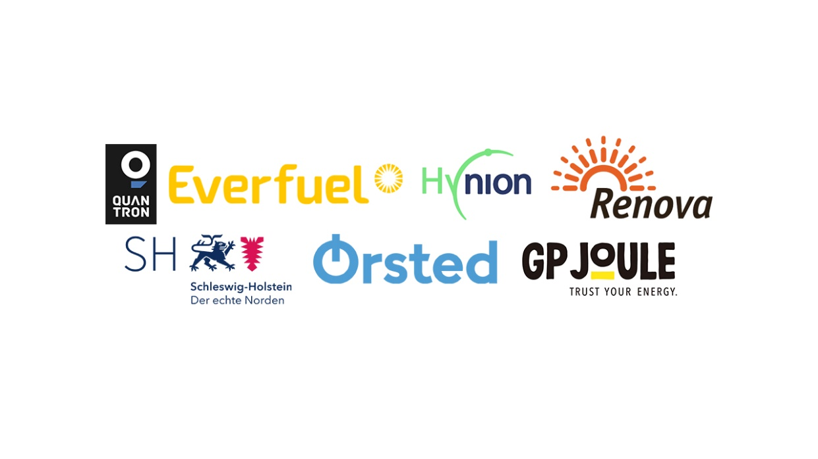
STRING is a membership organisation that connects local governments from Germany, Denmark, Sweden and Norway, to collaborate on cross-border infrastructure development, facilitate the green transition in the transport sector and accelerate innovation and export in green tech.

For further inquiry, visual material, and interview requests, please contact Viktor Erik Gruwier Zeuthen, communications manager, e-mail: vze@stringnetwork.org or by phone +45 9356 9364.

