PRESS RELEASE Augsburg (Germany), February 16th, 2022
QUANTRON takes off emission-free with the CIZARIS electric bus
- World premiere: First all-electric bus from QUANTRON
- Launch as an attractive twelve-meter electric bus (BEV) with proven battery and traction technology that narrows the price gap between diesel bus and zero-emission bus. Zero-emission for everyone!
- Modern, QUANTRON's own vehicle design with adapted company logo lays the foundation for the steadily growing zero-emission QUANTRON portfolio. Further vehicles of the QUANTRON brand will follow.
- Robust lithium iron phosphate batteries from CATL, the world's largest battery producer, combined with an efficient central synchronous motor ensure reliable propulsion and ranges of up to 370 kilometers.

QUANTRON's new twelve meters long electric bus will stimulate the market for zero-emission and at the same time affordable buses and will be called CIZARIS. The new bus model in the Augsburg-based company's bus portfolio will launch as an all-electric version (CIZARIS 12 EV), followed in 2023 by a fuel cell drive (CIZARIS 12 H) using a largely identical powertrain. QUANTRON enjoys a special position here as a "Preferred Partner" thanks to its entrepreneurial connection with the Asian manufacturer EV Dynamics. The name of the new offering for sustainable and reliable mobility in cities says it all: the basic "CI" stands for "City" - i.e. the area of application - the central and prominent "Z" stands for "Zero (emissions)" and the suffix "ARIS" is derived from the Greek and stands for "the noblest/the best".
The CIZARIS represents the entry of electric vehicle pioneer QUANTRON, founded in 2019, into the sustainable and tender-driven city bus market, which is becoming increasingly important for transport companies due to the European "Clean Vehicles Directive". In doing so, the designers are drawing on a vehicle platform that has proven itself hundreds of times over in Asia's largest electric bus markets in recent years. At the QUANTRON plant in Augsburg-Gersthofen, the design features typical of the brand as well as the customer-specific adaptations are made for the highly regulated municipal transport sector.

The electric bus is the first QUANTRON model to carry the evolutionary QUANTRON lettering and the new logo. It stands for the combination of the three brand values "Reliable - Energetic - Brave". These values are also embodied in the striking three-part intermittent "running light indicators" in the front, which are similarly installed in other QUANTRON models.
The CIZARIS city bus illustrates QUANTRON's brand values at first glance with its purposefully placed color components in "Absolute Zero Blue". The front of the vehicle is visually appealing thanks to its windscreen, which is pulled far down and has large radii on the outside, leaving space below for the new logo. Thanks to its design as a purely electric bus, the vehicle does not have a conventional "power unit tower" in the rear and thus offers an impressive 24 to 35 seats – in total, depending on the battery package, there is room for 81 to 95 passengers – significantly more than many competitors.
Access through two or three 1,200 mm wide doors makes it clear to passengers that they are dealing with a true space artist. Wide passages between the axles or to the optional third door at the rear contribute to the airy and pleasant impression of space, as does the enormous headroom of 2,449 mm. The front area up to door two is fully low-floor and very easy to clean thanks to beautifully shaped keel seats. For the first time in this segment, the robust seat covers are manufactured using textile digital printing and feature the QUANTRON logo in the specially created parametric design pattern. A highly efficient Valeo heat pump/air conditioning unit with a cooling capacity of 33 kW provides the right climate on board. Of course, antiviral filters as well as a closed driver's cab are among the possible equipment options adapted to the respective countries. A special highlight in the interior is the elaborately perforated aluminum ceiling with indirect lateral light as well as further LED lights mounted transversely to it, the color of which can be changed on request.
The driver's workplace of the CIZARIS is mounted on a raised platform from which the driver meets his customers at "eye level". Here, every driver finds the optimum position on high-quality and versatile adjustable seats from Isringhausen or Grammer. The easy-grip steering wheel with the new brand logo is also adjustable in two directions. The basic principle of the cockpit could be summed up as "less is more": the very functionally designed panel with large monitor for rearview camera and co. has very few buttons. On the right of the steering wheel is the recuperation lever, which can be used to select the power of the brake energy recuperation in three stages. A fully digital instrument cluster from Actia provides information on all important processes and status messages, which can be optimally read at all times - as can the high-resolution camera mirror monitors. The CIZARIS is one of the few city buses to also offer a separate front observation camera with a large monitor above the cockpit. The electric bus is equipped with the latest electronic safety systems such as ABS/ASR, EBS 5.0, ECAS from European production, and the turn-off assistant from Mobileye can also be retrofitted on request. And optimum fire protection is ensured in the rear compartment, in the battery modules and other high-voltage components by means of fire detectors (temperature/gas sensors) and separate powder extinguishing cartridges - even though the LFP batteries are considered by all experts to be largely "incombustible".
QUANTRON relies on the combination of robust and reliable lithium iron phosphate batteries and highly efficient synchronous central motor from Dana/TM4, which has been used in tens of thousands of buses for years. From QUANTRON's point of view, this combination, which has so far been rather rare in Europe, represents the optimum two-man team for converting the energy on board into propulsion as safely and efficiently as possible. With between 242 and 424 kilowatt hours of selectable battery capacity, CATL's roof-mounted-only battery packs are fast-charged with 65 to 150 kW of direct current (DC) in two to five hours. In the medium-heavy eSORT 2 cycle, this energy is sufficient for 220 to 370 kilometer (220 to 370 mile) circulations at a do-duty (DoD) charge rate of 10 percent.
The vehicle-mounted and water-cooled Dana/TM4 central motor based on the permanent synchronous principle (PSM) is appealing due to its low speeds and particularly high efficiency compared with asynchronous motors. It has an output of 145/245 kilowatts (nominal/maximum) and a maximum engine torque of 1,055/3,329 newton meters, which is developed without any gear changes. With the introduction of the fuel cell version, an even more powerful powertrain will be used.
QUANTRON does everything in its power to help the customer configure the vehicle and analyze its routes and electrical equipment as early as the purchasing process with its experts. The basis for a long bus life is a complex cataphoretic dip painting of the frame (KTL) and other effective corrosion protection measures. The warranty terms are basically two years for the entire vehicle, and eight years or 3,000 charging cycles (or 80 percent charging capacity - whichever comes first) for the important batteries. In total, QUANTRON has a network of 700 service partners in Europe, many of whom can also service electric buses. In a multi-stage service concept, it is checked in each case whether the customer's workshop can be upgraded to work largely self-sufficiently with the support of QUANTRON technicians.
For the market launch of the QUANTRON CIZARIS, the sales focus is initially on the markets of Eastern Europe, the Middle East, Scandinavia and Southern Europe. Due to the special requirements of the German market, such as the VDV specifications regarding the driver's workstation and other systems, the market launch in Germany, Austria and Switzerland will take place in the second half of 2022.
Technical data QUANTRON CIZARIS 12 EV
Length/width/height | 12.180/2.550/3.450 mm
Wheelbase/overhangs front/rear;  turning circle | 5.900/2.800/3.450/22.922 mm
Engine | Vehicle-mounted, water-cooled DANA TM 4 SUMO MD HV3000 6P synchronous central engine behind the drive axle; power (nominal/maximum) 145/245 kW; torque (nominal/maximum) 1,055/3,329 newton meters
Batteries | Temperature-controlled lithium iron phosphate (LFP) batteries mounted on the roof (max. 6 modules each front and rear); 242 to 424 kilowatt hours selectable capacity; charging time with 65 to 150 kW (DC) two to five hours; range eSORT2 around 220 to 370 kilometers, customer-specific position of CCS combo type 2 connector r., li., rear
Chassis/Safety | Vo. Dana comfort rigid axle with stabilizer max. load 7.5t; rear Dana hypoid axle with stabilizers; max. load 11.5t (techn. 13t); tires 275/70 R22.5 (with aluminum rims); ABS/ASR, EBS 5.0, ECAS, mirror replacement system with nose observation camera; rear view camera; turn assist (MirrorEye) and attention assist on request; fire detection/extinguishing system in all relevant components
Seating/Total capacity | Two-door: 31 to 36 / 89-93*  Three-door: 25 to 34 / 91-95*  * with smallest battery pack

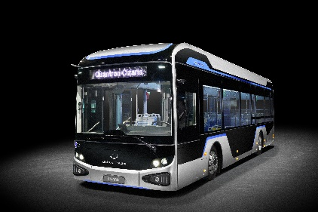
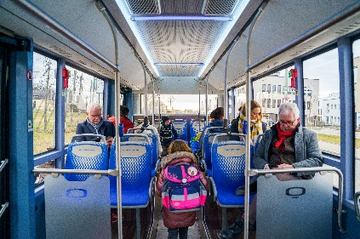
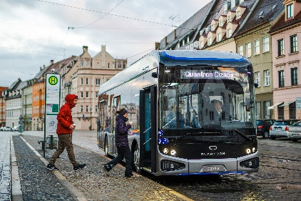
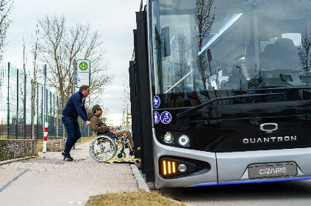
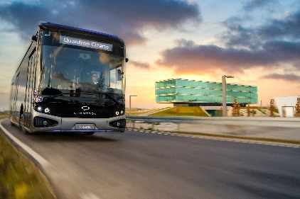
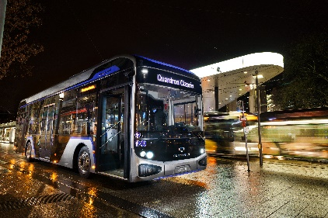
Picture preview:
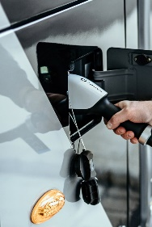

You can find the original photo in low and high resolution here: Press releases from Quantron AG (https://www.quantron.net/en/q-news/press-releases/)

Caption
The QUANTRON CIZARIS twelve-meter electric bus (BEV).

About Quantron AG
Quantron AG is a system provider of clean battery and hydrogen-powered e-mobility for commercial vehicles such as trucks, buses and vans. In addition to new electric vehicles, the wide range of services offered by the innovation forge includes the electrification of used and existing vehicles, the creation of individual overall concepts including the appropriate charging infrastructure as well as rental, financing and leasing offers and driver training. Quantron AG also sells batteries and integrated customised electrification concepts to manufacturers of commercial vehicles, machinery and intralogistics vehicles. The German company from Augsburg in Bavaria is a pioneer and innovation driver for e-mobility in passenger, transport and freight traffic. It has a network of 700 service partners and the comprehensive knowledge of qualified experts in the fields of power electronics and battery technology, through its cooperation with CATL, the world's largest battery producer. Quantron AG, as a high-tech spin-off of the renowned Haller GmbH, combines 140 years of commercial vehicle experience with state-of-the-art e-mobility know-how.

You can find more information at www.quantron.net
Visit the Quantron AG on its social media channels on LinkedIn and YouTube.

Your contact:
Volker Seitz, CCO Quantron AG, press@quantron.net, +49 (0) 821 78 98 40 86

