PRESS RELEASE March 2nd, 2022
QUANTRON receives European Transport Award for Sustainability 2022
- The European Transport Award for Sustainability recognizes outstanding sustainable performance with economic success within the commercial vehicle industry.
- Quantron AG receives the award for its all-electric Q-Light BEV van.

The European Transport Award for Sustainability was presented for the sixth time. The prize, offered by HUSS-Verlag and its renowned trade medium TRANSPORT, recognizes companies from the commercial vehicle industry that offer sustainable products, services, projects, studies or initiatives. Quantron AG received the award in the "vans and delivery vehicles" category for its all-electric Q-Light BEV van.

An independent jury of commercial vehicle experts, including Professor Dr. Dirk Engelhardt (Spokesman of the Board of the German Freight Transport and Logistics Association) and Professor Dr. Uwe Clausen (Fraunhofer Institute for Logistics) evaluated the entries based on the topics of economy, ecology and social responsibility. The environmentally friendly Q-Light BEV from Quantron AG impressed the jury with its emission-free and quiet electric drive and its wide range of applications. The e-transporter has already been in daily use for months at corporations such as IKEA.

Michael Perschke, CEO and Member of the Board of Quantron AG, accepted the award at the award ceremony in Munich: "We are very pleased to receive this award. Our Q-Light BEV stands for emission-free and thus climate-friendly delivery. With our zero-emission commercial vehicles, QUANTRON is already making an important contribution to the decarbonization of freight and passenger transport."

Picture (preview):
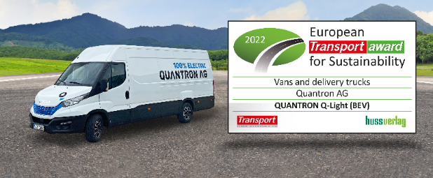
You can find the original photo in low and high resolution here: Press releases from Quantron AG (https://www.quantron.net/en/q-news/press-releases/)
Caption
The Q-Light BEV from QUANTRON is winner of the European Transport Award for Sustainability 2022

About Quantron AG
Quantron AG is a system provider of clean battery-electric and hydrogen-electric e-mobility for commercial vehicles such as trucks, buses and vans. The wide range of services is based on the two business units Q-Retrofit (electrification of used and existing vehicles from diesel to zero-emission electric drive) and Q-Mobility (supply of own zero-emission vehicles of the QUANTRON brand). With the Q-Ecosystem, Quantron AG also offers an overall concept for zero-emission mobility. This includes the creation of individual overall concepts including the appropriate charging infrastructure as well as rental, financing and leasing offers and training courses and workshops at the QUANTRON Academy. The e-mobility pioneers also sell batteries and integrated customized electrification concepts to manufacturers of commercial vehicles, machinery and intralogistics vehicles. The German company from Augsburg in Bavaria has a network of 700 service partners and the extensive knowledge of qualified experts in the fields of power electronics and battery technology. As a high-tech spinoff of the renowned Haller GmbH, it combines over 140 years of commercial vehicle experience with state-of-the-art e-mobility know-how.
QUANTRON stands for the core values Reliable, Energetic, Brave. The team of experts at the innovation driver for e-mobility is making a significant contribution to sustainable, environmentally friendly passenger and freight transport. You can find more information at www.quantron.net
Visit the Quantron AG on its social media channels on LinkedIn and YouTube.

Your contact:
Volker Seitz, CCO Quantron AG, press@quantron.net, +49 (0) 821 78 98 40 86

