Your heart beats for innovation and sustainability? JOIN US NOW!
At Quantron innovation and experience work together every day towards a more sustainable mobility. In our company you will find a flexible working environment with a unique high level of motivation.
We have a fast-paced, exciting, and collaborative culture where you will have the possibility to quickly implement your ideas, with a low level of hierarchy and bureaucracy.

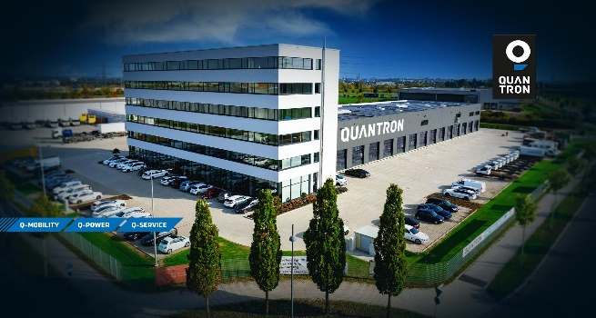

Manager Corporate & Product Strategy -Physical & Digital Solutions Ecosystem with Focus H2 (M/F/D)
Full-time

Project SCOPE & Responsibilities:

- Corporate and Product Strategy Focus:
  - Project Steering and Strategic Business Planning (Vehicles, Components, Solutions, Infrastructure, Quantron as a Service) as well as special projects linked to strategic company targets & Vision in line with Zero Emission Energy & Hydrogen solutions
  - Visualization of KPIs with implementation of standard Templates and processes
  - Zero Emission Innovation & technology scouting
  - Incentives and state subsidies management for vehicles & infrastructure
  - Benchmarking on technology, vehicle, physical and digital ecosystem such as competitor corporate level for new businesses and legacy players in commercial vehicles and mobility segment

- Hydrogen & Ecosystem Focus:
  - H2 Ecosystem Scenario & Business Planning incl. Strategic Concept establishment with cross functional application for
  - Quantron “Inside” with focus on FCEV + BEV Truck, Bus vehicles such as Battery & Technology solutions
  - Sustainable Energy for green H2 and electricity (Quantron Energy)
  - H2 Refueling & Charging Infrastructure (Quantron Power Station)
  - Physical & Digital H2 Solutions in Sales & After Sales (Quantron Customer Care)

- Supporting Investor Relations and data consolidation
- Supporting Business Planning & Corporate Project Management
- Supporting the Top Management

Qualifications:

- Master’s degree in engineering or business / electrical engineering / Business IT / Business Administration & Engineering / Finance Engineering or experience in similar relevant field. Bachelor’s degree would be acceptable if earlier professional track record meets requirements
- Experience in developing products digital solutions in the automotive industry incl. financial planning and forecasting
- Very good knowledge of strategic vehicle & platform development
- Commercial vehicle or mobility solutions experience
- Proficient understanding of interconnected platforms and ecosystems
- Very good knowledge of zero emission solutions and technologies in the industry
- Experience in creating technology strategies and capability roadmaps
- Proficient skills in English and German
- Reliable, flexible, and independent way of working
- Excellent teamwork and communication skills
- Open mindset and ability to grow

Why us?

- We work only on sustainable mobility
- Combining expertise with passion you can quickly grow with us both in terms of skills and responsibilities
- For us Teamworking comes before hierarchy and approval process
- Flexible working schedule
We consider diversity as a crucial ingredient for our growth. As an equal opportunity employer, we base our talent acquisition decisions on skills and experience. What we value is energy, courage, and reliability. We look forward to receiving your application and learn something more about your unique story.

Join now the e-revolution in passenger and cargo transportation! 2022 is the year to #GROWWITHUS!
Send us a detailed application including a curriculum vitae and motivation letter to hr@quantron.net

Want to know more about Quantron? Follow us on social media!
www.quantron.net

