PRESS RELEASE April 22th, 2022
Martin Lischka takes over Marketing and Corporate Communications at QUANTRON
Quantron AG's Head of Strategy, Martin Lischka, is additionally assuming the position of Head of Marketing and Communications at the systems provider for sustainable battery-electric and hydrogen-powered mobility solutions for commercial vehicles with immediate effect.
A proven e-mobility expert, Lischka has more than twelve years of experience in the automotive industry in BEV product strategy, market research, and portfolio & go-to-market management, and has successfully launched international brands as well as companies.
Picture (preview):
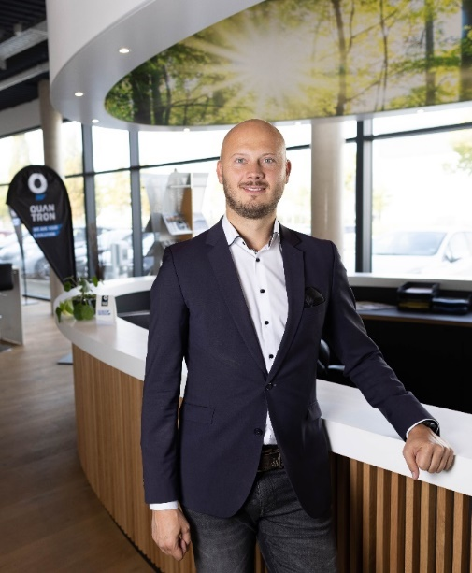
You can find the original photo in low and high resolution here: Press releases from Quantron AG (https://www.quantron.net/en/q-news/press-releases/)
Caption
Martin Lischka, Head of Marketing & Communications Quantron AG

About Quantron AG
Quantron AG is a system provider of sustainable battery-electric and hydrogen-electric e-mobility for commercial vehicles such as trucks, buses and vans. The wide range of services is based on the two business units Q-Retrofit (electrification of used and existing vehicles from diesel to zero-emission electric drive) and Q-Mobility (supply of own zero-emission vehicles of the QUANTRON brand). With the Q-Ecosystem, Quantron AG also offers an overall concept for zero-emission mobility. This includes the creation of individual overall concepts including the appropriate charging infrastructure as well as rental, financing and leasing offers and training courses and workshops at the QUANTRON Academy. The e-mobility pioneers also sell batteries and integrated customized electrification concepts to manufacturers of commercial vehicles, machinery and intralogistics vehicles. The German company from Augsburg in Bavaria has a network of 700 service partners and the extensive knowledge of qualified experts in the fields of power electronics and battery technology. As a high-tech spinoff of the renowned Haller KG, it combines over 140 years of commercial vehicle experience with state-of-the-art e-mobility know-how.
QUANTRON stands for the core values Reliable, Energetic, Brave. The team of experts at the innovation driver for e-mobility is making a significant contribution to sustainable, environmentally friendly passenger and freight transport. You can find more information at www.quantron.net
Visit the Quantron AG on its social media channels on LinkedIn and YouTube.

Your contact:
Martin Lischka, Head of Marketing & Communications Quantron AG, m.lischka@quantron.net, +49 (0) 176 97755896
Stephanie Miller, Marketing & Communications Quantron AG, press@quantron.net

