Your heart beats for innovation and sustainability? JOIN US NOW!
At Quantron, innovation and experience work together every day, paving the way for towards a
more sustainable mobility solutions. In our company you will find a flexible working environment with a unique
high level of motivation.
We have a fast-paced, exciting, and collaborative culture where you will have the possibility to quickly implement
your ideas, with a low level of hierarchy and bureaucracy.

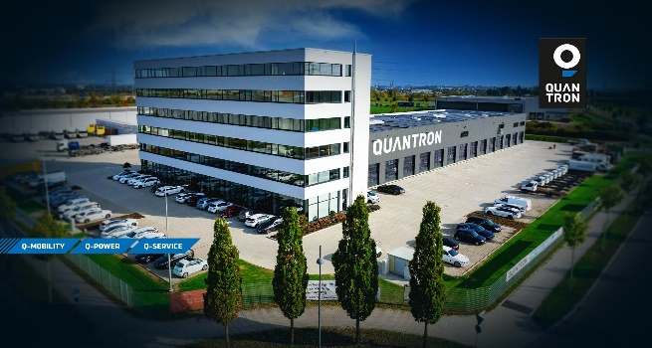

(Senior) Integration Engineer Electric Architecture
(M/W/D)
Full-time

Accountabilities:

- Become our Champion in the field of electrical architectures
- Developing a complete system architecture based on off-the-shelf components
- Analysis of drivetrain and auxiliaries
- Developing of complete vehicle architecture and controls
- Validation and testing of the entire system
- Documentation and accompanying of the whole software stack for homologation
- Steering cross-functional synergies with different teams and partners
- Provide a credible advice by leveraging cross-functional technical and functional domains

Qualifications:

- Master’s degree in electrical engineering / Mechatronic or experience in relevant field
- Experience in developing functionalities in the automotive industry
- Experience in Vehicle architectures (CAN-BUS) and wiring harness
- Confident in managing various components and interfaces
- Understanding of industrial norms and standards including functional safety

- Proficient skills in English
- Reliable, structured, and independent way of working
- Excellent teamwork and communication skills

Why us?

- We work only on sustainable mobility
- Combining expertise with passion you can quickly grow with us, both in terms of skills and responsibilities
- For us teamworking comes before hierarchy and approval process
- Flexible working schedule

We consider diversity as a crucial ingredient for our growth. As an equal opportunity employer, we base our
talent acquisition decisions on skills and experience. What we value is energy, courage, and reliability. We look
forward to receiving your application and to learn something more about your unique story.

Join now the e-revolution in passenger and cargo transportation! 2022 is the year to #GROWWITHUS!
Send us a detailed application including a curriculum vitae and motivation letter to hr@quantron.net

Want to know more about Quantron? Follow us on social media!
www.quantron.net

