PRESS RELEASE May 10th, 2022
QUANTRON business gains further momentum in EMEA and North America
- QUANTRON Q-Days 2022 event fills order books
- Order intake of a multiple million amount with double-digit order volume for QUANTRON zero-emission BEV and FCEV commercial vehicles from logistics industry
- US market activities get more traction through rising sales enquiries of Class 8 FCEV trucks - QUANTRON expands to cover the strong market demand
- A letter of intent has been signed with FRIEM, global leader in the electric energy conversion and green hydrogen, to leverage EYES and introduce a new QUANTRON site in Italy, as part of QUANTRON's expansion strategy for electrification for commercial vehicles.

The development of a comprehensive ecosystem in the segment of zero-emission mobility in passenger and freight transport focused by Quantron AG is progressing according to the plan. Against this background, the specialist for sustainable mobility concepts and system solutions in the field of passenger and freight transport draws a very positive conclusion of its "Q-Days 2022". During the three-day event, which took place from April 26 to 28, more than 200 invited investors, customers and press representatives were given deep insights into current and future developments in sustainable mobility solutions and service offerings. On the part of both investors and neutral market eyes from the analyst and press landscape, QUANTRON's approach was unanimously described as positive and highly competitive. "Technologically and commercially pioneering ecosystems are characterized by a high level of protection against competitors", was the comment of one QUANTRON anchor investor, who described this factor as a key investment reason alongside a strong management team.
In addition, the Germany-based zero-emissions specialists were able to book new orders in the mid-single-digit million euro range at the Q-Days, both for converting commercial vehicles to electric drives and for new vehicles from the Quantron model range.
"The overall balance of the event clearly underlines the validity of our approach to build a comprehensive ecosystem together with leading international partners, offering pioneering concepts and solutions in the field of zero-emission mobility, covering a broad value chain of future passenger and freight transport," said Andreas Haller, founder and Chairman of the Board of Quantron AG.
QUANTRON takes further activities to prepare for the rising number of sales enquiries of Class 8 FCEV trucks in the strategic market USA. During the QUANTRON Q-Days the US plans were shared with a selected group of investors and partners to underline the importance of the region North America. QUANTRON will expand with a focus on Class 8 trucks powered by hydrogen fuel cells to cover the strong market demand in line with ESG goals and global investor requirements.
In addition, the letter of intent (LOI) between QUANTRON and EYES, a subsidiary of the Italian FRIEM Group, global leader in electric energy conversion and green hydrogen, was also signed during the Q-Days. The cooperation between the two specialists in electrification for commercial vehicles serves to introduce a new QUANTRON entity in Italy as part of QUANTRON's international expansion strategy.
Fabrizio Simoni, CEO of EYES as part of the FRIEM Group, commented: "I am looking forward to working together with QUANTRON. Both companies share the same vision and values and pursue the goal of reducing CO₂ emissions through zero-emission vehicles in Italy as well. With this partnership, we combine our expertise in the field of electric conversion and thus bring even more e-commercial vehicles onto European roads."

Image (preview):
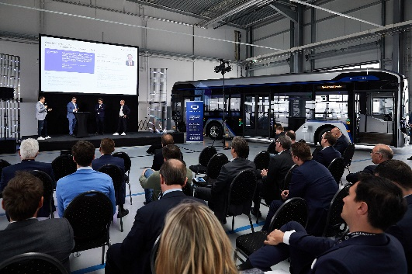 | Image 1: Investor presentation at Q-Days 2022.
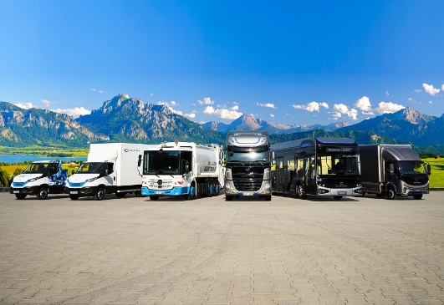 | Image 2: Zero-emission commercial vehicles of the QUANTRON portfolio
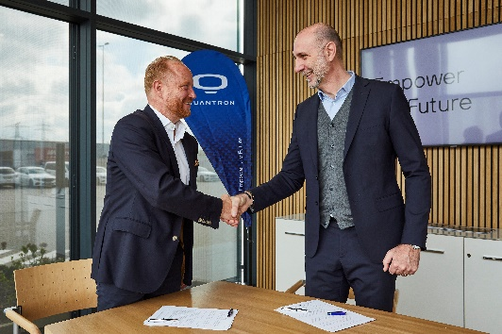 | Image 3: LOI signing between Andreas Haller (Founder and Member of the Board QUANTRON, left) and Fabrizio Simoni (CEO EYES, FRIEM-Group, right).

You can find the original photo in low and high resolution here: Press releases from Quantron AG (https://www.quantron.net/en/q-news/press-releases/)

About Quantron AG
Quantron AG is a system provider of sustainable battery-electric and hydrogen-electric e-mobility for commercial vehicles such as trucks, buses and vans. The wide range of services is based on the two business units Q-Retrofit (electrification of used and existing vehicles from diesel to zero-emission electric drive) and Q-Mobility (supply of own zero-emission vehicles of the QUANTRON brand). With the Q-Ecosystem, Quantron AG also offers an overall concept for zero-emission mobility. This includes the creation of individual overall concepts including the appropriate charging infrastructure as well as rental, financing and leasing offers and training courses and workshops at the QUANTRON Academy. The e-mobility pioneers also sell batteries and integrated customized electrification concepts to manufacturers of commercial vehicles, machinery and intralogistics vehicles. The German company from Augsburg in Bavaria has a network of 700 service partners and the extensive knowledge of qualified experts in the fields of power electronics and battery technology. As a high-tech spinoff of the renowned Haller KG, it combines over 140 years of commercial vehicle experience with state-of-the-art e-mobility know-how.
QUANTRON stands for the core values Reliable, Energetic, Brave. The team of experts at the innovation driver for e-mobility is making a significant contribution to sustainable, environmentally friendly passenger and freight transport. You can find more information at www.quantron.net
Visit the Quantron AG on its social media channels on LinkedIn and YouTube.

Your contact:
Martin Lischka, Head of Marketing & Communications Quantron AG, m.lischka@quantron.net,
Stephanie Miller, Marketing & Communications Quantron AG, press@quantron.net

