PRESS RELEASE May 3rd, 2022
QUANTRON Q-Days World premiere of the QUANTRON QARGO 4 EV and cooperation network sustainably expanded as part of the H₂ offensive

- World premiere as highlight of the event: Launch of the QUANTRON QARGO 4 EV light truck

- Extended portfolio of zero emission BEV and FCEV vehicle and ecosystem solutions presented to a selected audience of press, investors, and customers

- More than 200 guests from more than 15 nations attended the successful event on site and digital

- Kick-off of the H₂ Hydrogen Offensive with QUANTRON partner Ballard Power Systems with a planned world premiere at the IAA Transportation in September 2022

At the Q-Days 2022 event in Augsburg, Germany, which was held by Quantron AG from April 26 to 28, the specialist for sustainable mobility for people and goods showed a deep insight into the future of zero-emission mobility concepts and trend-setting ecosystems. Over the three days, more than 200 invited guests from more than 15 nations were able to experience a deeper look behind the scenes of the system provider, which presented its broad portfolio of zero-emission commercial vehicles and ecosystem solutions. One highlight was the world premiere of the QUANTRON QARGO 4 EV van, which expands the Q-Light Truck portfolio.
Technical data of the QUANTRON QARGO 4 EV*
Max. engine performance | 120 kW
Operating range | up to 350 km*
Battery capacity | 81 kWh
Charging time (DC)  Performance (DC) | 1.2 hours  60 kW
Payload | 2300 kg
Wheel base | 3300 mm
Perm. total weight | 4500 kg

* All information refers to the current status as of May 2022. QUANTRON AG reserves the right to change the technical properties and specifications of its products without prior notice. The operating range was simulated according to WLTP and varies depending on the payload and driving profile.

Over the three days of the event, press representatives, investors and customers gained exciting insights live on site into the world of sustainable mobility concepts and solutions for passenger and freight transport, which is increasingly being shaped by QUANTRON. Among other things, the focus was on the all-electric QUANTRON CIZARIS 12 EV city bus, which was launched as the first Q-Mobility vehicle of the QUANTRON brand back in mid-February and was now presented live to a broad audience for the first time. Another new addition to the portfolio was the QUANTRON QHD BEV 50-280 as a 4x2 tractor unit.

With this broad portfolio, which was described by investors, industry analysts as impressive because it is precisely aligned with today's and the future needs of passenger and transport traffic, QUANTRON particularly underlines its pioneering role in the development of an emission-free eco-system in the commercial vehicle segment. Underlining this background, the cooperation between QUANTRON and Ballard Power Systems, one of the world's leading suppliers of fuel cell technologies, was also a focal point of the Q-Days, besides the presentations of the company's product and solution portfolio.

"On the one hand, the Q-Days represent the start of Quantron AG's H₂ Hydrogen offensive with Ballard Power Systems, a global leader in fuel cell technologies," highlighted Andreas Haller, QUANTRON founder and CEO, adding, "In the future, the two companies will drive the market launch of zero-emission fuel cell vehicles as part of their strategic partnership and introduce additional vehicles before the end of 2022."

"At Q-Days, we did not only share what QUANTRON is already capable of, but also where the journey will take us in the coming years. The development of hydrogen fuel cell powered vehicles is an important means of introducing zero-emission vehicles for long-distance travel and greater independence from oil and gas as an energy source for the transportation industry," commented Michael Perschke, CEO of QUANTRON AG, on the Ballard cooperation.
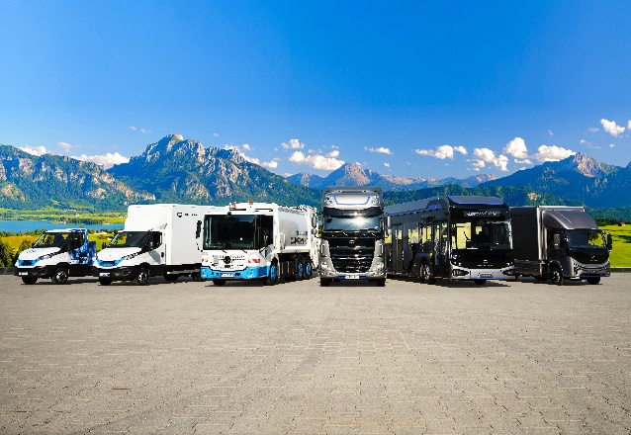
Picture (preview):

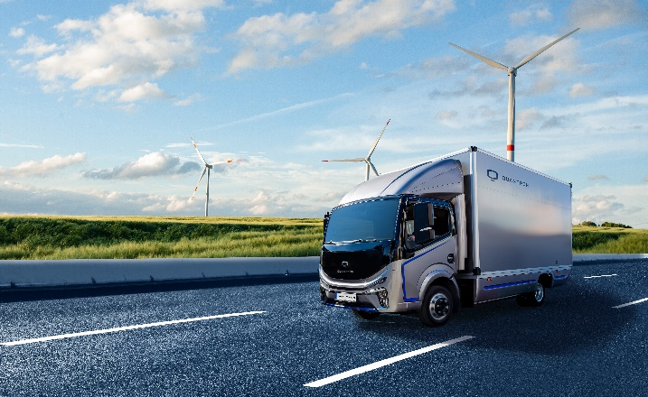
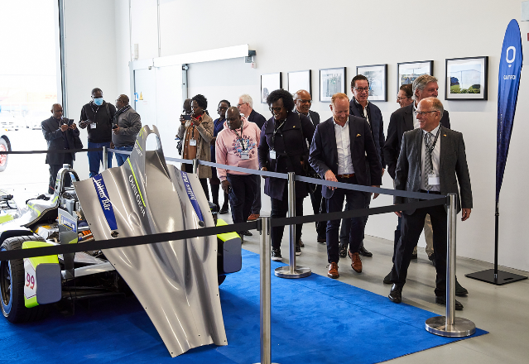

You can find the original photo in low and high resolution here: Press releases from Quantron AG (https://www.quantron.net/en/q-news/press-releases/)
Caption
Image 1: Quantron AG's portfolio of zero-emission commercial vehicles.
Image 2: The new QUANTRON QARGO 4 EV
Image 3: International participants at Q-Days 2022

About Quantron AG
Quantron AG is a system provider of sustainable battery-electric and hydrogen-electric e-mobility for commercial vehicles such as trucks, buses and vans. The wide range of services is based on the two business units Q-Retrofit (electrification of used and existing vehicles from diesel to zero-emission electric drive) and Q-Mobility (supply of own zero-emission vehicles of the QUANTRON brand). With the Q-Ecosystem, Quantron AG also offers an overall concept for zero-emission mobility. This includes the creation of individual overall concepts including the appropriate charging infrastructure as well as rental, financing and leasing offers and training courses and workshops at the QUANTRON Academy. The e-mobility pioneers also sell batteries and integrated customized electrification concepts to manufacturers of commercial vehicles, machinery and intralogistics vehicles. The German company from Augsburg in Bavaria has a network of 700 service partners and the extensive knowledge of qualified experts in the fields of power electronics and battery technology. As a high-tech spinoff of the renowned Haller KG, it combines over 140 years of commercial vehicle experience with state-of-the-art e-mobility know-how.
QUANTRON stands for the core values Reliable, Energetic, Brave. The team of experts at the innovation driver for e-mobility is making a significant contribution to sustainable, environmentally friendly passenger and freight transport. You can find more information at www.quantron.net
Visit the Quantron AG on its social media channels on LinkedIn and YouTube.

Your contact:
Martin Lischka, Head of Marketing & Communications Quantron AG, m.lischka@quantron.net
Stephanie Miller, Marketing & Communications Quantron AG, press@quantron.net

