PRESS RELEASE 10th June 2022
Boom in demand for zero-emission commercial vehicles at the municipal level
- The world's leading trade fair for water, sewage, waste and raw materials management (IFAT 2022) shows a sharp increase in the demand for BEV and FCEV commercial vehicles especially from municipal companies and businesses
- E-mobility specialist QUANTRON records increased incoming orders and enquiries for commercial vehicles at the IFAT, especially in the heavy and light segments after the presentation of QUANTRON´s BEV and hydrogen commercial vehicles

Quantron AG, specialist in battery and hydrogen-powered commercial vehicles, was an exhibitor at IFAT 2022 in Munich. IFAT is the largest platform worldwide for water, sewage, waste and raw materials management with around 120,0000 visitors and 3,000 exhibitors from 155 countries. During the four days of the trade fair, Quantron AG received various orders for new zero-emission vehicles and numerous enquiries about converting existing diesel commercial vehicles to electric drives, primarily from municipal companies.
The demand from the companies focused on all-electric vehicles from the heavy-duty segment, e.g. refuse collection vehicles such as the QUANTRON QHB 27-280 as well as light and medium-duty transporters both equipped with hydrogen fuel cell technology, realised with the exhibited QUANTRON QLI FCEV, and battery-electric driven as with the QUANTRON QARGO 4 EV.
"It is clearly noticeable that municipal companies in particular feel the pressure to act and now want to convert their fleets to be emission-free," says Reiner Dellori, Chief Product Advisor at Quantron AG. “The problem for many companies is the implementation of the EU Clean Vehicles Directive on the one hand, with rising operating costs for diesel-powered vehicles and the inability of established manufacturers to deliver on the other. In contrast, QUANTRON is able to deliver suitable vehicles within only a few months.”
As a result, QUANTRON was able to sell additional battery-electric operated QUANTRON QARGO 4 EV Light Transporters at the fair. The vehicle was launched at the end of April 2022 and ideally suited for sustainable transportation tasks in inner-city areas and for last-mile deliveries. Fully-electric refuse collection trucks in particular are of great interest to local authorities. With the QUANTRON QHB 27-280, which is based on the Mercedes-Benz Econic, QUANTRON is producing a vehicle that is particularly pleasant for residents and vehicle personnel alike thanks to its emission-free and low-noise mode of operation. Featuring a battery capacity of 280 kWh, the refuse collection truck effortlessly manages a complete shift and can simply be charged overnight for everyday use.
Furthermore, QUANTRON was also able to inspire customers regarding its hydrogen-powered vehicles. The QUANTRON QLI FCEV Light Transporter, based on the Iveco Daily, was developed in close cooperation with QUANTRON partner and fuel cell expert, AE Driven Solutions. The tremendous interest shown by trade fair visitors in the hydrogen fuel cell vehicle demonstrates that municipal companies are very open-minded when it comes to the innovative energy source.
Together with its partner, Ballard Power Systems, QUANTRON is working on the development of hydrogen-powered vehicles in the heavy sector. The first vehicle of the joint hydrogen offensive will be presented at the IAA Transportation Fair in September 2022.

Preview photos:
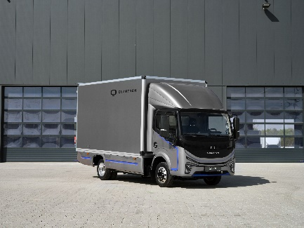 | QUANTRON QARGO 4 EV
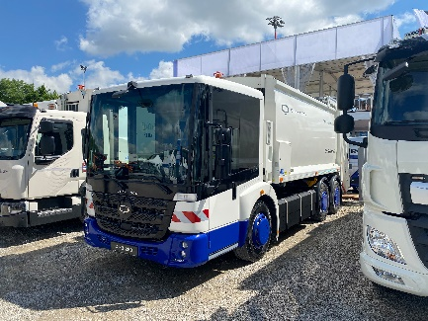 | QUANTRON QHB 27-280
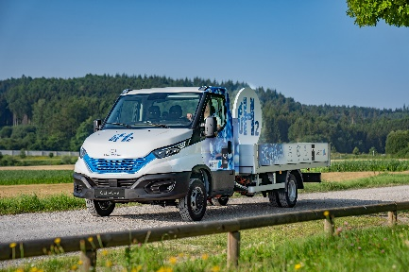 | QUANTRON QLI FCEV

The original photo is available in both low and high resolutions here: Quantron AG press releases (https://www.quantron.net/q-news/pr-berichte/)
About Quantron AG
Quantron AG is a system provider of sustainable battery-electric and hydrogen-electric e-mobility for commercial vehicles such as trucks, buses and vans. The wide range of services is based on the two business units Q-Retrofit (electrification of used and existing vehicles from diesel to zero-emission electric drive) and Q-Mobility (OEM for own zero-emission QUANTRON vehicles). With the Quantron-as-a-Service Ecosystem (QaaS), Quantron AG also offers an overall concept for zero-emission mobility. This includes the creation of individual overall concepts including the appropriate charging infrastructure as well as rental, financing and leasing offers and training courses and workshops at the QUANTRON Academy. The e-mobility pioneers also sell batteries and integrated customized electrification concepts to manufacturers of commercial vehicles, machinery and intralogistics vehicles. The German company from Augsburg in Bavaria has a network of 700 service partners and the extensive knowledge of qualified experts in the fields of power electronics and battery technology. As a high-tech spinoff of the renowned Haller KG, it combines over 140 years of commercial vehicle experience with state-of-the-art e-mobility know-how.
QUANTRON stands for the core values RELIABLE, ENERGETIC, BRAVE . The international team of experts at the innovation driver for e-mobility is making a significant contribution to sustainable, environmentally friendly passenger and freight transport. More informationen available at www.quantron.net
Visit Quantron AG on our social media channels onLinkedIn and YouTube.
Contact persons:
Martin Lischka, Head of Marketing & Communications Quantron AG, m.lischka@quantron.net
Stephanie Miller, Marketing & Communications Quantron AG, presse@quantron.net

