PRESS RELEASE 22nd June 2022
QUANTRON focuses online sales activities of commercial vehicles with strong partners
- QUANTRON, known specialist for sustainable mobility concepts and system solutions in the field of passenger and freight transport for electric commercial vehicles in the lightweight sector, has started a collaboration with TruckScout24.
- The first truck to be offered online is the QUANTRON QARGO 4 EV which is now available across Europe via the sales platform TruckScout24.
- The first 50 online buyers of the new QUANTRON QARGO 4 EV will receive a promotional price of 62.900€ plus VAT with a "First Edition" online price discount of 4.000€.

Germany-based Quantron AG, a leader in zero-emission transportation solutions for people and goods, focuses on online sales for electric commercial vehicles in the light sector. Up to now, new commercial vehicles have largely been offered and sold to a trade-oriented market via stationary or direct sales, the websites of the respective manufacturers or at special trade fairs. Online platforms have immense potential here.
As a visionary company in the commercial vehicle scene for battery-electric and hydrogen-powered commercial vehicles, Quantron AG is breaking new ground in the process of selling new vehicles on online platforms. For this, the e-mobility company uses the reach of the established commercial vehicle online sales platform, TruckScout24. An important part and prerequisite of this cooperation is that TruckScout24 has set up "Electric Trucks" as a new category and search criterion on its platform.
"We are pleased that QUANTRON is the first European truck manufacturer to offer its new zero-emission vehicles on TruckScout24. In this way, together we can make the commercial vehicle sector more sustainable. Through our Europe-wide leading online marketplace, even more companies are becoming increasingly aware of emission-free commercial vehicles and can simply and easily contact providers such as QUANTRON. We expect that other providers will follow this initiative," according to Patrick Ratzke, Managing Director of TruckScout24.
Michael Perschke, CEO of QUANTRON, adds: “We very much want zero-emission commercial vehicles to become the norm. In order for this to happen, however, they must be present for the convenience of the customers, they must be easy to order and with short delivery times. The cooperation with TruckScout24 offers us a Europe-wide reach and we are one of the few providers currently in a position to deliver. Both together should be able to provide a strong impetus for emission-free transport over the last mile.”
Part of the cooperation is also a limited offer for the first 50 buyers of the new QUANTRON QARGO 4 EV. They will receive a “First Edition” online discount of € 4,000 on the official retail price of € 62,900 plus VAT. Delivery time for the vehicle is around three months.
The QUANTRON QARGO 4 EV is the ideal vehicle for sustainable transport over the last mile. Thanks to the fully electric drive, it is emission-free and extremely quiet on the road which means that inner-city operations are also possible day and night as well as in green environmental zones. The transporter has been tested under real conditions and was able to achieve ranges of up to 300 km. Batteries are supplied by CATL, the world's largest battery manufacturer, and can be fully re-charged in less than two hours. Through the Alltrucks network, QUANTRON also ensures a Europe-wide service for buyers outside of Germany for its vehicles.
After the market presentation of the vehicle at the end of May 2022 as part of the QUANTRON in-house "Q-Days 2022" show along with trade fair appearances in Munich at the IFAT and Oslo at the International Electric Vehicle Symposium, the spin-off of the renowned Haller KG with more than 140 years of commercial vehicle experience has received numerous enquiries and submitted orders for the vehicle. From this week onwards, it is also available via the leading online platform, TruckScout24.

Technical data: QUANTRON QARGO 4 EV*
Max. engine performance | 120 kW
Operating range | up to 300 km*
Battery capacity | 81 kWh
Charging time (DC)  Performance (DC) | 1-2 hours  60 kW
Payload | 2300 kg
Wheel base | 3300 mm
Perm. total weight | 4500 kg

** All information refers to the current status as of June 2022. QUANTRON AG reserves the right to change the technical properties and specifications of its products without prior notice. The operating range was simulated according to WLTP and varies depending on the payload and driving profile. The price only applies to the first fifty vehicles ex-works Augsburg and is time-limited.

Preview photos:
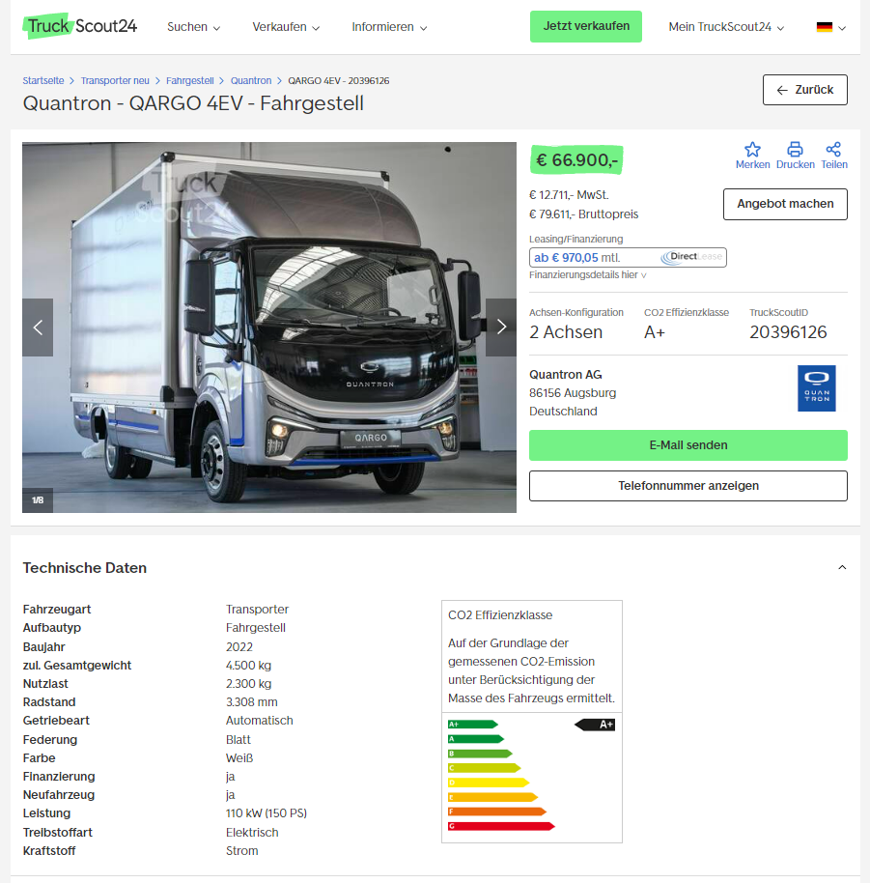

The original photo is available in both low and high resolutions here: Quantron AG press releases (https://www.quantron.net/q-news/pr-berichte/)
Photo captions
The QUANTRON QARGO 4 EV is now available on TruckScout24

About Quantron AG
Quantron AG is a system provider of sustainable battery-electric and hydrogen-electric e-mobility for commercial vehicles such as trucks, buses and vans. The wide range of services is based on the two business units Q-Retrofit (electrification of used and existing vehicles from diesel to zero-emission electric drive) and Q-Mobility (OEM for own zero-emission QUANTRON vehicles). With the Quantron-as-a-Service Ecosystem (QaaS), Quantron AG also offers an overall concept for zero-emission mobility. This includes the creation of individual overall concepts including customised charging solutions, hydrogen refuelling station infrastructure, as well as rental, financing and leasing offers as well as training courses and workshops in the QUANTRON Academy. The e-mobility pioneers also sell batteries and integrated customized electrification concepts to manufacturers of commercial vehicles, machinery and intralogistics vehicles. The German company from Augsburg in Bavaria has a network of 700 service partners and the extensive knowledge of qualified experts in the fields of power electronics and battery technology. As a high-tech spinoff of the renowned Haller KG, it combines over 140 years of commercial vehicle experience with state-of-the-art e-mobility know-how.
QUANTRON stands for the core values RELIABLE, ENERGETIC, BRAVE . The team of experts at the innovation driver for e-mobility is making a significant contribution to sustainable, environmentally friendly passenger and freight transport. More informationen available at www.quantron.net
Visit Quantron AG on our social media channels onLinkedIn and YouTube.
Contact persons:
Martin Lischka, Head of Marketing & Communications Quantron AG, m.lischka@quantron.net
Stephanie Miller, Marketing & Communications Quantron AG, presse@quantron.net

