PRESS RELEASE
July 13th, 2022
QUANTRON strengthens its sales, service and strategy unit

- Olaf Muschner takes over as Head of Service & Customer Care International in the After-Sales unit
- Tobias Steffen takes on the lead for the sales team and structure
- Dr. Srinath Rengarajan joins the Strategy unit as Senior Manager Corporate & Product Strategy

As part of its global orientation, Quantron AG is filling further strategically important positions in Service & Customer Care, Sales Team and Corporate & Product Strategy.

Olaf Muschner brings many years of management experience in the international after-sales sector of commercial vehicles and drive systems. Previously, he worked in sales and marketing at Iveco, primarily with a focus on customer service. His main responsibilities at QUANTRON include setting up a professional service network and ensuring service readiness by means of diagnostic and repair tools, documentation, training, and customer care. In addition to German, he also speaks Italian, English, Russian and French.

Tobias Steffen brings extensive experience from the commercial vehicle sector. Most recently, he was Sales Manager New Vehicles at Iveco West Nutzfahrzeuge GmbH where he was head of the sales team. There, he was responsible for the Light, Medium & Heavy segments which he was able to successfully expand with his team. Prior to that, he was District Manager for used vehicles at Iveco Magirus where he acquired in-depth knowledge of the remarketing of commercial vehicles. At QUANTRON, he will concentrate in future on the Van & Truck division primarily in the German, Austrian and Swiss markets as well as focusing on expanding the customer portfolio and further market penetration.

Dr. Srinath Rengarajan takes on the role of Senior Manager Corporate & Product Strategy. Dr. Rengarajan, who holds a doctorate in business administration, has extensive expertise in the areas of strategy and management consulting having previously held positions at Daimler Truck and Oliver Wyman. His responsibilities at QUANTRON include supporting management in the strategic direction of the company at the business, market and competitive levels along with growth initiatives and investor-related issues. Building on his previous professional experience as an engineer, he will also be heavily involved in product strategy initiatives at QUANTRON. Dr. Srinath Rengarajan is an honorary member of various organisations such as the Battery Associates and Indo-German Young Leaders Forum.

"With the competent reinforcement of our international team, we are perfectly positioned to take off globally. We need to use our temporal and technological lead over the established providers to position ourselves in the internationally important commercial vehicle markets with our own QUANTRON brand vehicles and, in a second step, roll out our complete ecosystem, Quantron-as-a-Service. I am very much looking forward to successfully meeting these challenges together with our new colleagues," says Michael Perschke, CEO and board member of Quantron AG.

Founded in 2019 as a spin-off of the Haller Group, QUANTRON AG combines 140 years of commercial vehicle experience with modern technology and now consists of an international team of over 100 employees.

Pictures (Please click on the image preview to download):
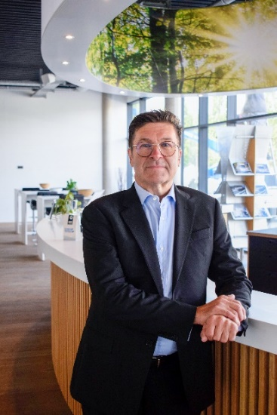 | Olaf Muschner, Head of Service & Customer Care International Quantron AG
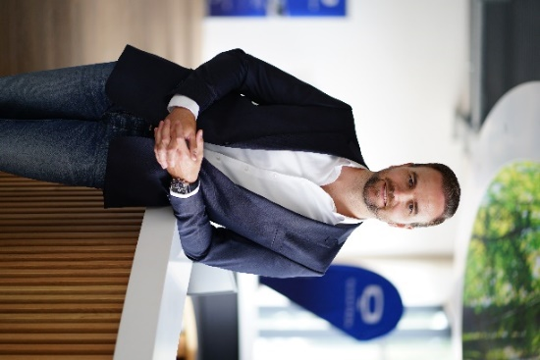 | Tobias Steffen, Sales Team Lead Quantron AG
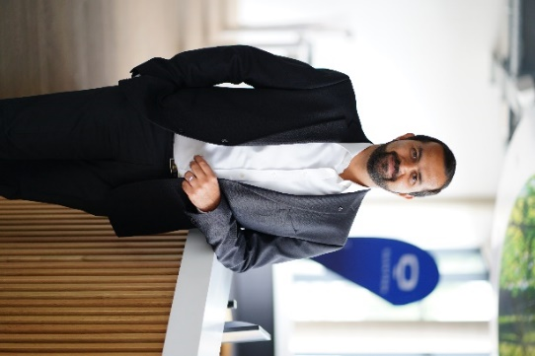 | Dr. Srinath Rengarajan, Senior Manager Corporate & Product Strategy Quantron AG

You can find the original photo in low and high resolution here: Press releases from Quantron AG (https://www.quantron.net/en/q-news/press-releases/)

About Quantron AG
Quantron AG is a system provider of sustainable battery-electric and hydrogen-powered e-mobility for commercial vehicles such as trucks, buses and vans. The wide range of services is based on the two business units Q-Retrofit (electrification of used and existing vehicles from diesel to zero-emission electric drive) and Q-Mobility (OEM for own zero-emission QUANTRON vehicles). With the Quantron-as-a-Service Ecosystem (QaaS), Quantron AG also offers an overall concept for zero-emission mobility. This includes the creation of individual overall concepts including the tailormade charging solutions, hydrogen refilling infrastructure as well as rental, financing and leasing offers and training courses and workshops at the QUANTRON Academy. The e-mobility pioneers also sell batteries and integrated customized electrification concepts to manufacturers of commercial vehicles, machinery and intralogistics vehicles. The German company from Augsburg in Bavaria has a network of 700 service partners and the extensive knowledge of qualified experts in the fields of power electronics and battery technology. As a high-tech spinoff of the renowned Haller KG, it combines over 140 years of commercial vehicle experience with state-of-the-art e-mobility know-how.
QUANTRON stands for the core values Reliable, Energetic, Brave. The team of experts at the innovation driver for e-mobility is making a significant contribution to sustainable, environmentally friendly passenger and freight transport. You can find more information at www.quantron.net
Visit the Quantron AG on its social media channels on LinkedIn and YouTube.

Your contact:
Martin Lischka, Head of Marketing & Communications Quantron AG, m.lischka@quantron.net
Stephanie Miller, Marketing & Communications Quantron AG, press@quantron.net

