PRESS RELEASE 27th July 2022
QUANTRON with strong growth in sales, vehicle portfolio and team of experts
- Strong sales growth in the first half of 2022
- Substantial increase in demand for zero-emission commercial vehicles: Over 500 international customer enquiries processed with concrete offers
- However: current funding practice blocks further contract awards
- Transformation to OEM: QUANTRON's product pipeline is well filled with in-house developments for passenger and freight transport
- Start of Hydrogen Offensive - world premiere of the 44 t FCEV truck with the goal of "Best in Class in 2023 in range and refueling capacity" at the IAA in September 2022

In the first half of 2022, Quantron AG was able to further expand its pioneering and leading position in the field of battery and hydrogen-electric commercial vehicles as the market leader in retrofitting in the DACH region. In spite of the current challenges in the supply chain sector, the specialist for sustainable passenger and goods transport was able to increase sales in the first six months of this year by more than 360 % compared to the previous year.
This was mainly due to the fact that the e-mobility experts from Germany, in addition to converting used or new commercial vehicles to emission-free drives, are introducing their own models to the market as OEMs. One of the zero-emission fleet customers is IKEA. The furniture company has ordered around 50 battery-electric light transporters for last-mile deliveries and is already supplying over 300 customers using emission-free QUANTRON vehicles every day in the greater Vienna area thus saving over 197 t of CO₂ annually in this way. Other new customers are logistics and disposal companies such as Ansorge, Breitsamer, DORR as well as the Knorr- Bremse Group from Munich, the world market leader for braking systems for rail and commercial vehicles.
“Demand for zero-emission commercial vehicles has increased significantly during the past six months. At QUANTRON alone, we have served more than 500 customer enquiries across Europe with concrete offers,” says Michael Perschke, CEO of Quantron AG. “In Germany, however, the market is blocked by the current funding practice. After the second call for financial support for commercial vehicles with alternative drives was extended once again until 24th August, companies and municipalities are waiting to place their orders in order to have certainty regarding the amount of the financial support. The current funding practice therefore acts as an investment barrier and is shifting purchasing decisions and thus also the emission-reducing effects to 2023,” Perschke continues.
As a result, QUANTRON does not expect a significant increase in sales until 2023, partly due to the heavy truck offensive with BEV and FCEV drive concepts. Despite these obstacles and the geopolitical challenges, the company´s management is confident of being able to achieve the 2022 target of 20 to 25 million euros.
Well-filled product pipeline
In addition to converting used or new commercial vehicles to emission-free drives, QUANTRON develops its own commercial vehicles as OEMs which are generating great interest in the market due to their short-term availability and the technology used in the manufacture.
In the area of passenger transportation the QUANTRON CIZARIS 12 EV is attracting international interest. The all-electric bus is already available in northern and southern Europe, and will also be available in various versions for the DACH region from January 2023 onwards. The excellent consumption values combined with high performance can be seen in the range of up to 370 km (according to SORT 2) which can be achieved thanks to the proven vehicle technology and LFP4 batteries from the world's leading battery manufacturer, CATL. The FCEV model is currently under development and homologation
In the freight transport sector, QUANTRON offers the in-house developed, fully-electric light transporter QUANTRON QARGO 4 EV. With a range of up to 350 km as well as accommodating a payload of 2,300 kg, the zero-emission vehicle is ideal for last-mile deliveries.
While QUANTRON offers all-electric vehicles for inner-city or short-distance use, the company relies on green hydrogen as the most efficient fuel solution for long-distance and heavy-duty operations with high payloads. In cooperation with Ballard Power Systems, world market leader in the development of fuel cells, several hydrogen-powered vehicles have been developed including an FCEV heavy-duty truck (40-60t) that will have its world premiere at the IAA Transportation in September.
As part of its hydrogen offensive, QUANTRON is further expanding its 360-degree Quantron-as-a-Service (QaaS) ecosystem. In future, QUANTRON wants to orchestrate the production of green hydrogen and sustainable electricity and cooperate with hydrogen filling stations and charging options thus significantly increasing customer acceptance for this vehicle category.
The QUANTRON team also grew in tandem with the economic development during the first six months of this year. The company, founded in 2019, now has a workforce of more than 110 employees from 14 nationalities including North America, Middle East and Asia. Over 50% of these work in the technical R&D and product areas.
In the period leading up to the IAA, QUANTRON is working on further strategic partnerships to establish itself as a European key player in the Hydrogen Economy in the transportation sector.
Preview photos (Please click on the image preview to download):
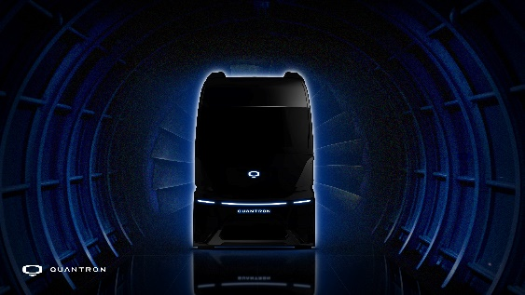 | QUANTRON FCEV Heavy-Duty EU Truck – world premiere at the IAA in Hanover in September
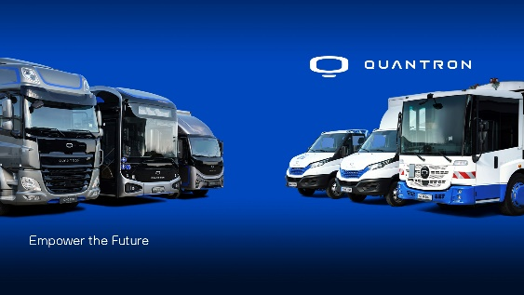 | The QUANTRON portfolio
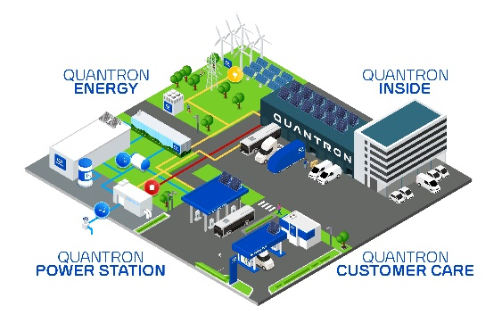 | The 360 degree Quantron-as-a-Service (QaaS) ecosystem
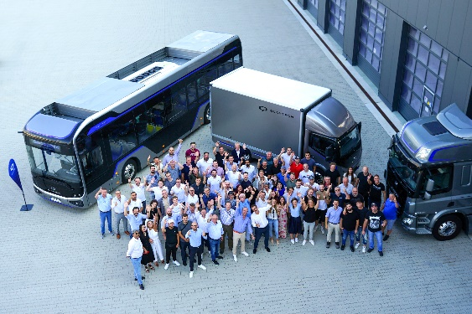 | QUANTRON Team

The original photos are available in both low and high resolutions here: Quantron AG press releases (https://www.quantron.net/q-news/pr-berichte/)

About Quantron AG
Quantron AG is a system provider of sustainable battery-electric and hydrogen-electric e-mobility for commercial vehicles such as trucks, buses and vans. The wide range of services is based on the two business units Q-Retrofit (electrification of used and existing vehicles from diesel to zero-emission electric drive) and Q-Mobility (OEM for own zero-emission QUANTRON vehicles). With the Quantron-as-a-Service Ecosystem (QaaS), Quantron AG also offers an overall concept for zero-emission mobility. This includes the creation of individual overall concepts including customised charging solutions, hydrogen refuelling station infrastructure, as well as rental, financing and leasing offers as well as training courses and workshops in the QUANTRON Academy. The e-mobility pioneers also sell batteries and integrated customized electrification concepts to manufacturers of commercial vehicles, machinery and intralogistics vehicles. The German company from Augsburg in Bavaria has a network of 700 service partners and the extensive knowledge of qualified experts in the fields of power electronics and battery technology. As a high-tech spinoff of the renowned Haller KG, it combines over 140 years of commercial vehicle experience with state-of-the-art e-mobility know-how.
QUANTRON stands for the core values RELIABLE, ENERGETIC, BRAVE . The team of experts at the innovation driver for e-mobility is making a significant contribution to sustainable, environmentally friendly passenger and freight transport. More informationen available at www.quantron.net
Visit Quantron AG on our social media channels onLinkedIn and YouTube.
Contact persons:
Martin Lischka, Head of Marketing & Communications Quantron AG,
m.lischka@quantron.net

Stephanie Miller, Marketing & Communications Quantron AG,
presse@quantron.net

