PRESS RELEASE August 10th, 2022
Strategic realignment in the bus sector at QUANTRON
In the course of the strategic realignment as a manufacturer of own complete buses as OEM, Quantron AG will no longer distribute KARSAN products by the end of the year. However, QUANTRON will continue to provide technical support to its customers for their KARSAN products in the after-sales department.
Future outlook of business unit QUANTRON Bus
The future QUANTRON complete buses, including the all-electric QUANTRON CIZARIS 12 EV low-floor bus, are customized according to the strict Quantron AG quality standards. In the after-sales division, QUANTRON also focuses on full customer support for service and spare parts provided within the company as part of the 360 degree QaaS service offering, which also includes customer advisory service for infrastructure and solutions.
Sales in the bus sector will be expanded and further developed in the international markets by Alexander Stucke as Head of Sales Bus.
Images (Please click on the image preview to download):
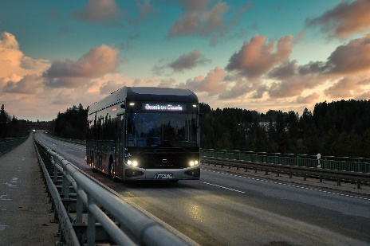 | QUANTRON CIZARIS 12 EV
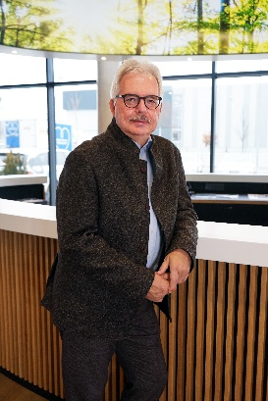 | Alexander Stucke, Head of Sales Bus Quantron AG

About Quantron AG
Quantron AG is a system provider of sustainable battery-electric and hydrogen-powered e-mobility for commercial vehicles such as trucks, buses and vans. The wide range of services is based on the two business units Q-Retrofit (electrification of used and existing vehicles from diesel to zero-emission electric drive) and Q-Mobility (OEM for own zero-emission QUANTRON vehicles). With the Quantron-as-a-Service Ecosystem (QaaS), Quantron AG also offers an overall concept for zero-emission mobility. This includes the creation of individual overall concepts including the tailormade charging solutions, hydrogen refilling infrastructure as well as rental, financing and leasing offers and training courses and workshops at the QUANTRON Academy. The e-mobility pioneers also sell batteries and integrated customized electrification concepts to manufacturers of commercial vehicles, machinery and intralogistics vehicles. The German company from Augsburg in Bavaria has a network of 700 service partners and the extensive knowledge of qualified experts in the fields of power electronics and battery technology. As a high-tech spinoff of the renowned Haller KG, it combines over 140 years of commercial vehicle experience with state-of-the-art e-mobility know-how.
QUANTRON stands for the core values Reliable, Energetic, Brave. The team of experts at the innovation driver for e-mobility is making a significant contribution to sustainable, environmentally friendly passenger and freight transport. You can find more information at www.quantron.net
Visit the Quantron AG on its social media channels on LinkedIn and YouTube.

Your contact:
Martin Lischka, Head of Marketing & Communications Quantron AG, m.lischka@quantron.net
Stephanie Miller, Marketing & Communications Quantron AG, press@quantron.net

