PRESS RELEASE September 20th, 2022
Hydrogen Highlight at IAA Transportation 2022 – QUANTRON orders 140 fuel cell modules from Ballard after receiving extraordinarily high customer request
- QUANTRON presents a h2-powered world premiere with championship range of up to 1,500km for its Nordic version and up to 700 km for its standard EU version at IAA Transportation 2022: The hydrogen heavy duty truck QUANTRON QHM FCEV
- Due to a strong demand and more than 250 initial inquiries, QUANTRON orders the first 140 fuel cell engines from Ballard Power Systems, one of the world's leading hydrogen experts
- The QUANTRON FCEV system developed by Ballard Power is the first heavy duty truck specific tailor made system in 43 years of Ballard history – and QUANTRON the global launch client
- In the next step, a total of four FCEV models are planned in cooperation with Ballard Power for 2023, all hydrogen-powered and zero-emission.
At the IAA Transportation 2022 in Hanover, QUANTRON is currently presenting the QUANTRON QHM FCEV hydrogen truck, a world champion in terms of range. The vehicle with integrated FCmove™-XD 120 kW fuel cell from Ballard Power Systems (NASDAQ: BLDP), one of the world’s leading hydrogen experts, reaches up to 1,500km in the QUANTRON QHM 44-2000 variant. The QUANTRON QHM FCEV was unveiled yesterday at the trade fair and more than 250 initial inquiries and the first orders for the vehicle have already been placed. These include Germany with a particularly high demand in the context of the recent funding applications as well as Norway for which the QUANTRON QHM FCEV 44-2000 variant was specially developed as an operating area.

As a result, QUANTRON ordered 140 fuel cell engines from Ballard to secure the supply chain, totaling approximately 17MW with an option to purchase an additional 50 units. The fuel cell modules are expected to be delivered in 2023 and 2024.

As of September 2021, QUANTRON and Ballard are engaged in a strategic partnership to accelerate the development of heavy duty hydrogen vehicles. Resulting from this strong cooperation, Ballard has made a minority equity investment in Quantron AG as part of QUANTRON’s financing round of up to 50 million euros. Ballard’s investment proceeds will be used by QUANTRON to develop their truck fuel cell vehicle platforms, under the terms of a Joint Development Agreement. Ballard will be the exclusive fuel cell supplier to QUANTRON for these platforms.

The zero-emission fuel cell electric vehicle platforms developed by QUANTRON will integrate Ballard fuel cell products for various truck applications in Europe and the US. QUANTRON’s initial market focus is Germany, where their new 44t fuel cell truck has been unveiled at IAA Transportation 2022. In the next step, a total of four FCEV models are planned in cooperation with Ballard Power for 2023.

“We are seeing growing global demand and policy support for zero emission transport as companies strive to reach decarbonization targets. This collaboration accelerates our entry into the European truck market and aims to have QUANTRON’s initial hydrogen-powered, zero emission trucks on the road in the next 18 months,” said Randy MacEwen, CEO, Ballard Power Systems.

“QUANTRON is thrilled to advance our strategic partnership with Ballard. We see compelling mobility use cases where fuel cell engines are the most suitable zero emission solution, given the power and range requirements of the application,” commented Andreas Haller, founder, and Chairman of Quantron AG.

Michael Perschke, CEO of Quantron AG added, “We want to offer our customers the best solution possible, and our continued collaboration with Ballard allows us to advance our environmentally friendly offerings to meet our customers’ needs, including range, payload, and refueling time, with an increasingly competitive total cost of ownership. As a next step we need to solve the chicken and egg situation and form multiple green hydrogen production & fueling partnerships.”

Pursuant to its strategic investment, Ballard will have the right to appoint a representative to QUANTRON’s Board of Directors.

Images (Please click on the image preview to download):
You can find the original images in low and high resolution here: Press releases from Quantron AG (https://www.quantron.net/en/q-news/press-releases/)
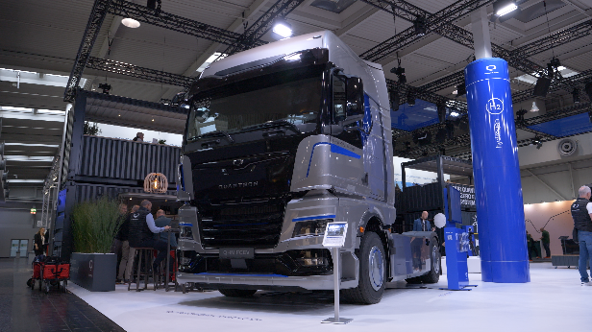  QUANTRON QHM FCEV at IAA Transportation 2022 | 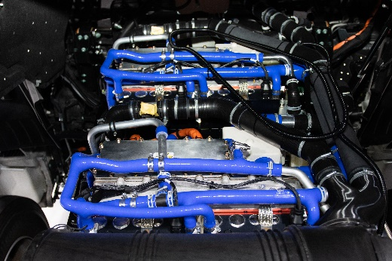  FCmove™-XD 120 kW fuel cell from Ballard Power Systems
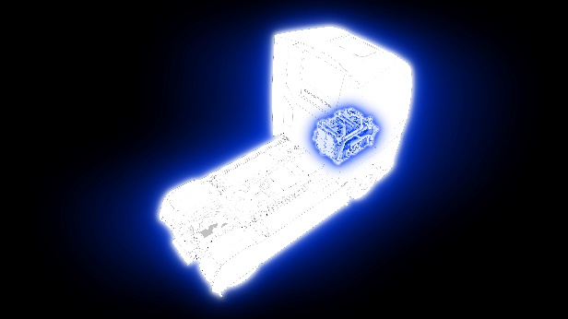
The fuel cell from Ballard Power Systems, integrated in the QUANTRON QHM FCEV

About Quantron AG
Quantron AG is a platform provider and specialist for sustainable mobility for people and goods; in particular for trucks, buses and vans with fully electric powertrains and H₂ fuel cell technology. As a high-tech spinoff of the renowned Haller KG, the German company from Augsburg in Bavaria combines over 140 years of commercial vehicle experience with state-of-the-art e-mobility know-how and positions itself globally as a partner to existing OEMs.
With the Quantron-as-a-Service Ecosystem (QaaS), QUANTRON offers an overall concept that covers all facets of the mobility value chain: QUANTRON INSIDE includes a wide range of both new vehicles and conversions for existing and used vehicles from diesel to battery and hydrogen electric powertrains using the highly innovative QUANTRON INSIDE technology. In addition, Quantron AG sells batteries and integrated customized electrification concepts. QUANTRON CUSTOMER CARE ensures digital and physical aftersales solutions with a Europe-wide network of 700 service partners, as well as a service offering for maintenance, repair and spare parts, telematics and in-cloud solutions for remote diagnostics and fleet management. Customers receive individual solutions: rental, financing and leasing offers such as training courses and workshops at the QUANTRON Academy. In the future, QUANTRON ENERGY will realize the production of green hydrogen and electricity as a platform. To this end, Quantron AG has joined forces with strong global partners. This Hydrogen Alliance also forms an important building block for QUANTRON POWER STATION, the supply of vehicles with the necessary green charging and H₂ refueling infrastructure.
QUANTRON stands for the core values Reliable, Energetic, Brave. The team of experts at the innovation driver for e-mobility is making a significant contribution to sustainable, environmentally friendly passenger and freight transport. You can find more information at www.quantron.net
Visit the Quantron AG on its social media channels on LinkedIn and YouTube.
Your contact:
Martin Lischka, Head of Marketing & Communications Quantron AG, m.lischka@quantron.net
Stephanie Miller, Marketing & Communications Quantron AG, press@quantron.net

