PRESS RELEASE September 13th, 2022
NEUMAN & ESSER and Ballard invest in QUANTRON and establish a Hydrogen Alliance for a 360° H2 Ecosystem
- Following the seed round in March 2021, Quantron AG successfully closes its A- financing round totaling up to 50 million euros to further develop its business model
- Investors in the A round include German machinery and equipment manufacturer NEUMAN & ESSER and Canadian fuel cell technology group Ballard Power Systems (Nasdaq: BLDP)
- The Vision is to create an open H2 Alliance – from fuel cells and H2 infrastructure through to an H2 refuelling alliance - open to other manufacturers of fuel cell powered trucks and buses.

As part of a financing round of Quantron AG totaling up to 50 million euros, the world's leading fuel cell expert Ballard Power Systems Inc. from Canada and the German hydrogen system specialist NEUMAN & ESSER are investing in Quantron AG.
With a company valuation of 250 million euros, NEUMAN & ESSER acquires a minority stake and secures an option for further investment. Through this, the machine and plant manufacturer underscores its commitment to this strategic partnership. Ballard Power is also acquiring a minority stake in the single-digit million range and is additionally entering into a development cooperation with QUANTRON for the accelerated market launch of fuel cell vehicles with up to 4 vehicles over the next 12 months.
Quantron AG is a specialist for battery- and hydrogen-electric commercial vehicles. With Quantron-as-a-Service (QaaS), it offers a 360-degree OEM-open ecosystem for its customers. The financing round serves to accelerate the development of further BEVs and FCEVs with a focus on Heavy Duty Trucks and to further expand the QaaS ecosystem together with QUANTRON's partner network. In the future, the Hydrogen Alliance will provide customers with a 360-degree open platform that, in addition to zero-emission H2 vehicles, will also include the associated infrastructure ranging from H2 generation through to refueling.
NEUMAN & ESSER focuses on hydrogen-related products and services to support customers in the decarbonisation of their energy or industrial systems and decentralised applications. A significant part of the product portfolio focuses on the generation and use of climate-neutral hydrogen. The globally operating group of companies contributes to the Hydrogen Alliance by providing the necessary infrastructure, in particular electrolysers and reformer technologies as well as piston and membrane compressors for transport and storage through to complete hydrogen filling stations and filling plants. With its comprehensive portfolio, NEUMAN & ESSER facilitates sector coupling as an important prerequisite for the transformation of the fossil fuel-based oil & gas sector into a sustainable economy with climate-neutral hydrogen.
The world's leading fuel cell experts at BALLARD POWER SYSTEMS have acquired a minority stake in Quantron AG as part of a financing round to accelerate the introduction of fuel cell vehicles in Europe and the United States. Ballard's investment is intended to support the development of fuel cell vehicle platforms under a Joint Development Agreement ("JDA"). Ballard will be QUANTRON's exclusive fuel cell supplier for these truck platforms.
As a key partner of the alliance, Deutsche Tamoil / HEM has joined as the first fuelling station provider and will, together with QUANTRON, explore the feasibility of integrating H2 fuelling stations in its more than 400 HEM fuelling stations in Germany which would be upgraded in a stagged process with H2 fuelling capabilities whereby a focus being also on the heavy duty truck fuelling requirements of QUANTRON´s customers.
"We are committed to providing our customers with the best possible solutions. The successfully concluded financing round gives us the necessary scope to further develop our Fuel Cell vehicle development, while at the same time consolidating our partner network required for this purpose. Positioned in this way we can optimally meet the needs of our customers, including range, payload and refueling time. However we don’t see ourself as a competitor to existing OEMs – but rather as an engineering and H2-fueling platform partner thus allowing the acceleration of hydrogen adoption as a source of energy for transportation with a focus on heavy duty and long distance transportation", says Michael Perschke, CEO of QUANTRON.
“In addition to battery technology, for which we also offer solutions, the range of hydrogen applications is the second elementary component of the decarbonisation of the mobility sector. In order to meet the growing demand for hydrogen in this sector, through our strategic partnership we can combine infrastructure know-how with fuel cell vehicle technology in order to create an ecosystem. This gives the increasing number of customers access to a fully integrated mobility platform,” say Stefanie and Alexander Peters, Managing Partners at NEUMAN & ESSER.
“This is really one of the world’s first commercially available fuel cell trucks for the demanding 44 ton heavy segment. And we know of course moving forward over the next years and decades that freight logistics will grow and GHG-emissions will therefore grow unless we have market value zero emission solutions. So we are very excited to attack this market opportunity in a partnership with QUANTRON where we bring together a vehicle integration expert and a leading fuel cell supplier.”, stated Randy McEwen, CEO of Ballard Power Solutions.
Image preview:
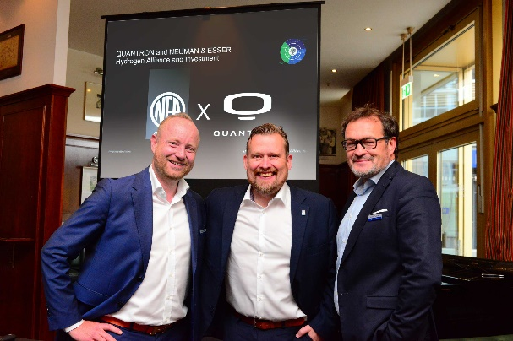 | NEA Group MD Jens Wulff & Quantron AG Board Members Andreas Haller (left) & Michael Perschke (right) Announce Investment and Cooperation
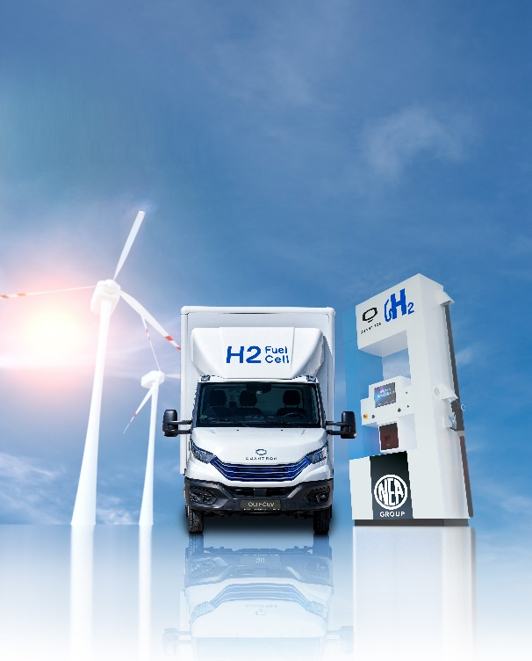 | QUANTRON – NEUMAN & ESSER POWER STATION
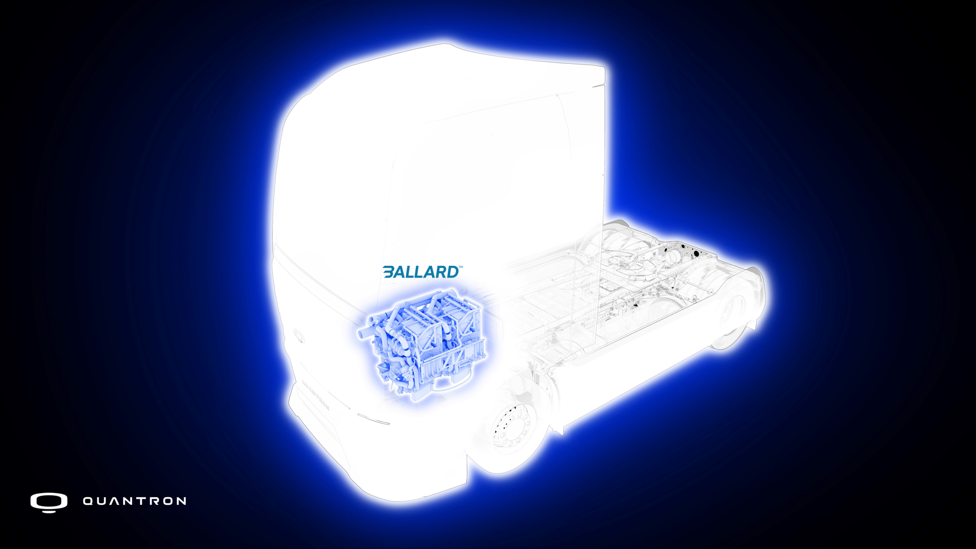 | QUANRTRON QHM FCEV & BALLARD Fuel Cell
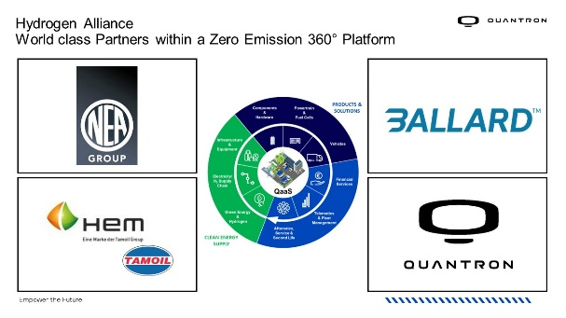 | Hydrogen Alliance
About Quantron AG
Quantron AG is a platform provider and specialist for sustainable mobility for people and goods; in particular for trucks, buses and vans with fully electric powertrains and H₂ fuel cell technology. As a high-tech spinoff of the renowned Haller KG, the German company from Augsburg in Bavaria combines over 140 years of commercial vehicle experience with state-of-the-art e-mobility know-how and positions itself globally as a partner to existing OEMs.
With the Quantron-as-a-Service Ecosystem (QaaS), QUANTRON offers an overall concept that covers all facets of the mobility value chain: QUANTRON INSIDE includes a wide range of both new vehicles and conversions for existing and used vehicles from diesel to battery and hydrogen electric powertrains using the highly innovative QUANTRON INSIDE technology. In addition, Quantron AG sells batteries and integrated customized electrification concepts. QUANTRON CUSTOMER CARE ensures digital and physical aftersales solutions with a Europe-wide network of 700 service partners, as well as a service offering for maintenance, repair and spare parts, telematics and in-cloud solutions for remote diagnostics and fleet management. Customers receive individual solutions: rental, financing and leasing offers such as training courses and workshops at the QUANTRON Academy. In the future, QUANTRON ENERGY will realize the production of green hydrogen and electricity as a platform. To this end, Quantron AG has joined forces with strong global partners. This Hydrogen Alliance also forms an important building block for QUANTRON POWER STATION, the supply of vehicles with the necessary green charging and H₂ refueling infrastructure.
QUANTRON stands for the core values Reliable, Energetic, Brave. The team of experts at the innovation driver for e-mobility is making a significant contribution to sustainable, environmentally friendly passenger and freight transport. You can find more information at www.quantron.net
Visit the Quantron AG on its social media channels on LinkedIn and YouTube.

Your contact:
Martin Lischka, Head of Marketing & Communications Quantron AG, m.lischka@quantron.net
Stephanie Miller, Marketing & Communications Quantron AG, press@quantron.net

