PRESS RELEASE
September 19th, 2022
IAA Transportation World Premieres:
QUANTRON unveils longest-range hydrogen and electric trucks based on newly developed platforms

- World premiere of the QUANTRON QHM FCEV Heavy Truck, a tractor unit for heavy long-distance transport with a range of up to 1500 km
- Technology highlights on board with platform partners: Latest fuel cell technology from Ballard Power and integrated E-axle from Allison Transmission
- Presentation of the QUANTRON QHM BEV Truck, a near-production concept vehicle based on an all-electric platform with an operating range of up to 350 km
- Other highlights at the IAA Transportation
  - the QUANTRON QLI FCEV hydrogen transporter from 3.5 to 4.2 tons, which can be used for applications requiring an operating range of up to 500 km as well as for the last mile, and the all-electric QUANTRON QLI BEV as a transporter from 3.5 to 7.2 tons for the last mile
  - the all-electric QUANTRON CIZARIS 12 EV low-floor bus with a range of up to 370 km (according to SORT 2)

Under the motto "People and Goods on the move", this year's IAA Transportation from 20th to 25th September 2022 in Hanover will focus on the sustainable switch to alternative drives for logistics and transport. As a technology and platform partner for OEMs, Quantron AG is one of the pioneers in the industry and offers conversions of diesel vehicles to battery and hydrogen-electric drives as well as the sale of its own zero-emission vehicles. At this year's transport and commercial vehicle show, QUANTRON is presenting a number of zero-emission commercial vehicles which are based on the two self-developed hydrogen and battery-electric platforms respectively, and are currently among the vehicles with the longest operating ranges.

Hydrogen Truck World Premiere at IAA: QUANTRON QHM FCEV Platform
As part of a strategic partnership, QUANTRON has developed an FCEV Heavy Duty Truck together with one of the world's leading hydrogen experts Ballard Power Systems. The QUANTRON QHM FCEV stands out through the use of state-of-the-art components, including the FCmove™-XD 120 kW fuel cell newly developed by Ballard and the integrated eGen Power® 130D E-axle from Allison Transmission, a world leader in drive systems. In addition, QUANTRON offers an optionally available aero package for all QHM FCEV trucks which has been desi gned to improve the operating range by a further 10%.

As a tractor unit for heavy long-distance transport, the QUANTRON QHM FCEV 44-1000 makes a very impressive case through a set of unique selling propositions:
An operating range of around 700 km depending on the load and topographical requirements
- Integration of all components within the frame structure for maximum everyday suitability - in compliance with legal requirements and without any compromises in the dimensions
- Application of the ISO directive for tractor-trailer combinations to ensure interchangeability of semitrailers and tractor units at national and international level
- Long-distance driver's cab
- Hydrogen tank of about 54 kg fully integrated in the chassis
- Optimized H2 consumption through specially developed intelligent Q-ENERGY management system
- Maximum efficiency in the interaction between E-axle, fuel cell, high-voltage battery and 24V as well as HV auxiliary consumers
- Available for immediate order and delivery in Q2 2023
Further highlight: semitrailer tractor version on the same basis for use in Norway:
QUANTRON QHM FCEV 60-2000 and QUANTRON QHM FCEV 44-2000 stand out from the competition through their exceptionally large tank capacities of up to 116 kg, which are fully integrated in the chassis and positioned behind the cab. This will enable ranges of up to 1500 km with a single H2 tank filling.
Under the designation QUANTRON QHM FCEV 27-1000, this configuration will also be available as a road train version for long-distance heavy load transports.
New electric truck platform: QUANTRON QHM BEV
As another world first, QUANTRON is presenting an all-electric heavy-duty truck platform at the IAA Transportation: the QUANTRON QHM BEV is available as the QUANTRON QHM BEV 44-400 tractor unit as well as the QUANTRON QHM BEV 27-400 chassis in a large number of variants. The up to 392 kWh high-voltage battery can be re-charged to provide a performance of up to 350 kW DC has an operating range of up to 350 km depending on weight and topographical requirements. The QUANTRON QHM BEV is already available for order.
For body manufacturers, the vehicles from Quantron AG offer the highest degree of standardization and body-friendliness. With a basic vehicle that is known to body manufacturers throughout Europe, many bodies can be installed and used as is usually the case without any problems.
Regarding the heavy QUANTRON QHM BEV vehicles in particular, electrification takes place without changing the power take-off technology in the area of "engine-dependent power take-off" or "gearbox-dependent power take-off". Even the position and installation space of the power take-offs and frame mountings remain the same. As a result, QUANTRON offers body manufacturers an optimal interface and solution that is unique in this segment. At the QUANTRON IAA Transportation stand, visitors can the inspect the body-friendliness at first hand on the exhibits on display.

Other zero-emission highlights: QUANTRON QLI FCEV and QUANTRON CIZARIS 12 EV
With the QUANTRON QLI FCEV, QUANTRON is also presenting a light truck equipped with a Ballard Power hydrogen fuel cell drive that has an operating range of up to 500 km. This is now available to order in the 3.5 to 4.2 tonne class. The quiet and emission-free transporter can be used flexibly and for a wide range of applications thanks to its different body variants, in particular for longer distance tours but also for the last mile.

On the VanSelect partner stand, the all-electric QUANTRON QLI BEV transporter of 3.5 to 7.2 tonnes is on display and is the ideal zero-emission solution for intra-urban tasks in towns and municipalities. As a 3.5 t lightweight variant, this is characterized by its efficiency and suitability for everyday use, and designed to accommodate payloads of up to 1,000 kg (depending on the body). Classified as an N1 vehicle, it can already be driven with a Class B driving license and does not require any additional certificates.

Likewise being presented is the QUANTRON CIZARIS 12 EV. With its proven battery and traction technology, the all-electric bus offers a reliable, low-noise and environmentally friendly mobility solution with an operating range of up to 370 km (according to SORT 2).

Technical data

 | QUANTRON QHM FCEV  44-1000* | QUANTRON QHM FCEV  27-1000* | QUANTRON  QHM FCEV  60-2000* | QUANTRON  QHM FCEV  44-2000*
Continuous engine power | 400 kW | 400 kW | 400 kW | 400 kW
Max. engine power | 550 kW | 550 kW | 550 kW | 550 kW
Max. range | up to 700 km | up to 700 km | up to 1100 km | up to 1500 km
Tank volume | 54 kg | 54 kg | 116 kg | 116 kg
Battery capacity | 118 kWh | 118 kWh | 118 kWh | 118 kWh
Fuel cell power | 240 kW | Up to 240 kW | 240 kW | 240 kW
Axle configuration | 4x2, 6x2 | 4x2, 6x2 | 6x2 | 6x2
SOP | Q2 2023 | Q2 2023 | Q3 2023 | Q3 2023

 | QUANTRON QHM BEV 44-400* | QUANTRON QHM BEV 27-400*
Continuous engine power | 375 kW | 375 kW
Max. engine power | Up to 350 km | Up to 350 km
Max. range | 280-392 kWh | 280-392 kWh
Tank volume | 20-80 % SOC in less than 1 h | 20-80 % SOC in less than 1 h
Battery capacity | 350 kW DC | 350 kW DC
Fuel cell power | 3600 mm | 3600 mm
Axle configuration | 4x2, 6x2 | 4x2, 6x2

*All data refer to the current status September 2022. Quantron AG reserves the right to change the technical features and specifications of its products without prior notice. The range was simulated according to WLTP and varies depending on payload and driving profile.

Image preview
You can find the original photo in low and high resolution here: Press releases from Quantron AG (https://www.quantron.net/en/q-news/press-releases/)
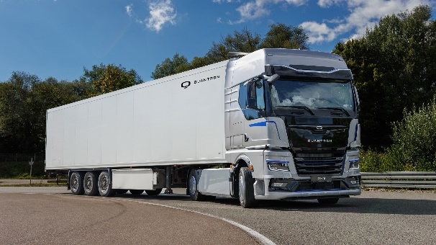  QUANTRON QHM FCEV | 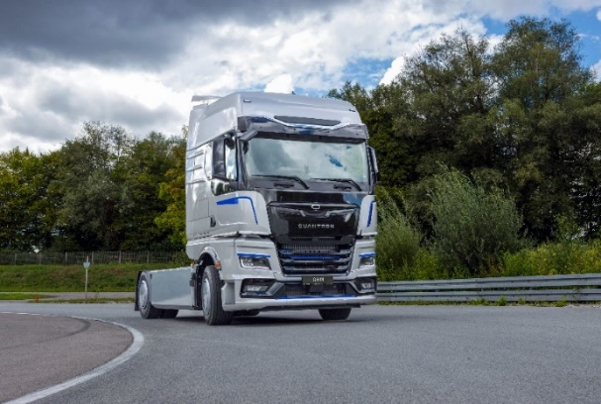  QUANTRON QHM FCEV
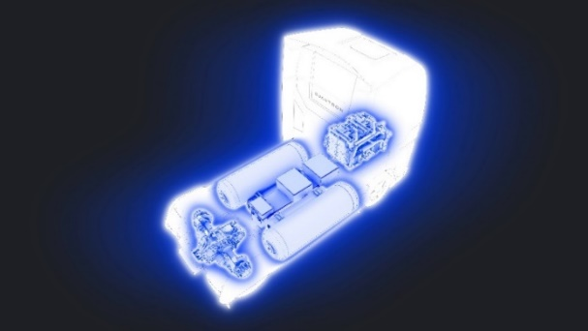  In the QUANTRON QHM FCEV, all components are integrated within the frame structure | 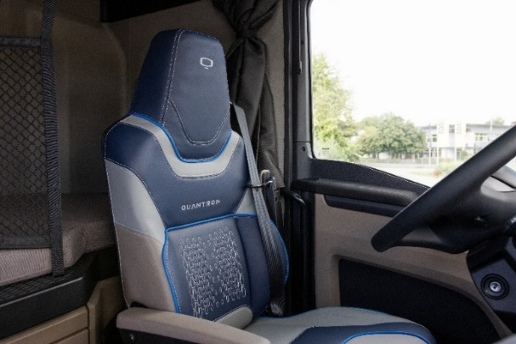  QUANTRON QHM FCEV - Interior
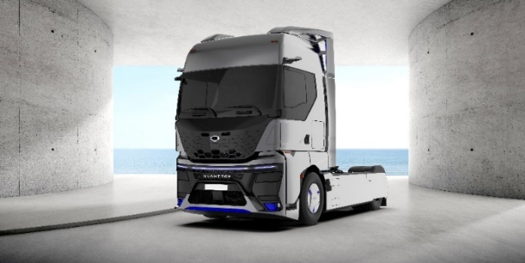  QUANTRON QHM FCEV – optionally available aero package | 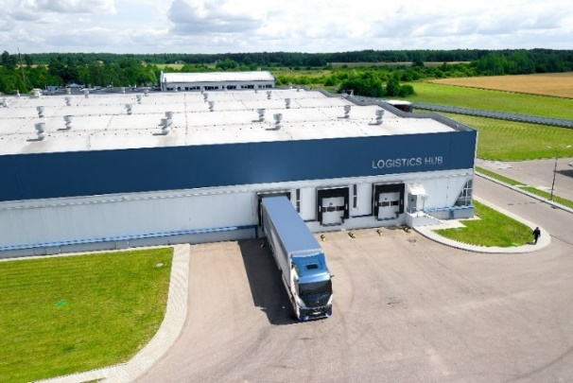  QUANTRON QHM FCEV with aero package in operation
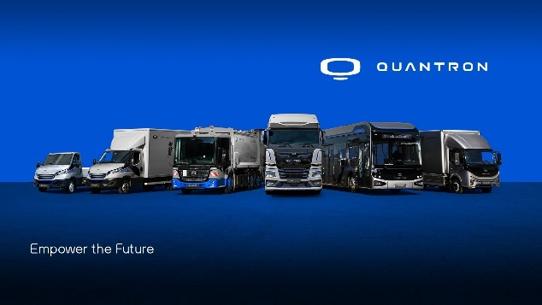
QUANTRON portfolio
About Quantron AG
Quantron AG is a platform provider and specialist for sustainable mobility for people and goods; in particular for trucks, buses and vans with fully electric powertrains and H₂ fuel cell technology. As a high-tech spinoff of the renowned Haller KG, the German company from Augsburg in Bavaria combines over 140 years of commercial vehicle experience with state-of-the-art e-mobility know-how and positions itself globally as a partner to existing OEMs.
With the Quantron-as-a-Service Ecosystem (QaaS), QUANTRON offers an overall concept that covers all facets of the mobility value chain: QUANTRON INSIDE includes a wide range of both new vehicles and conversions for existing and used vehicles from diesel to battery and hydrogen electric powertrains using the highly innovative QUANTRON INSIDE technology. In addition, Quantron AG sells batteries and integrated customized electrification concepts. QUANTRON CUSTOMER CARE ensures digital and physical aftersales solutions with a Europe-wide network of 700 service partners, as well as a service offering for maintenance, repair and spare parts, telematics and in-cloud solutions for remote diagnostics and fleet management. Customers receive individual solutions: rental, financing and leasing offers such as training courses and workshops at the QUANTRON Academy. In the future, QUANTRON ENERGY will realize the production of green hydrogen and electricity as a platform. To this end, Quantron AG has joined forces with strong global partners. This Hydrogen Alliance also forms an important building block for QUANTRON POWER STATION, the supply of vehicles with the necessary green charging and H₂ refueling infrastructure.
QUANTRON stands for the core values Reliable, Energetic, Brave. The team of experts at the innovation driver for e-mobility is making a significant contribution to sustainable, environmentally friendly passenger and freight transport. You can find more information at www.quantron.net
Visit the Quantron AG on its social media channels on LinkedIn and YouTube.

Your contact:
Martin Lischka, Head of Marketing & Communications Quantron AG, m.lischka@quantron.net
Stephanie Miller, Marketing & Communications Quantron AG, press@quantron.net

