PRESS RELEASE October 12th, 2022
Up to 500 QUANTRON Class 8 Fuel Cell Trucks for US-based TMP Logistics Group Ltd.
- Framework agreement signed between QUANTRON and TMP Logistics Group Ltd. for an order of up to 500 Class 8 trucks with FCEV drive system for delivery by 2024.
- Immense market potential in the US: The total market for Class 8 vehicles by 2030 is around 280,000 to 300,000 vehicles, a large proportion of which will be fully electric and powered by hydrogen fuel cells in future
- Strong support for the collaboration from the German delegation alongside Hubert Aiwanger, Deputy Minister President of Bavaria and Bavarian Minister of Economic affairs
German e-mobility specialist QUANTRON has signed a framework agreement with TMP Logistics Group Ltd. for an order of up to 500 Class 8 trucks with FCEV drive system. The contract signing took place in a dedicated ceremony after the Hydrogen Americas Summit 2022 on October 12 at the Delegation of German Industry and Commerce (DGIC). The event was supported by the German Embassy in Washington D.C.
The vehicles, which will be operated via Quantron-as-a-Service (QaaS), are scheduled for delivery by 2024. It is also intended to integrate zero-emission vehicles from third-party suppliers into the QaaS platform and offer zero-emission solutions to customers on a per-mile basis based on total cost of ownership (TCO). QUANTRON is the preferred supplier of FCEV-powered Class 8 trucks to TMP Logistics.

The framework agreement was signed by Andreas Haller, founder and Chairman of the Board of QUANTRON, and on behalf of TMP Logistics by Michael Watts (Business Development & Strategic Partnerships) representing Raymond F. Staples,Esq.

Staples, a pioneering entrepreneur and investor in the emerging market of Central and Eastern Europe, is the Founder and Chairman of the global investment firm TMP Holdings Inc., as well as Chairman and CEO of the TMP Logistics Group, an integrated group of more than a dozen trucking, logistics and logistics related software companies in the USA, including the National Freight group of companies. National Freight is the largest linehaul contractor in the USA for FedEx Ground.

QUANTRON is a platform provider and specialist for sustainable mobility for people and goods, and offers a 360-degree OEM-open ecosystem through its Quantron-as-a-Service (QaaS) option. In addition to zero-emission BEV and FCEV vehicles and the corresponding customer care, the associated infrastructure from H2 generation to refueling is also encompassed.

The signing of the framework agreement took place with the support of the German Embassy and the Chamber of Foreign Trade during a delegation trip led by Hubert Aiwanger. The Deputy Minister President of the Free State of Bavaria and Bavarian Minister of Economic Affairs promotes and supports regional development as well as the development of the energy industry in the field of green transport and hydrogen in Bavaria.

"Bavaria backed the right horse early on with hydrogen," says Hubert Aiwanger. "The decarbonization of truck transport is a central task in the energy transition. The current energy crisis is calling even louder for solutions without fossil fuels, and the trend toward the use of hydrogen has been accelerated. In the US alone, the demand for heavy-duty fuel cell trucks is estimated at up to 300,000 vehicles by 2030. This Bavarian-American framework agreement marks the start of close transatlantic cooperation in the promising market for climate-neutral mobility. In Europe too, hydrogen trucks must achieve a breakthrough in the next few years."

The contract signing followed the Hydrogen Americas Summit, where QUANTRON CEO Michael Perschke highlighted the formation of Quantron USA Inc. This was launched with the aim of further expanding activities in the North American market. The American subsidiary is headed by Raymond F. Staples and Andreas Haller as co-founders of Quantron US and Richard Haas as CEO.

Green hydrogen vehicles for transportation of goods have an immense market potential in the US. The total market for Class 8 vehicles to be electrified and equipped with fuel cell drives is around 280,000 to 300,000 vehicles in the USA by 2030. This means enormous growth potential of alternative powertrains with hydrogen and all-electric drive from around 2,000 units in 2022 to over 35,000 in 2034.

"We are proud that QUANTRON, with the support of the U.S. Chamber of Commerce, Ambassador Dr. Emily Haber, and Bavarian Minister of of Economic Affairs Hubert Aiwanger, is able to help advance the hydrogen economy in the heavy Class 8 commercial vehicle sector in the U.S.," emphasized Michael Perschke, CEO of Quantron AG. "With our contribution of 500 heavy-duty FCEV trucks, we support the $8 billion hydrogen program funded by President Biden's Bipartisan Infrastructure Law and are pleased to spearhead the effort to help businesses and communities across the country benefit from clean energy and hydrogen investments.”

Images (Please click on the image preview to download):
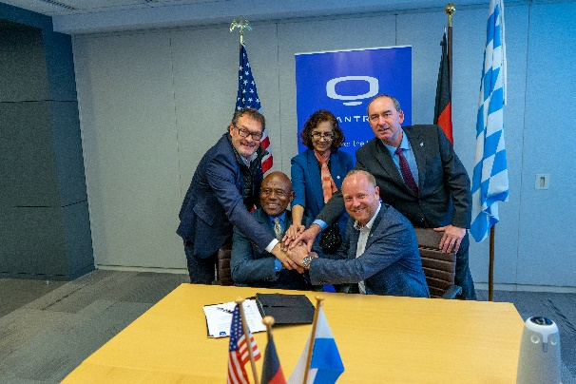 | Signature process for 500 units of FCEV Class 8 trucks  (Michael Perschke – CEO QUANTRON, Michael Watts – Strategic Partnerships TMP Logistics Group, Dr. Sunita Satyapal – US Department of Energy Hydrogen Program Coordinator, Hubert Aiwanger - Deputy Minister President of Bavaria and Bavarian Minister of Economic affairs, and Andreas Haller, QUANTRON Founder and Chairman of the Board)
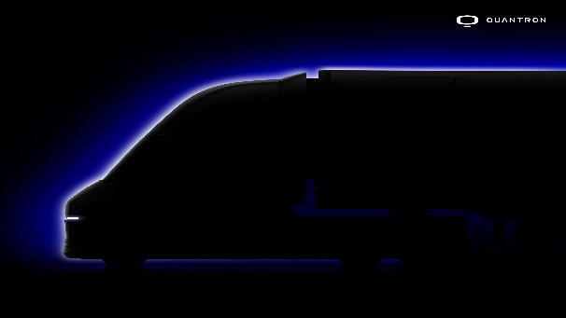 | QUANTRON USA Class 8 FCEV Truck Teaser
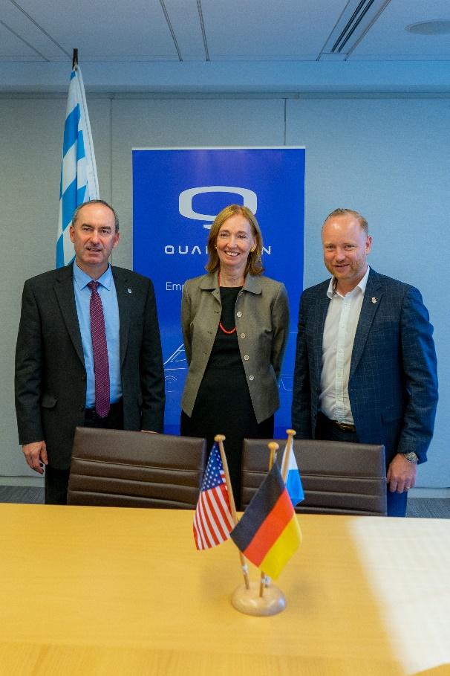 | Decarbonization of Trucking Summit in the US Federal Ministry of Economic Affairs  (Hubert Aiwanger –Deputy Minister President of Bavaria and Bavarian Minister of Economic affairs, Dr. Emily Haber – German Ambassador and Andreas Haller – Founder and Chairman of the Board of QUANTRON)

You can find the original images in low and high resolution here: Press releases from Quantron AG (https://www.quantron.net/en/q-news/press-releases/)
About Quantron AG
Quantron AG is a platform provider and specialist for sustainable mobility for people and goods; in particular for trucks, buses and vans with fully electric powertrains and H₂ fuel cell technology. As a high-tech spinoff of the renowned Haller KG, the German company from Augsburg in Bavaria combines over 140 years of commercial vehicle experience with state-of-the-art e-mobility know-how and positions itself globally as a partner to existing OEMs.
With the Quantron-as-a-Service Ecosystem (QaaS), QUANTRON offers an overall concept that covers all facets of the mobility value chain: QUANTRON INSIDE includes a wide range of both new vehicles and conversions for existing and used vehicles from diesel to battery and hydrogen electric powertrains using the highly innovative QUANTRON INSIDE technology. In addition, Quantron AG sells batteries and integrated customized electrification concepts. QUANTRON CUSTOMER CARE ensures digital and physical aftersales solutions with a Europe-wide network of 700 service partners, as well as a service offering for maintenance, repair and spare parts, telematics and in-cloud solutions for remote diagnostics and fleet management. Customers receive individual solutions: rental, financing and leasing offers such as training courses and workshops at the QUANTRON Academy. In the future, QUANTRON ENERGY will realize the production of green hydrogen and electricity as a platform. To this end, Quantron AG has joined forces with strong global partners. This Hydrogen Alliance also forms an important building block for QUANTRON POWER STATION, the supply of vehicles with the necessary green charging and H₂ refueling infrastructure.
QUANTRON stands for the core values Reliable, Energetic, Brave. The team of experts at the innovation driver for e-mobility is making a significant contribution to sustainable, environmentally friendly passenger and freight transport. You can find more information at www.quantron.net
Visit the Quantron AG on its social media channels on LinkedIn and YouTube.
Your contact:
Martin Lischka, Head of Marketing & Communications Quantron AG, m.lischka@quantron.net
Stephanie Miller, Marketing & Communications Quantron AG, press@quantron.net

