PRESS RELEASE October 11th, 2022
European e-mobility specialist QUANTRON expands to North America
- In the future, Quantron AG will also offer its commercial vehicles with hydrogen fuel cell drive and battery electric drive as well as retrofit packages on the North American market
- To enter the North American market, the company has founded Quantron US Inc. and appointed Richard Haas as CEO of Quantron US. Raymond Staples becomes Chairman of the Board and co-founder of Quantron-as-a-service USA
- Target is in 2025 to achieve 50% of its turnover in the North American market
- Strong demand for hydrogen vehicles in the US is supported by 8 billion in financing opportunities

Quantron AG offers innovative mobility solutions for environmentally friendly goods and passenger transport. The Augsburg-based company not only supplies numerous European customers with battery- and hydrogen-electric commercial vehicles for the long-term reduction of C02 emissions, but also offers a 360° product & solution ecosystem around zero-emission mobility with Quantron-as-a-service.

QUANTRON will now implement this business model in the U.S., along with plans to develop new commercial vehicle designs with BEV and FCEV powertrains. Several inquiries from US fleet operators about these new technologies have supported the decision to expand into North America.

Based on its strategic partnership with the Canadian fuel cell expert Ballard Power Systems (NASDAQ: BLDP), QUANTRON has the ambition to be one of the trailblazers in the hydrogen-based zero-emission long-range vehicle segment in the U.S. By 2025, QUANTRON aims to generate around 50% of its turnover in the North American market, with a strong focus on hydrogen solutions for long range transport such as Class 8 trucks.

Michael Perschke, CEO of Quantron AG: "The foundation of a subsidiary in the US is an important step towards our goal of putting zero-emission vehicles on the roads globally. In Europe, close to 100 vehicles converted by QUANTRON are already successfully in use. We see potential for the USA in the early years of a triple-digit volume annually. I am very pleased that Richard Haas, with his more than 40 years of multicultural experience in the mobility industry, will be joining us as president and CEO for Quantron US."
Prior to joining Quantron, Richard Haas was president and CEO of automotive start-up Mahindra Automotive North America, launching a new assembly plant in the Detroit area. Before that, he was Director of Engineering for the Tesla Model S and a veteran at Ford Motor Company, including a five-year stint in Ford South America, where he was part of a small task force that included the launch of multiple new products at a greenfield assembly complex in northeast Brazil.
Richard Haas: „The opportunity at QUANTRON is unique and compelling in an industry that is now embracing emerging non-IC technologies - particularly the Hydrogen Fuel Cell Electric Powertrain space for medium and large commercial vehicles. I’m honored and excited to be one of the first players in this space in the United States.“
Raymond F. Staples,Esq joins Andreas Haller (founder and Chairman of the Board of QUANTRON) as co-founder of Quantron-as-a-service (QaaS) USA the board of directors to expand QaaS in North America. He will take on the role of Chairman of the Board at Quantron US.
In the US, there is a high demand for alternative-fuel vehicles. Recently the Biden-Harris Administration has annnounced a $8 billion funding opportunity to create regional clean hydrogen hubs (H2Hubs) across the country, which will form a critical arm of America's future clean energy economy.
“These H2Hubs are a once-in-a-generation opportunity to lay the foundation for the clean hydrogen future President Biden is building—one that will lift our economy, protect the planet, and improve our health,” said U.S. Secretary of Energy Jennifer M. Granholm.
Andreas Haller, founder and Chairman of the Board of Quantron AG: "QUANTRON is contributing its share in the future to advance the hydrogen infrastructure and vehicles with the best partners and with the open Quantron-as-a-service ecosystem and to realize the full potential of clean hydrogen energy for generations to come."

Image (Please click on the image preview to download):
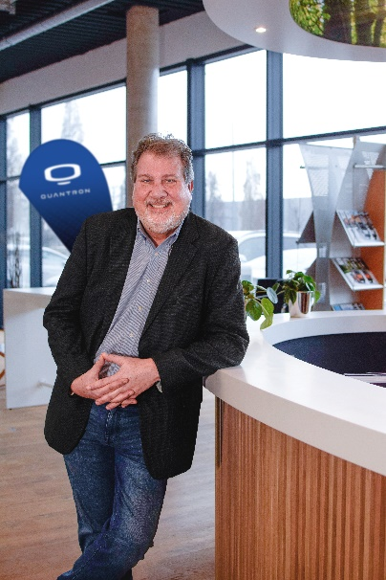
Richard Haas, President and CEO, Quantron US, Inc.

You can find the original image in low and high resolution here: Press releases from Quantron AG (https://www.quantron.net/en/q-news/press-releases/)

About Quantron AG
Quantron AG is a platform provider and specialist for sustainable mobility for people and goods; in particular for trucks, buses and vans with fully electric powertrains and H₂ fuel cell technology. As a high-tech spinoff of the renowned Haller KG, the German company from Augsburg in Bavaria combines over 140 years of commercial vehicle experience with state-of-the-art e-mobility know-how and positions itself globally as a partner to existing OEMs.
With the Quantron-as-a-Service Ecosystem (QaaS), QUANTRON offers an overall concept that covers all facets of the mobility value chain: QUANTRON INSIDE includes a wide range of both new vehicles and conversions for existing and used vehicles from diesel to battery and hydrogen electric powertrains using the highly innovative QUANTRON INSIDE technology. In addition, Quantron AG sells batteries and integrated customized electrification concepts. QUANTRON CUSTOMER CARE ensures digital and physical aftersales solutions with a Europe-wide network of 700 service partners, as well as a service offering for maintenance, repair and spare parts, telematics and in-cloud solutions for remote diagnostics and fleet management. Customers receive individual solutions: rental, financing and leasing offers such as training courses and workshops at the QUANTRON Academy. In the future, QUANTRON ENERGY will realize the production of green hydrogen and electricity as a platform. To this end, Quantron AG has joined forces with strong global partners. This Hydrogen Alliance also forms an important building block for QUANTRON POWER STATION, the supply of vehicles with the necessary green charging and H₂ refueling infrastructure.
QUANTRON stands for the core values Reliable, Energetic, Brave. The team of experts at the innovation driver for e-mobility is making a significant contribution to sustainable, environmentally friendly passenger and freight transport. You can find more information at www.quantron.net
Visit the Quantron AG on its social media channels on LinkedIn and YouTube.
Your contact:
Martin Lischka, Head of Marketing & Communications Quantron AG, m.lischka@quantron.net
Stephanie Miller, Marketing & Communications Quantron AG, press@quantron.net

