PRESS RELEASE Augsburg, 5th October 2022
Successful IAA trade show for QUANTRON
- Significant increase in market acceptance
- Well-filled order books
- Double-digit turnover expected for 2022
- Outlook for business development in India and USA

This year's IAA Transportation trade show was very successful for Quantron AG. Through its presence at the fair in Hanover from 20th - 25th September, the Augsburg-based company was able to make a strong impression as one of the pioneers in the field of emission-free mobility, particularly in Europe and North America. The company's market-dominating position in the development of fuel cell-powered commercial vehicles and heavy-duty trucks was particularly reflected in the response of the international business and specialist media as well as among potential investors and customers.
With its FCEV model series, which attracted visitors attention through the respective world premieres, QUANTRON positioned itself clearly at the top of the industry especially in terms of range performance that visibly left the competition behind, something which was also recognised by the media. One special highlight at the trade show by the spin-off enterprise of the traditional Augsburg company, Haller, was the presentation of its propriety 360-degree QaaS ecosystem concept, the core of which is emission-free mobility - ranging from the production of green hydrogen and infrastructure through to financing and maintenance concepts. The mobility expert from Augsburg also underlined the unique position of the QUANTRON market approach in the field of emission-free mobility with the founding of a "hydrogen alliance" with well-known companies from the energy, infrastructure, mobility and financial sectors.
The cooperation and investment agreements that QUANTRON have concluded with the leading fuel cell supplier Ballard Power Systems Inc. from Vancouver as well as with the German company, Neumann & Esser, and the drive specialist Allison Transmission from Indianapolis were very clearly received in the public´s perception. With these agreements, QUANTRON is continuously expanding its own ecosystem (Quantron-as-a-Service). Further investment agreements are currently being prepared.
The performance and model range in the battery area was also well received by the general public and other interested parties.
Not least against this background, the Augsburg-based company was also able to fill the order books during the six days of the trade fair which had been prepared for by means of a sneak preview for the press, potential customers and investors held shortly before the start of the IAA. Overall, incoming orders accelerated noticeably. A number of vehicle orders were placed during discussions on the periphery of the fair and preliminary talks were held during the IAA itself with interested parties from Great Britain and Asia, including Malaysia and Singapore, which focused on vehicles with right-hand drive. The increasing demand for heavy-duty trucks powered by fuel cells was particularly noticeable during the talks.
The first deliveries of the new models are scheduled for mid-2023. QUANTRON customers include companies from the logistics, business and food sectors as well as from public sector enterprises. In order to be able to meet the constantly growing demand, QUANTRON has ordered the first batch of 140 latest generation fuel cells from Ballard.
The order books are not only full for the current year. Rather, the company expects a massive increase in incoming orders for 2023 and a high double-digit turnover by the end of 2023. In addition, Quantron AG has plans for business developments in India and USA. More information on this will follow in October.

Media quotes:
Der Tagesspiegel: "David is faster than Goliath: while Mercedes-Benz aims to launch its fuel cell truck GenH2 Truck FC between 2027 and 2029, QUANTRON will be producing its hydrogen model in series from 2023 onwards. At the very least, the top model from Augsburg will also be ahead in terms of range: 1500 kilometres will set a world record, QUANTRON announced on Monday at the IAA Transportation trade show in Hanover. The standard model achieves 600 to 700 kilometres on one tank of hydrogen. The Mercedes manages a good 1000 kilometres."
Tagesschau.de: "Fuel cell trucks can also be seen in Hanover. New company QUANTRON presents its first hydrogen truck with a range of 700 kilometres at the IAA Transportation. It contains a (2x) 120-kW fuel cell newly developed by Ballard Power Systems. This, along with the hydrogen tanks, are installed in the chassis. A special cost model has been designed to attract freight forwarders: they only pay for the use of the vehicle by kilometres and the hydrogen actually required. As early as 2024 or 2025, diesel will probably cost more per kilometre than hydrogen," said QUANTRON's management.
Frankfurter Allgemeine Zeitung: "Major German commercial vehicle manufacturers are in danger of falling behind in the field of heavy-duty trucks equipped with environmentally-friendly drive systems. The IAA Transportation commercial vehicle show in Hanover provides just the setting for comparing products and technical solutions. Currently, the American-Italian combination of Iveco and Nikola, the start-up QUANTRON or Volvo Truck seem to be ahead of the game which underlines the strong impression Quantron AG is making as well as the leading position it has so quickly gained in the shark tank of competition."
The international press has also responded very positively about the subject and certified QUANTRON to have become the “range world champion” at the IAA Transportation. The headline in Automotive World is: “IAA Transportation World Premieres: Quantron unveils longest-range hydrogen and electric trucks based on newly-developed platforms.” Yahoo Finance and The Autopian also cite the immense 900-mile range which has been realised by integrating the tanks into the chassis and additional tanks: "Big rig builder Quantron claims this hydrogen truck has a 900-mile range."

Images (click on image preview to download):
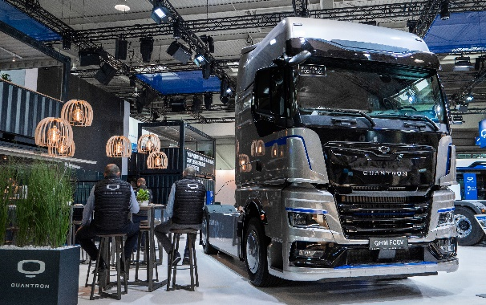 | World premiere: QUANTRON QHM FCEV hydrogen truck
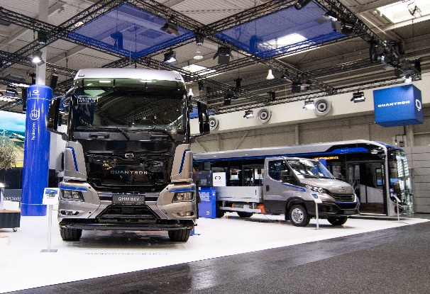 | QUANTRON stand at the IAA
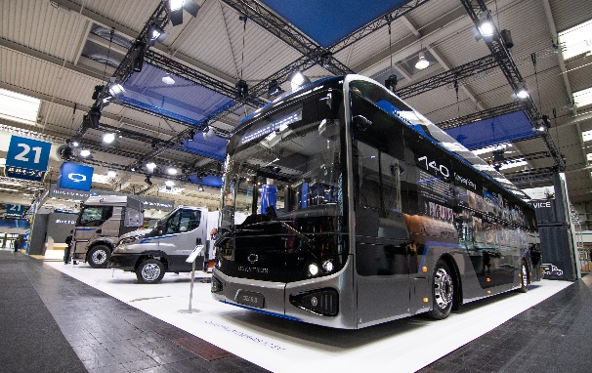 | The fully-electric QUANTRON CIZARIS 12 EV city bus
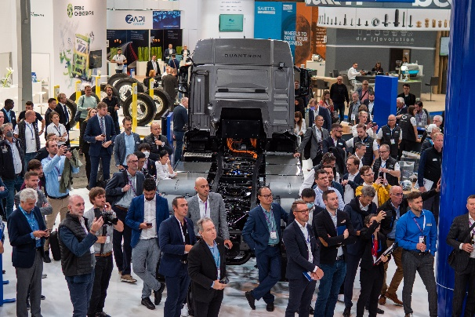 | QUANTRON press conference at the IAA
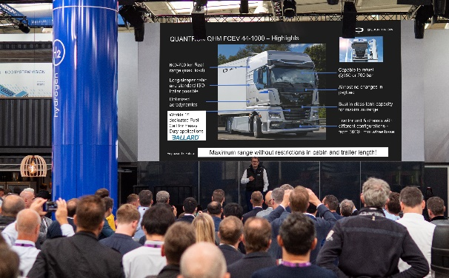 | QUANTRON presentation by Michael Perschke (CEO) on the QUANTRON QHM FCEV hydrogen truck
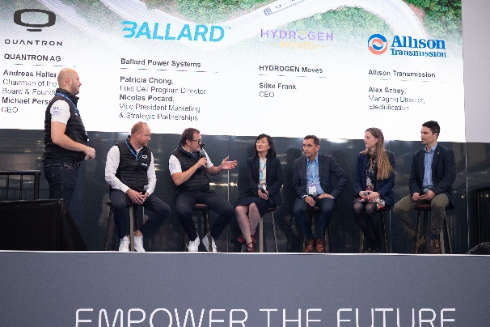 | QUANTRON panel talk at the IAA with representatives from Ballard Power Systems, Hydrogen Moves GmbH and Allison Transmission.
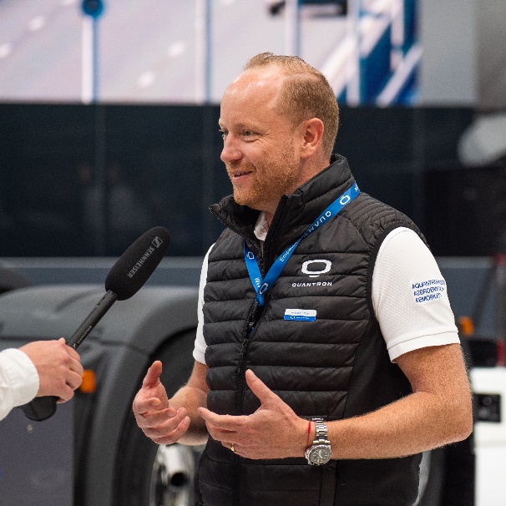 | Andreas Haller (founder and Chairman of the Board of QUANTRON) at the IAA 2022
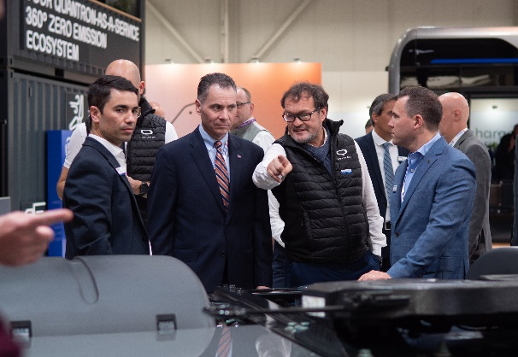 | Michael Perschke (CEO QUANTRON) at the IAA 2022
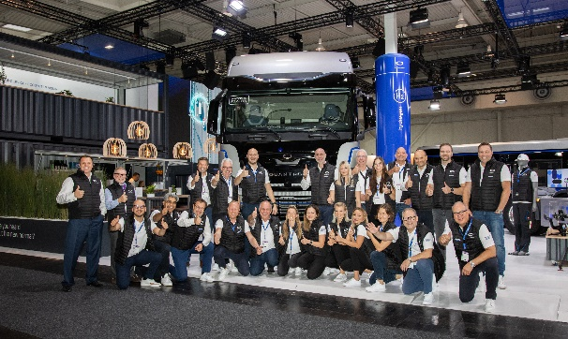 | The QUANTRON team at the IAA 2022

The original photos are available in both low and high resolutions here: Quantron AG press releases (https://www.quantron.net/q-news/pr-berichte/)

About Quantron AG
Quantron AG is a platform provider and specialist in sustainable mobility for people and goods; in particular, for trucks, buses and vans with all-electric drive trains and H₂fuel cell technology.. As a high-tech spin-off of the renowned Haller KG, the Augsburg/Bavaria-based company combines more than 140 years of commercial vehicle experience with the very latest e-mobility know-how, and positions itself globally as a partner to existing OEMs.
With the Quantron-as-a-Service Ecosystem (QaaS), QUANTRON offers an overall concept that includes all facets of the mobility value-added chain: QUANTRON INSIDE includes a wide range of new vehicles as well as conversions for existing and used vehicles from diesel to battery and hydrogen-electric drives with the highly innovative QUANTRON INSIDE technology. In addition, Quantron AG markets and sells batteries and integrated, customised electrification concepts. With a Europe-wide network of 700 service partners,QUANTRON CUSTOMER CARE guarantees digital and physical after-sales solutions along with a range of services for maintenance, repairs and spare parts, telematics and in-cloud solutions for remote diagnosis and fleet management. Customers receive individual advice on, among other things, tailored charging and tank solutions, rental, financing and leasing offers. Training courses and workshops are also offered in the QUANTRON Academy. In the future, QUANTRON ENERGY will realise the production of green hydrogen and electricity as a platform. To this end, Quantron AG has teamed up with a number of strong global partners. At the same time, this Hydrogen Alliance is also an important building block for the QUANTRON POWER STATION, the supply of vehicles with the necessary green charging and H2-tank infrastructure.
QUANTRON stands for the core values RELIABLE, ENERGETIC, BRAVE . The team of experts at the innovation driver for e-mobility is making a significant contribution to sustainable, environmentally friendly passenger and freight transport. More informationen available at www.quantron.net
Visit Quantron AG on our social media channels onLinkedIn and YouTube. More informationen available at www.quantron.net

Contact persons:
Martin Lischka, Head of Marketing & Communications Quantron AG, m.lischka@quantron.net
Stephanie Miller, Marketing & Communications Quantron AG, presse@quantron.net

