PRESS RELEASE Riyadh, Saudi Arabia, November 09, 2022

Electromin and QUANTRON expand their business through a strategic long-term distribution partnership in Saudi Arabia
- Electromin will promote, distribute and service Quantron AG products in Saudi Arabia with an initial focus on BEV last-mile vehicles like the QUANTRON QARGO 4 EV
- QUANTRON brings in their European BEV & FCEV competence (New & Refit) while Electromin and Petromin have a Service Network of over 700 service stations and also a leading truck & bus leasing company in Saudi Arabia
- Both parties continue to analyze other future strategic options and collaboration models

Electromin has entered a strategic partnership with sustainable e-mobility pioneers, Quantron AG. Electromin is a turnkey e-mobility solutions company wholly owned by the Petromin Corporation ("Petromin"), a leading mobility solutions provider in Saudi Arabia.
This collaboration combines Electromin's expertise in the entire e-mobility ecosystem with Quantron AG's industry expertise in the field of electrified commercial vehicles and makes QUANTRON an attractive partner for existing OEMs.
As a high-tech spin off of the renowned Haller KG, Quantron AG combines over 140 years of commercial vehicle experience with state-of-the-art e-mobility know-how. The German company not only supplies numerous customers with battery- and hydrogen-electric commercial vehicles for the long-term reduction of C02 emissions but also offers a 360° product & solution ecosystem regarding zero-emission mobility with Quantron-as-a-service.
Electromin is a technology-driven e-mobility solutions provider offering complete turnkey solutions which includes in-depth consultation, ongoing network operation and maintenance. Electromin's main focus of action is throughout the Middle East and is building a public charging network that provides a convenient charging experience for e-drivers.
Commenting on the partnership, Mr. Kalyana Sivagnanam, Group CEO of Petromin said "QUANTRON has selected Electromin as its distribution partner for the QUANTRON QARGO 4 EV light truck in KSA. Naturally, we are open to adding other QUANTRON products.
In time, this agreement will be extended to include other emission-free products, based on market suitability and requirements. This is the start of a bigger partnership as we are also exploring other avenues of mutual interest to strengthen this alliance. At Petromin, we strongly believe in sustainability and are guided by our principles of responsible corporate citizenship. Two years ago, we embarked on an exciting journey with an ambitious goal to transform our historical and successful company from primarily a premier lubricant manufacturer and operator of the largest network of quick service facilities to a world class automotive technology, advanced mobility, and avant-garde transportation solutions company. As part of that journey, we introduced Electromin, a technology-driven, turnkey e-mobility solutions provider that is now leading the electrification of the Kingdom and GCC.”
Michael Perschke, CEO of Quantron AG, commented on the strategic partnership with Electromin: "QUANTRON is a very successful player in Europe because we are technology-independent and offer our customers BEV and FCEV solutions that support them on their way to becoming a provider of zero-emission transport solutions. Recently, at the IAA in Hanover, we presented the QUANTRON QHM FCEV, a European H2 range champion with up to 116 kg of hydrogen on board."
Andreas Haller, CEO and founder of QUANTRON added: "We have been looking for international growth opportunities and Saudi Arabia is one of our key markets. This is how we became aware of Electromin and the Petromin Corporation and found many parallels in strategy and vision. That's why we decided to join forces. We look forward to building together unique competencies for zero-emission solutions in KSA."

Images (Please click on the image preview to download):
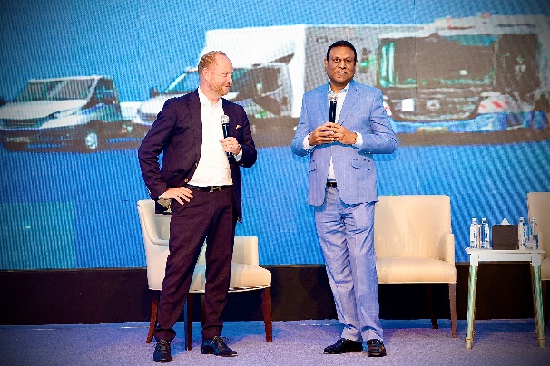 | Andreas Haller, Chairman of the Board & Founder of Quantron AG & Kalyana Sivagnanam, Group CEO of Petromin, in Riyadh
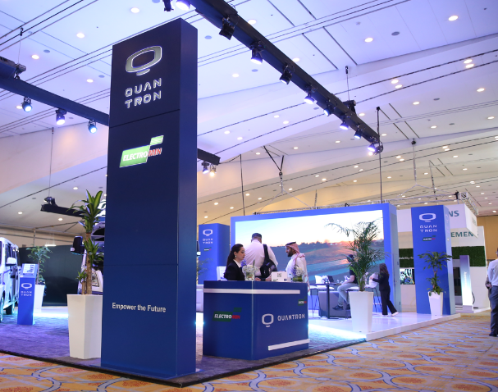 | EV Auto Show in Riyadh

You can find the original images in low and high resolution here: Press releases from Quantron AG (https://www.quantron.net/en/q-news/press-releases/)
About Petromin Corporation:
Petromin is the leading Saudi company in the advanced lubricants, automotive technology, multi-modal mobility, and sustainable transportation segment, with an unmatched reputation for the highest quality products and services in the industry today. The company has been operating in the Kingdom of Saudi Arabia, since 1968, when it started building its reputation for producing the highest quality lubricants in the region. With more than 6000 employees, Petromin exports its products to over 40 countries in the GCC, Middle East, Africa, and Asia. Petromin offers fast and reliable vehicle maintenance services which have benefited a considerable proportion of drivers in Saudi Arabia. It is backed by an extensive network of service centers that provide unparalleled coverage across the Kingdom.
Follow Petromin on social:
Twitter: @Petromincorp
Instagram: @Petromincorp
Facebook: @Petromincorp
About Electromin:
Electromin is the leading Saudi turnkey, technology driven e-mobility solutions provider for passenger vehicles, commercial and government fleets, public transit and large infrastructure projects. Electromin is building a charging network to offer a seamless charging experience for EV drivers across the Kingdom. Industry experts from around the world ensure that Electromin can provide the knowledge and experience to the KSA market.
Visit Electromin website at: https://electromin.com/
About Quantron AG
Quantron AG is a platform provider and specialist for sustainable mobility for people and goods; in particular for trucks, buses and vans with fully electric powertrains and H₂ fuel cell technology. As a high-tech spinoff of the renowned Haller KG, the German company from Augsburg in Bavaria combines over 140 years of commercial vehicle experience with state-of-the-art e-mobility know-how and positions itself globally as a partner to existing OEMs.
With the Quantron-as-a-Service Ecosystem (QaaS), QUANTRON offers an overall concept that covers all facets of the mobility value chain: QUANTRON INSIDE includes a wide range of both new vehicles and conversions for existing and used vehicles from diesel to battery and hydrogen electric powertrains using the highly innovative QUANTRON INSIDE technology. In addition, Quantron AG sells batteries and integrated customized electrification concepts. QUANTRON CUSTOMER CARE ensures digital and physical aftersales solutions with a Europe-wide network of 700 service partners, as well as a service offering for maintenance, repair and spare parts, telematics and in-cloud solutions for remote diagnostics and fleet management. Customers receive individual solutions: rental, financing and leasing offers such as training courses and workshops at the QUANTRON Academy. In the future, QUANTRON ENERGY will realize the production of green hydrogen and electricity as a platform. To this end, Quantron AG has joined forces with strong global partners. This Hydrogen Alliance also forms an important building block for QUANTRON POWER STATION, the supply of vehicles with the necessary green charging and H₂ refueling infrastructure.
QUANTRON stands for the core values Reliable, Energetic, Brave. The team of experts at the innovation driver for e-mobility is making a significant contribution to sustainable, environmentally friendly passenger and freight transport. You can find more information at www.quantron.net
Visit the Quantron AG on its social media channels on LinkedIn and YouTube.
Your contact:
Jörg Zwilling, Director Global Communication & Business Development, j.zwilling@quantron.net
Stephanie Miller, Marketing & Communications Quantron AG, press@quantron.net

