PRESS RELEASE November 15th, 2022
QUANTRON expands its international team to support the development of the Hydrogen Alliance
- Jörg Zwilling is in charge of QUANTRON's global communications and PR activities as Director Global Communications & Business Development
- Julia Szeszat will support QUANTRON's financing rounds and additional steps in the capital market as Head of Investor Relations & Funding
- Tarkeshwar Rao becomes Director Customer Service and Digital Ecosystem
- Moritz Meyle strengthens the area of finance as Head of Business Controlling
- Torsten Petrich assumes the position of Head of Product Management

Parallel to the expansion of the QUANTRON partner network with the Hydrogen Alliance, the QUANTRON team is also growing and has expanded its team with the addition of five new experts at management level who will use their expertise to support the company in implementing its global hydrogen goals.
Jörg Zwilling will lead QUANTRON's global communications and PR activities as Director Global Communications & Business Development. The trained lawyer can draw on more than 20 years of experience in sales-oriented functions with global responsibility. He was responsible for marketing and communication functions at such brands as Harley-Davidson, Mercedes-Benz and Daimler Commercial Vehicles. As a two-time founder, he gained considerable personal experience in business development which he will use to support QUANTRON in its ambitious growth.
Julia Szeszat supports the management team in the finance department regarding corporate investor relations. She has more than ten years of experience in the investor relations function which includes the adidas Group and Linde AG where she also completed her CIRO certification. She then built up the IR function at Hensoldt and carried out the IPO on the Frankfurt Stock Exchange and last year accompanied the IPO on the Nasdaq at the Munich start-up Sono Motors. At QUANTRON, her focus is placed on setting up the investor relations function, the financing round and further steps in the capital market.
As a further addition to the finance department, Moritz Meyle is now Head of Business Controlling for Quantron AG. He will concentrate on increasing financial product performance and corporate planning. Most recently, he coordinated portfolio controlling at AUDI AG. As a qualified engineer, he also has experience as a developer in the field of driving dynamics and production experience in his time at the prototype centre at SEAT in Barcelona.
As Director Customer Service and Digital Ecosystem, Tarkeshwar Rao will lead QUANTRON's activities in the area of customer service and digitisation of the 360-degree customer journey as well as the cooperation project with QUANTRON's Indian partner, ETO Motors Private Limited. He has over 19 years of experience in the automotive/commercial vehicle industry which includes positions at Mercedes-Benz India, more than eight years at Audi India and most recently at Automobili Pininfarina as Head of Global After Sales.
Torsten Petrich takes over the position of Head of Product Management and will be responsible for controlling product development processes at QUANTRON, as well as supporting sales on the product side and leading product training. He has 32 years of experience in the commercial vehicle industry, including management of major international projects at MAN Truck & Bus SE in Asia, most recently as Head of Sales and Operations in Hong Kong.
Michael Perschke, CEO of Quantron AG: “We are very pleased to welcome more senior executives to our team. Together we will work on the vision of building Quantron AG into a global H2 player in Europe and the USA, with further growth potential in the Middle East and India.”

Images (Please click on the image preview to download):
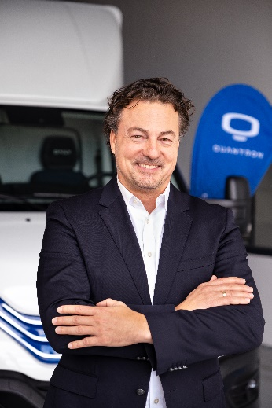 | Jörg Zwilling, Director Global Communications & Business Development Quantron AG
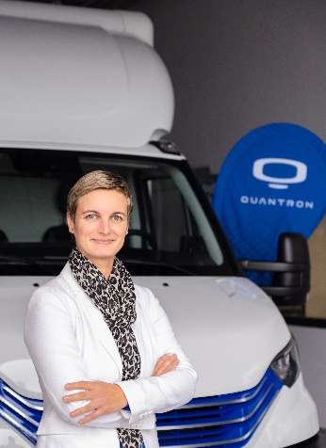 | Julia Szeszat, Head of Investor Relations & Funding Quantron AG
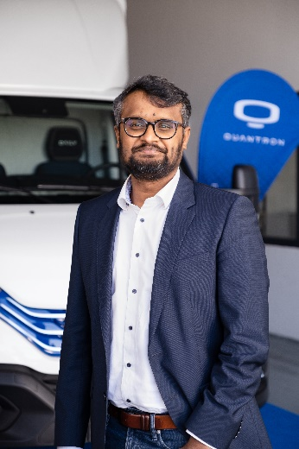 | Tarkeshwar Rao, Director Customer Service and Digital Ecosystem Quantron AG
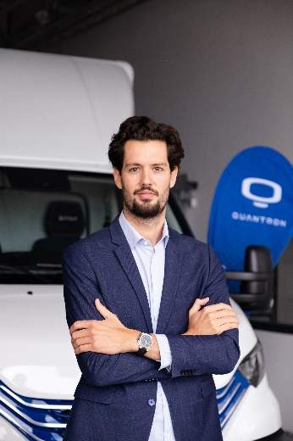 | Moritz Meyle, Head of Business Controlling Quantron AG
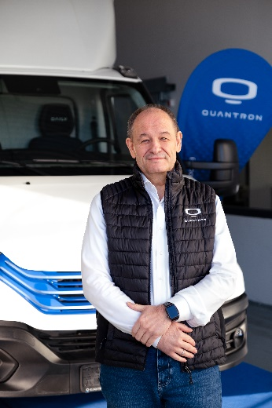 | Torsten Petrich, Head of Product Management Quantron AG

You can find the original images in low and high resolution here: Press releases from Quantron AG (https://www.quantron.net/en/q-news/press-releases/)

About Quantron AG
Quantron AG is a platform provider and specialist for sustainable mobility for people and goods; in particular for trucks, buses and vans with fully electric powertrains and H₂ fuel cell technology. As a high-tech spinoff of the renowned Haller KG, the German company from Augsburg in Bavaria combines over 140 years of commercial vehicle experience with state-of-the-art e-mobility know-how and positions itself globally as a partner to existing OEMs.
With the Quantron-as-a-Service Ecosystem (QaaS), QUANTRON offers an overall concept that covers all facets of the mobility value chain: QUANTRON INSIDE includes a wide range of both new vehicles and conversions for existing and used vehicles from diesel to battery and hydrogen electric powertrains using the highly innovative QUANTRON INSIDE technology. In addition, Quantron AG sells batteries and integrated customized electrification concepts. QUANTRON CUSTOMER CARE ensures digital and physical aftersales solutions with a Europe-wide network of 700 service partners, as well as a service offering for maintenance, repair and spare parts, telematics and in-cloud solutions for remote diagnostics and fleet management. Customers receive individual solutions: rental, financing and leasing offers such as training courses and workshops at the QUANTRON Academy. In the future, QUANTRON ENERGY will realize the production of green hydrogen and electricity as a platform. To this end, Quantron AG has joined forces with strong global partners. This Hydrogen Alliance also forms an important building block for QUANTRON POWER STATION, the supply of vehicles with the necessary green charging and H₂ refueling infrastructure.
QUANTRON stands for the core values Reliable, Energetic, Brave. The team of experts at the innovation driver for e-mobility is making a significant contribution to sustainable, environmentally friendly passenger and freight transport. You can find more information at www.quantron.net
Visit the Quantron AG on its social media channels on LinkedIn and YouTube.
Your contact:
Jörg Zwilling, Director Global Communication & Business Development, j.zwilling@quantron.net
Stephanie Miller, Marketing & Communications Quantron AG, press@quantron.net

