PRESS RELEASE
21st December 2022
Comprehensive hydrogen concept from QUANTRON honoured with Frost & Sullivan Best Practices Award
- QUANTRON is a prizewinner in the category "European Heavy-Duty Fuel-Cell Trucking New Product Innovation"
- The award honours Quantron AG's comprehensive hydrogen concept which includes FCEV vehicles as well as after-sales services along with the tank infrastructure through Quantron-as-a-Service
As experts for sustainable mobility, Quantron AG is a recipient of the Frost & Sullivan Best Practices Award in the category "European Heavy-Duty Fuel-Cell Trucking New Product Innovation". Frost & Sullivan has been supporting global companies for six decades now in order to advance and showcase new technologies, megatrends and business models. The Best Practices Award honours companies that offer innovative products or solutions to important customer problems. The award recognises QUANTRON's integrated and holistic hydrogen concept.
Hydrogen-based ecosystems for sustainable freight transport represent a future-oriented opportunity for zero-emission mobility both in terms of technology and mass-marketing. Quantron's own ecosystem, Quantron-as-a-Service, includes both the QUANTRON CUSTOMER SOLUTIONS area with physical and digital after-sales services and QUANTRON ENERGY which ensures the generation and provision of green energy and green hydrogen as well as the appropriate infrastructure network.
In addition to fully electric commercial vehicles, QUANTRON also focuses on fuel cell-powered vehicles. With a 54 kg H2 tank fully integrated into the chassis, the QUANTRON QHM FCEV heavy truck can cover a distance of up to 700 km with one filling whilst transporting a maximum payload. In the QUANTRON QHM FCEV 44-2000 version, the truck stands out from its competitors through its extraordinarily large tank volume of up to 116 kg. This means that ranges of up to 1500 km are possible with a single H2 tank filling. Other products under development include 4.2 t and 7.2 t FCEV trucks as well as 6x2 truck tractor units and a refuse collection vehicle. As a result, Quantron AG is able to serve important market needs very effectively.
Michael Perschke, CEO of QUANTRON AG: “The Best Practices Award is a recognition of the activities of the entire Quantron team and our partners during this past year. Our goal is to become one of the leading companies in the field of zero-emission vehicles thus making our contribution to a sustainable and carbon-neutral future. In order to achieve this, we in the Hydrogen Alliance work closely with global partners such as Ballard Power Systems and NEUMAN & ESSER.”
Anil Reddi, Director of Quantron-as-a-Service: “We are delighted to be recognised by Frost & Sullivan. Quantron-as-a-Service is a product tailored for and with the customer, aiming to become the new standard when it comes to improving efficiency in day-to-day trucking operations, whilst keeping operating costs transparent and predictable for our customers.”

Further information on the selection criteria for the Forst & Sullivan Awards and the evaluation of Quantron AG can be found here.

Images (click on image preview to download):
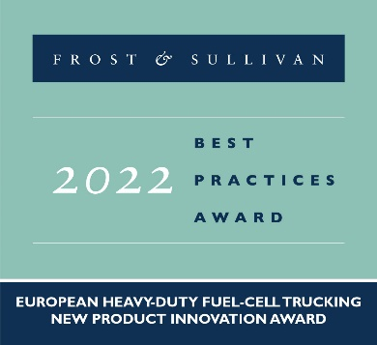 | QUANTRON is a prizewinner of the Frost & Sullivan Best Practices Award in the category "European Heavy-Duty Fuel-Cell Trucking New Product Innovation"
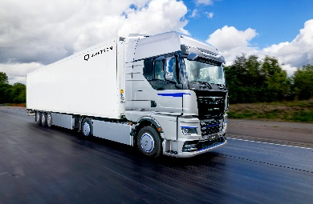 | The QUANTRON QHM FCEV heavy-duty fuel cell truck
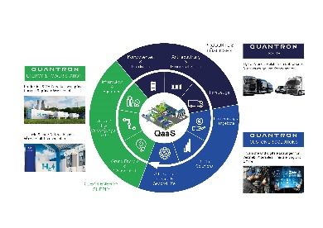 | The Quantron-as-a-Service (QaaS) ecosystem

The original images are available in both low and high resolutions here: Quantron AG press releases (https://www.quantron.net/q-news/pr-berichte/)

About Quantron AG
Quantron AG is a platform provider and specialist in sustainable mobility for people and goods; in particular, for trucks, buses and vans with all-electric drive trains and H₂fuel cell technology. As a high-tech spin-off of the renowned Haller KG, the Augsburg/Bavaria-based company combines more than 140 years of commercial vehicle experience with the very latest e-mobility know-how, and positions itself globally as a partner to existing OEMs.
With the Quantron-as-a-Service Ecosystem (QaaS), QUANTRON offers an overall concept that includes all facets of the mobility value-added chain: QUANTRON INSIDE includes a wide range of new vehicles as well as conversions for existing and used vehicles from diesel to battery and hydrogen-electric drives with the highly innovative QUANTRON INSIDE technology. In addition, Quantron AG markets and sells batteries and integrated, customised electrification concepts. With a Europe-wide network of 700 service partners, CUSTOMER SOLUTIONS guarantees digital and physical after-sales solutions along with a range of services for maintenance, repairs and spare parts, telematics and in-cloud solutions for remote diagnosis and fleet management. Customers receive individual advice on, among other things, tailored charging and tank solutions, rental, financing and leasing offers. Training courses and workshops are also offered in the QUANTRON Academy. In the future, QUANTRON ENERGY will realise the production of green hydrogen and electricity as a platform. To this end, Quantron AG has teamed up with a number of strong global partners. At the same time, this Hydrogen Alliance is also an important building block for the QUANTRON POWER STATION, the supply of vehicles with the necessary green charging and H2-tank infrastructure.
QUANTRON stands for the core values RELIABLE, ENERGETIC, BRAVE. The team of experts at the innovation driver for e-mobility is making a significant contribution to sustainable, environmentally friendly passenger and freight transport.
Visit Quantron AG on our social media channels on LinkedIn and YouTube. More informationen available at www.quantron.net

Contact persons:
Jörg Zwilling, Director Global Communication & Business Development, j.zwilling@quantron.net
Stephanie Miller, Marketing & Communications Quantron AG, presse@quantron.net

