PRESS RELEASE December 6th, 2022
All-electric city bus QUANTRON CIZARIS 12 EV wins German Sustainability Award Design 2023
- On December 1, 2022, the QUANTRON CIZARIS 12 EV was awarded the German Sustainability Award Design 2023 (“Deutscher Nachhaltigkeitspreis Design 2023”).
- The jury awarded the prize based on Quantron AG's holistic concept for environmentally friendly local transport
The zero-emission QUANTRON CIZARIS 12 EV city bus has been awarded the German Sustainability Award Design 2023 (“Deutscher Nachhaltigkeitspreis Design 2023”). The prize was awarded for the third time this year to a total of 17 winners. It honors products, systems and services that represent particularly sustainable alternatives with an exemplary effect.
The QUANTRON CIZARIS 12 EV was selected as the winner by the jury from more than 100 entries. The decision was made in favor of the all-electric city bus due to its functional interior and exterior design, which allows easy access even for people with limited mobility, as well as QUANTRON's comprehensive sustainability concept. Thus, the company not only supplies its customers with the zero-emission vehicle, but with the Quantron-as-a-Service Ecoystem also addresses all other necessary areas for sustainable inner-city public transport, such as a sufficient charging infrastructure.
Michael Perschke, CEO of Quantron AG, said, "We are delighted to be among the winners of the German Sustainability Award 2023 with the QUANTRON CIZARIS. With our zero-emission vehicles, we want to make climate-friendly mobility the new standard in urban transport."
Alexander Stucke, Head of Bus Sales at Quantron AG, said “The Award is an honor and recognition of our work to position the QUANTRON CIZARIS as one of the segment-leading BEV 12meter busses. It´s convincing regrading user friendliness, BEV range as well as usability for drivers. In 2023 we will start first deliveries in Europe and participate in tenders all over Europe.”
The all-electric QUANTRON CIZARIS 12 EV low-floor bus is customized to the individual requirements of the customer and the route driven every day. Depending on the battery size, it achieves a range of up to 450 km in daily use. The vehicle interior is also tailored to the customer's specific wishes. The interior offers space for up to 95 passengers. The seat upholstery can be customized using an innovative textile digital print. To ease guidance for visually impaired passengers, color accents can be used to highlight seats.
The award ceremony took place in Düsseldorf, Germany, as part of the 15th German Sustainability Day. The award of the Stiftung Deutscher Nachhaltigkeitspreis e.V. enjoys a stellar reputation in the industry and is awarded in cooperation with the German government, municipal organizations, business associations, civil society organizations and research institutions.

Images (Please click on the image preview to download):
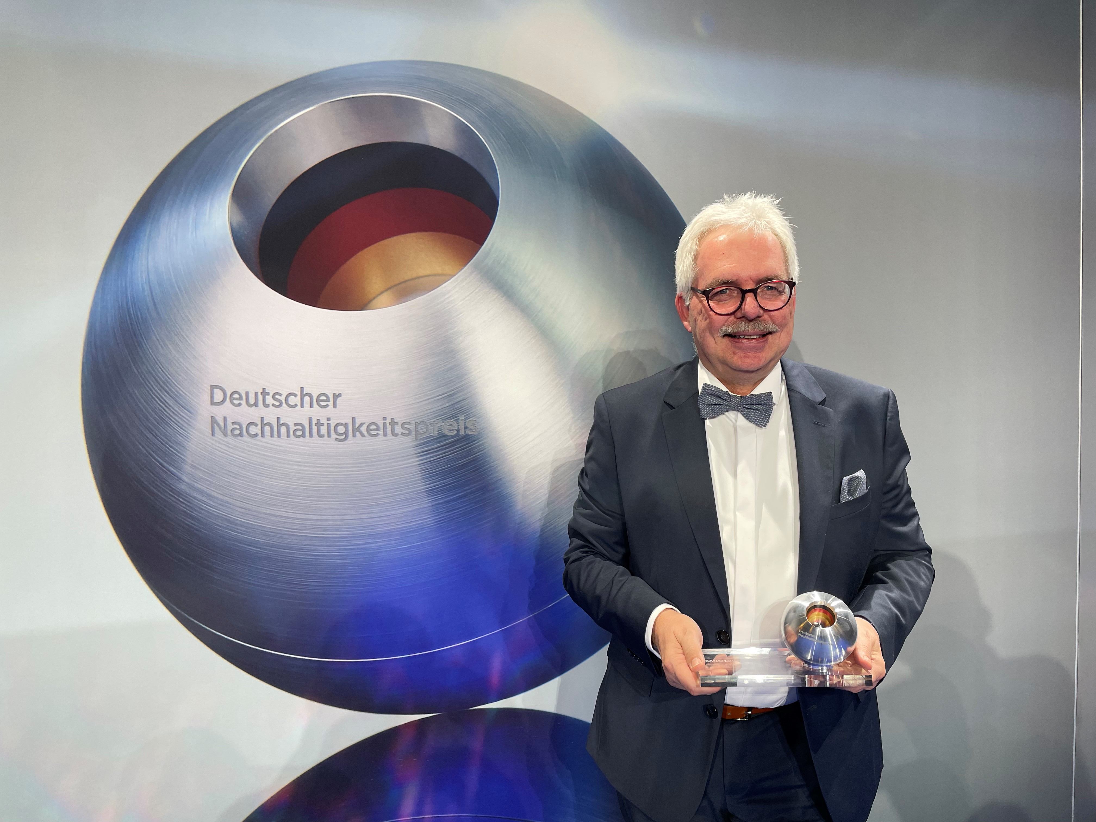 | Alexander Stucke, Head of Sales Bus Quantron AG, accepted the German Sustainability Award Design 2023
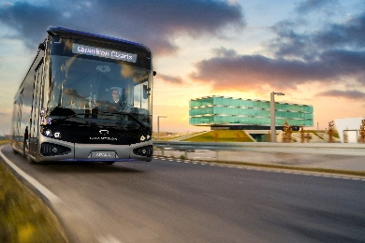 | QUANTRON CIZARIS 12 EV - Winner of the German Sustainability Award Design 2023

You can find the original images in low and high resolution here: Press releases from Quantron AG (https://www.quantron.net/en/q-news/press-releases/)

About Quantron AG
Quantron AG is a platform provider and specialist for sustainable mobility for people and goods; in particular for trucks, buses and vans with fully electric powertrains and H₂ fuel cell technology. As a high-tech spinoff of the renowned Haller KG, the German company from Augsburg in Bavaria combines over 140 years of commercial vehicle experience with state-of-the-art e-mobility know-how and positions itself globally as a partner to existing OEMs.
With the Quantron-as-a-Service Ecosystem (QaaS), QUANTRON offers an overall concept that covers all facets of the mobility value chain: QUANTRON INSIDE includes a wide range of both new vehicles and conversions for existing and used vehicles from diesel to battery and hydrogen electric powertrains using the highly innovative QUANTRON INSIDE technology. In addition, Quantron AG sells batteries and integrated customized electrification concepts. QUANTRON CUSTOMER CARE ensures digital and physical aftersales solutions with a Europe-wide network of 700 service partners, as well as a service offering for maintenance, repair and spare parts, telematics and in-cloud solutions for remote diagnostics and fleet management. Customers receive individual solutions: rental, financing and leasing offers such as training courses and workshops at the QUANTRON Academy. In the future, QUANTRON ENERGY will realize the production of green hydrogen and electricity as a platform. To this end, Quantron AG has joined forces with strong global partners. This Hydrogen Alliance also forms an important building block for QUANTRON POWER STATION, the supply of vehicles with the necessary green charging and H₂ refueling infrastructure.
QUANTRON stands for the core values Reliable, Energetic, Brave. The team of experts at the innovation driver for e-mobility is making a significant contribution to sustainable, environmentally friendly passenger and freight transport. You can find more information at www.quantron.net
Visit the Quantron AG on its social media channels on LinkedIn and YouTube.
Your contact:
Jörg Zwilling, Director Global Communication & Business Development, j.zwilling@quantron.net
Stephanie Miller, Marketing & Communications Quantron AG, press@quantron.net

