PRESS RELEASE December 9th, 2022
QUANTRON receives KUMAS Environmental Award for its holistic Quantron-as-a-Service eco-system
- Quantron-as-a-Service (QaaS) was awarded the title "KUMAS Lead Project 2022".
- The QaaS full-service offering delivers all relevant services for ensuring emission-free logistics to the customer from a single source

For the 24th time in a row, the association KUMAS - Kompetenzzentrum Umwelt e. V. awarded its prize for outstanding achievements in environmental expertise. At the award ceremony on December 8, Quantron-as-a-Service was awarded the title "KUMAS Lead Project 2022". Quantron AG's comprehensive ecosystem enables zero-emission mobility solutions with a broad range of products and services, thus contributing to the reduction of CO2 emissions in daily passenger and freight transport.

Quantron-as-a-Service offers a unique solution for the customer that covers all facets of the mobility value chain. The Q-Ecosystem developed by QUANTRON enables zero-emission solutions for freight and passenger transport with a wide range of products and services. These include the vehicles with QUANTRON INSIDE technology, QUANTRON CUSTOMER CARE with a Europe-wide network of 700 service partners for digital and physical aftersales solutions, and the QUANTRON ENERGY division for the future provision of green hydrogen and electricity to customers.

Andreas Haller, founder and Chairman of the Board of Quantron AG, accepted the award at the ceremony in Augsburg, Germany: "I am proud that with our innovative 360-degree eco-system Quantron-as-a-Service we are one of the KUMAS Lead Projects 2022. With our full-service concept, we not only want to offer our customers a central platform for operating their climate-neutral fleet, but also make a significant contribution to achieving global climate targets."

The association KUMAS - Kompetenzzentrum Umwelt e. V. was founded in 1998 as part of the High-Tech Offensive and has since made an important contribution to sustainable development in Bavaria. The environmental prize is awarded annually to innovative processes, products, services, developments or research results.
Images (Please click on the image preview to download):
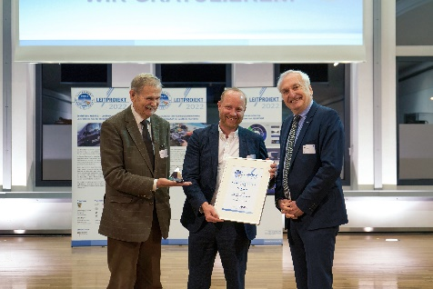 | Andreas Haller, founder and Chairman of the Board of Quantron AG, accepts the KUMAS Environmental Award  (Copyright: Quantron AG)
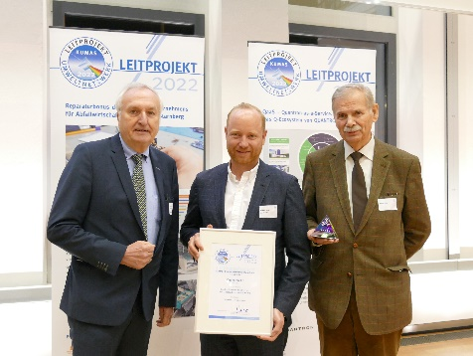 | Andreas Haller, founder and Chairman of the Board of Quantron AG, accepts the KUMAS Environmental Award  (Copyright: KUMAS e. V.)
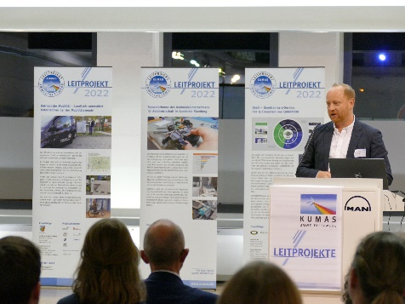 | Andreas Haller, founder and Chairman of the Board of Quantron AG, KUMAS award ceremony presentation  (Copyright: KUMAS e. V.)

You can find the original images in low and high resolution here: Press releases from Quantron AG (https://www.quantron.net/en/q-news/press-releases/)
About Quantron AG
Quantron AG is a platform provider and specialist for sustainable mobility for people and goods; in particular for trucks, buses and vans with fully electric powertrains and H₂ fuel cell technology. As a high-tech spinoff of the renowned Haller KG, the German company from Augsburg in Bavaria combines over 140 years of commercial vehicle experience with state-of-the-art e-mobility know-how and positions itself globally as a partner to existing OEMs.
With the Quantron-as-a-Service Ecosystem (QaaS), QUANTRON offers an overall concept that covers all facets of the mobility value chain: QUANTRON INSIDE includes a wide range of both new vehicles and conversions for existing and used vehicles from diesel to battery and hydrogen electric powertrains using the highly innovative QUANTRON INSIDE technology. In addition, Quantron AG sells batteries and integrated customized electrification concepts. QUANTRON CUSTOMER CARE ensures digital and physical aftersales solutions with a Europe-wide network of 700 service partners, as well as a service offering for maintenance, repair and spare parts, telematics and in-cloud solutions for remote diagnostics and fleet management. Customers receive individual solutions: rental, financing and leasing offers such as training courses and workshops at the QUANTRON Academy. In the future, QUANTRON ENERGY will realize the production of green hydrogen and electricity as a platform. To this end, Quantron AG has joined forces with strong global partners. This Hydrogen Alliance also forms an important building block for QUANTRON POWER STATION, the supply of vehicles with the necessary green charging and H₂ refueling infrastructure.
QUANTRON stands for the core values Reliable, Energetic, Brave. The team of experts at the innovation driver for e-mobility is making a significant contribution to sustainable, environmentally friendly passenger and freight transport. You can find more information at www.quantron.net
Visit the Quantron AG on its social media channels on LinkedIn and YouTube.
Your contact:
Jörg Zwilling, Director Global Communication & Business Development, j.zwilling@quantron.net
Stephanie Miller, Marketing & Communications Quantron AG, press@quantron.net

