PRESS RELEASE
January 30th, 2023
QUANTRON welcomes Reto Leutenegger as Managing Director of Quantron Switzerland AG and as an investor in Quantron AG
- Reto Leutenegger appointed Managing Director and member of the Board of Directors of Quantron Switzerland AG and welcomed as an investor in Quantron AG and international projects
- Switzerland offers ideal conditions for switching to alternative drives thanks to its strong economy and excellent transport infrastructure
- Quantron Switzerland AG is focusing on sustainable commercial vehicles with battery-electric drives and the introduction of commercial vehicles with fuel cell technology in 2023

QUANTRON, the Augsburg-based specialist for zero-emission transport solutions for passenger and freight transport, is expanding the management level of its subsidiary in Switzerland (Quantron Switzerland AG) with Reto Leutenegger named as Managing Director.
Alternative drive systems are a crucial factor for a more sustainable future in the logistics and transport branch. Quantron AG sees itself as responsible for further development of alternative drives and using them in its product range. This helps to reduce the environmental impact in the logistics and transport sector while simultaneously increasing the efficiency and competitiveness of its customers. The Swiss subsidiary focuses on the marketing of battery-electric commercial vehicles from 3.49 to 44 t total combination weight and vehicles with fuel cell technology. At the IAA in Hanover in September 2022, Quantron AG presented a hydrogen-powered 44 t truck that sets standards for heavy-duty zero-emission trucks and has resulted in numerous enquiries from Swiss companies.
In addition to his position as Managing Director, Reto Leutenegger will also serve as a member of the Board of Directors of Quantron Switzerland AG. Leutenegger brings extensive experience in the establishment and management of technology companies. He was previously Managing Director at E-FORCE ONE AG.
Michael Perschke, CEO of QUANTRON AG: “We are extremely pleased to welcome Reto Leutenegger, Managing Director of Quantron Switzerland AG. Reto complements our team and through his investment in Quantron AG, has also confirmed his confidence in QUANTRON's leading technology."
Andreas Haller, founder and Executive Chairman of Quantron AG: “Reto and I can look back on many years of trustful cooperation during his time at E-FORCE ONE AG. With his extensive experience as managing director of the e-mobility company, he will play an important role in marketing our zero-emission mobility solutions in Switzerland and actively developing the market for our QUANTRON hydrogen-powered solutions.”
Reto Leutenegger: “The development of alternative drives for the commercial vehicle sector was driven by a few small companies and not by the established vehicle manufacturers. However, some companies will disappear as a result of the market entry of OEMs while others will join forces and use their technological edge particularly when it comes to innovation. Quantron AG has exactly this far-reaching and future-oriented planning concept in order to always remain one step ahead of the existing players in this market and thus actively accelerate the sustainable transformation of the transport industry. It´s great to be driving forward the transformation of our future logistics and transport industry in Switzerland and globally with Quantron Switzerland AG. Quantron AG and E-FORCE ONE AG have already worked together in the past and this gives me the confidence that I can now actively help shape QUANTRON's successful course as a member of the management and as an investor".
Quantron Switzerland AG is part of QUANTRON's global growth plan. Switzerland offers ideal conditions for switching to alternative drives thanks to its strong economy and excellent transport infrastructure. The infrastructure for alternative drive systems is also growing faster in Switzerland than in other comparable countries. Quantron AG offers the largest range of products on the market, from light through to heavy commercial vehicles which are both fully electric and hydrogen-powered. With Quantron-as-a-Service (QaaS), customers receive additional services in the areas of financing, infrastructure, fleet management and service apart from the vehicles, which is essential for forward-looking and efficient planning.

Images (click on image preview to download):
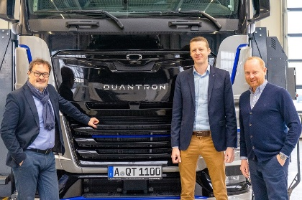 | From left to right: Michael Perschke (CEO Quantron AG), Reto Leutenegger (Managing Director Quantron Switzerland AG) and Andreas Haller (Founder and Executive Chairman Quantron AG)
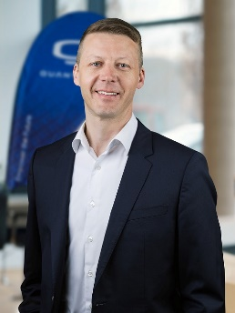 | Reto Leutenegger, Managing Director Quantron Switzerland AG

The original photos are available in both low and high resolutions here: Quantron AG press releases (https://www.quantron.net/en/q-news/press-releases/)
About Quantron AG
Quantron AG is a platform provider and specialist in sustainable mobility for people and goods; in particular, for trucks, buses and vans with all-electric drive trains and H₂fuel cell technology. As a high-tech spin-off of the renowned Haller KG, the Augsburg/Bavaria-based company combines more than 140 years of commercial vehicle experience with the very latest e-mobility know-how and positions itself globally as a partner to existing OEMs.
With the Quantron-as-a-Service Ecosystem (QaaS), QUANTRON offers an overall concept that includes all facets of the mobility value-added chain: QUANTRON INSIDE includes a wide range of new vehicles as well as conversions for existing and used vehicles from diesel to battery and hydrogen-electric drives with the highly innovative QUANTRON INSIDE technology. With a Europe-wide network of 700 service partners, QUANTRON CUSTOMER SOLUTIONS guarantees digital and physical after-sales solutions along with a range of services for maintenance, repairs and spare parts, telematics and in-cloud solutions for remote diagnosis and fleet management. Customers receive individual advice on, among other things, tailored charging and tank solutions, rental, financing and leasing offers. Training courses and workshops are also offered in the QUANTRON Academy. In the future, QUANTRON ENERGY will realise the production of green hydrogen and electricity as a platform. To this end, Quantron AG has teamed up with a number of strong global partners. At the same time, this Hydrogen Alliance is also an important building block for the QUANTRON POWER STATION, the supply of vehicles with the necessary green charging and H2-tank infrastructure.
QUANTRON stands for the core values RELIABLE, ENERGETIC, BRAVE . The team of experts at the innovation driver for e-mobility is making a significant contribution to sustainable, environmentally friendly passenger and freight transport.
Visit Quantron AG on our social media channels onLinkedIn and YouTube. More informationen available at www.quantron.net

Contact persons:
Jörg Zwilling, Director Global Communication & Business Development, j.zwilling@quantron.net
Stephanie Miller, Marketing & Communications Quantron AG, presse@quantron.net

