PRESS RELEASE January 25th, 2023
QUANTRON expands its Supervisory Board
- The Supervisory Board at Quantron AG has been complemented through the addition of four new members each of whom has extensive experience in their respective specialist fields. This corresponds to the generally strong growth of the pioneer and developer of sustainable transport solutions.
- Klaus Schmitt assumes the role of Chairman thereby taking over from Peter Haller. However, Peter Haller remains a member of the Supervisory Board.

Quantron AG, a specialist in sustainable mobility, has expanded its Supervisory Board from three to seven members and elected Klaus Schmitt as the new Chairman. He takes over the position from Peter Haller who remains active as a board member. The other new members are Denis Muratov, Marc Niefer and Marc-Peter Zander. The expansion of the Supervisory Board with a wide range of competencies ensures that Quantron AG will also be able to master challenges at an international level in the best possible way in the future.
Klaus Schmitt named as new Chairman of the Supervisory Board
Since 2021, Klaus Schmitt has mainly worked in an advisory capacity as well as supervisory board member at various companies. In addition to his position on the Supervisory Board of Quantron AG, he is also the Managing Director of the Andreas Haller Holding which holds the shares of company founder Andreas Haller in Quantron AG. Prior to this, he spent almost 15 years on the Board of Directors of a stock exchange-oriented company that is active throughout Europe.
Michael Perschke, CEO of QUANTRON AG: “We are pleased to welcome Klaus Schmitt as the new Chairman of the Supervisory Board and would like to thank Peter Haller for his mandate. Moreover, we are delighted that he will continue to support us with his advice and experience as a member of the newly expanded Supervisory Board.”
Peter Haller was the sole managing partner of Haller GmbH in the fourth generation for more than forty years until the handover to his son, Andreas Haller. With the founding of Quantron AG in 2019 as a spin-off of the Haller Group, Peter Haller assumed the position of Chairman of the Supervisory Board until December 2022.
Other members of the Supervisory Board at a glance
Gianluca Crestani has been a member of the Supervisory Board since 2019. Since 1996, he has been managing director and board member at various large logistics and transport companies.
Robert Schäble has likewise been on the supervisory board since the founding of Quantron AG. He works as an auditor and tax consultant at a corporate law firm.
Denis Muratov is one of the investors of Quantron AG as Managing Partner of the venture capital fund FUND4SE (Fund for Sustainability and Energy) in addition to his activities on the Supervisory Board. Over the past three decades, he has managed and successfully implemented a wide range of development projects in various industries. Over the past three decades, he has managed and successfully implemented a wide range of development projects in various industries.
Marc Niefer has global responsibility for Ballard's Trucks Division as General Manager of Trucks and Vice President Customer Care and supports the continued success of the company's customer care organisation. He has more than 25 years of international experience in the automotive industry where he previously held management positions in sales, marketing and customer service at Daimler AG.
Marc-Peter Zander is the founder and managing director of africon GmbH, a German strategy consultancy with a focus on Africa. He has more than 25 years of cross-cultural experience while doing business in Africa through international organisations such as the MAN Group and Wincor Nixdorf.
Michael Perschke thanked the existing members and welcomed the new additions: "The enlargement of the Supervisory Board is an important step in order to be able to successfully shape the future of Quantron AG as a globally fast expanding company. Each new member brings their own specialist knowledge and skills to the Supervisory Board which will provide a valuable enhancement of our previous board. We are very much looking forward to working together in the future.”

Images (click on image preview to download):
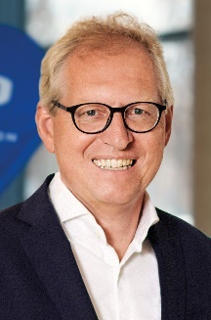 | Klaus Schmitt, Quantron AG Supervisory Board Chairman
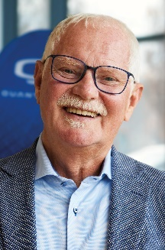 | Peter Haller, Quantron AG Supervisory Board Member
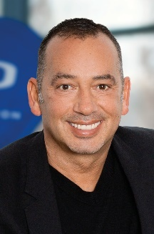 | Gianluca Crestani, Quantron AG Supervisory Board Member
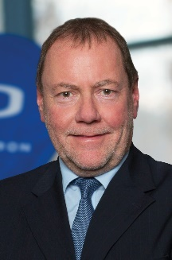 | Robert Schäble, Quantron AG Supervisory Board Member
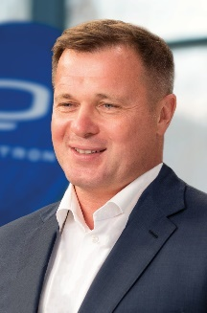 | Denis Muratov, Quantron AG Supervisory Board Member
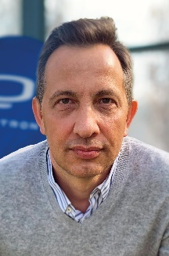 | Marc Niefer, Quantron AG Supervisory Board Member
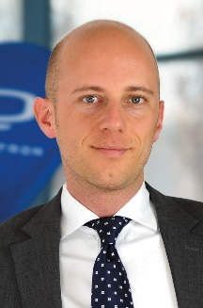 | Marc-Peter Zander, Quantron AG Supervisory Board Member
The original photos are available in both low and high resolutions here: Quantron AG press releases (https://www.quantron.net/q-news/pr-berichte/)
About Quantron AG
Quantron AG is a platform provider and specialist in sustainable mobility for people and goods; in particular, for trucks, buses and vans with all-electric drive trains and H₂fuel cell technology.. As a high-tech spin-off of the renowned Haller KG, the Augsburg/Bavaria-based company combines more than 140 years of commercial vehicle experience with the very latest e-mobility know-how, and positions itself globally as a partner to existing OEMs.
With the Quantron-as-a-Service Ecosystem (QaaS), QUANTRON offers an overall concept that includes all facets of the mobility value-added chain: QUANTRON INSIDE includes a wide range of new vehicles as well as conversions for existing and used vehicles from diesel to battery and hydrogen-electric drives with the highly innovative QUANTRON INSIDE technology. With a Europe-wide network of 700 service partners,QUANTRON CUSTOMER SOLUTIONS guarantees digital and physical after-sales solutions along with a range of services for maintenance, repairs and spare parts, telematics and in-cloud solutions for remote diagnosis and fleet management. Customers receive individual advice on, among other things, tailored charging and tank solutions, rental, financing and leasing offers. Training courses and workshops are also offered in the QUANTRON Academy. In the future, QUANTRON ENERGY will realise the production of green hydrogen and electricity as a platform. To this end, Quantron AG has teamed up with a number of strong global partners. At the same time, this Hydrogen Alliance is also an important building block for the QUANTRON POWER STATION, the supply of vehicles with the necessary green charging and H2-tank infrastructure.
QUANTRON stands for the core values RELIABLE, ENERGETIC, BRAVE . The team of experts at the innovation driver for e-mobility is making a significant contribution to sustainable, environmentally friendly passenger and freight transport.
Visit Quantron AG on our social media channels onLinkedIn and YouTube. More informationen available at www.quantron.net

Contact persons:
Jörg Zwilling, Director Global Communication & Business Development, j.zwilling@quantron.net
Stephanie Miller, Marketing & Communications Quantron AG, presse@quantron.net

