PRESS RELEASE Augsburg, February 1st, 2023
QUANTRON Tech Day highlights future technologies for emission-free transport and announcement of new board member
- QUANTRON presents future technology and its hydrogen ecosystem as part of the Tech Day programme
- In 2023, Quantron AG plans to further expand globally and introduce hydrogen-powered Class 8 heavy-duty trucks to the US market
- CTO René Wollmann named as designated board member
- White paper on battery-powered (BEV) and fuel cell-based (FCEV) drive solutions in the truck sector presented from a system perspective

As part of the first Tech Day, Quantron AG gave investors, politicians, press representatives and industry experts a comprehensive overview of developments in zero-emission drive systems. QUANTRON also announced the appointment of CTO René Wollmann to the Management Board of Quantron AG.

The event opened with the presentation of a white paper entitled “BEV or FCEV? The complementary roles of battery and fuel cell electric trucks”. To date, it is the most comprehensive analysis of the current status of battery-electric and fuel cell-based drive systems in the commercial vehicle sector. The white paper was presented by Dr. Srinath Rengarajan, Senior Manager Corporate & Portfolio Strategy at QUANTRON. He summarised his scientific analysis as follows: “Until now, there have been many dogmatic discussions based on narrowly defined or limited analyses. However, a holistic view shows that both BEV and FCEV technologies are required for the earliest possible realisation of emission-free transport solutions. Ultimately, the requirements of the end customers along with specific use cases decide on the most suitable solution.”
The whitepaper offers extensive analysis and data comparing the opportunities and challenges of both technologies and can be downloaded at https://www.quantron.net/en/q-news/download-area/.
CTO René Wollmann then gave an insight into the special features of the QUANTRON development DNA and its goals of combining the latest technologies with maximum customer benefit and maximum efficiency using the example of the heavy truck portfolio.
"For us, innovation means the adaptation and integration of trend-setting and efficient technologies in forward-looking and, above all, customer-focused solutions in the transport sector," says René Wollmann. “Through our own in-house 'think tank' and development competence, of which we are very proud, and the close cooperation with global technology partners, we are well positioned to be able to offer and deliver unique products to our customers. For example, our QUANTRON QHM as BEV and FCEV are scheduled to enter the market in the course of 2023 and can be considered a real game changer in the heavy truck class.”
As a globally expanding company, Quantron AG will be presenting zero-emission vehicles for the important US market for the first time this year, starting with a Class 8 heavy-duty truck complete with hydrogen drive for long-distance tours.

Michael Perschke, CEO QUANTRON AG: “In order to find a solution to decarbonise the transport sector, it is not enough to limit yourself to vehicle development. It has to be thought through in holistic terms. This is why we have set up Quantron-as-a-Service together with our partners such as Ballard Power Systems and NEUMAN & ESSER - a platform that combines all the building blocks required for sustainable mobility. In the medium term, this should also be open to other OEMs.”

With this approach, the recently received Frost & Sullivan Best Practices Award proves that QUANTRON is already one of the pioneers in the field of sustainable transport. This was awarded to honour QUANTRON's holistic hydrogen concept in the "European Heavy-Duty Fuel-Cell Trucking New Product Innovation" category. Previous winners of the Frost & Sullivan Best Practices Award include Bosch and Siemens Energy.

CTO René Wollmann appointed to the Management Board of Quantron AG
During the event, the company announced the appointment of René Wollmann as a member of the Management Board of Quantron AG. He will support Andreas Haller (Founder and Executive Chairman), Michael Perschke (CEO) and Herbert Robel (CHRO, Interim CFO and Co-Founder) on the Management Board. Wollmann has been working for QUANTRON as Chief Technology Officer (CTO) since November 2021. In this position, he has significantly advanced the development of the hydrogen-electric heavy truck, QUANTRON QHM FCEV.

Images (click on image preview to download):
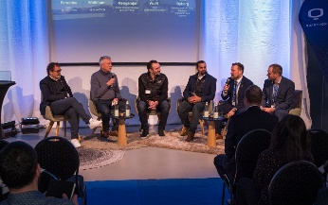 | Panel Talk at Tech Day (from left): Michael Perschke (CEO Quantron AG), Roger Atkins (Panel Talk moderator), René Wollmann (CTO Quantron AG), Dr. Srinath Rengarajan (Senior Strategy Manager Quantron AG), Jens Wulff (CEO NEUMAN & ESSER), Mike Byberg (EMEA Business Development and Sales Manager Ballard Power Systems)
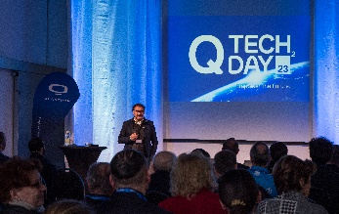 | Michael Perschke (CEO Quantron AG) at QUANTRON Tech Day 2023
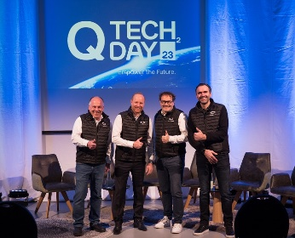 | Quantron AG Management Board (from left to right): Herbert Robel (CHRO, interim CFO and Co-Founder), Andreas Haller (Founder and Executive Chairman), Michael Perschke (CEO), and René Wollmann (CTO)
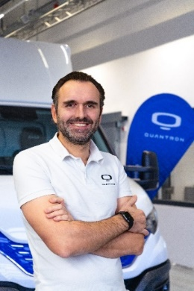 | Renè Wollmann, designated board member and CTO Quantron AG
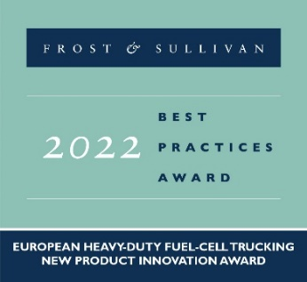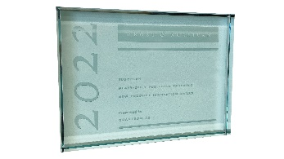 | QUANTRON is a prizewinner of the Frost & Sullivan Best Practices Award in the category "European Heavy-Duty Fuel-Cell Trucking New Product Innovation"  Further information on the selection criteria of the Forst & Sullivan Award and the evaluation of Quantron AG can be found here.
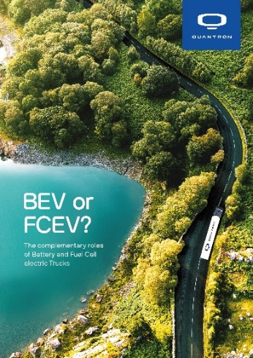 | “BEV or FCEV white paper? The complementary roles of battery and fuel cell electric trucks” – available for download here:  https://www.quantron.net/en/q-news/download-area/
The original photos are available in both low and high resolutions here: Quantron AG press releases (https://www.quantron.net/en/q-news/press-releases/)
About Quantron AG
Quantron AG is a platform provider and specialist in sustainable mobility for people and goods; in particular, for trucks, buses and vans with all-electric drive trains and H₂fuel cell technology.. As a high-tech spin-off of the renowned Haller KG, the Augsburg/Bavaria-based company combines more than 140 years of commercial vehicle experience with the very latest e-mobility know-how, and positions itself globally as a partner to existing OEMs.
With the Quantron-as-a-Service Ecosystem (QaaS), QUANTRON offers an overall concept that includes all facets of the mobility value-added chain: QUANTRON INSIDE features a wide range of new vehicles as well as conversions for existing and used vehicles from diesel to battery and hydrogen-electric drive systems with the highly innovative QUANTRON INSIDE technology. QUANTRON CUSTOMER SOLUTIONS guarantees digital and physical after-sales solutions through a Europe-wide network of 700 service partners as well as a service package for maintenance, repair and spare parts, telematics and in-cloud solutions for remote diagnostics and fleet management. Customers receive individual advice on, among other things, tailored charging and tank solutions, rental, financing and leasing offers. Training courses and workshops are also offered in the QUANTRON Academy. In the future, QUANTRON ENERGY will realise the production of green hydrogen and electricity as a platform. To this end, Quantron AG has teamed up with a number of strong global partners. At the same time, this Hydrogen Alliance is also an important building block for the QUANTRON POWER STATION, the supply of vehicles with the necessary green charging and H2-tank infrastructure.
QUANTRON stands for the core values RELIABLE, ENERGETIC, BRAVE. The team of experts at the innovation driver for e-mobility is making a significant contribution to sustainable, environmentally friendly passenger and freight transport.
Visit Quantron AG on our social media channels onLinkedIn and YouTube. More information is available at: www.quantron.net

Contact persons:
Jörg Zwilling, Director Global Communication & Business Development, j.zwilling@quantron.net
Stephanie Miller, Marketing & Communications Quantron AG, presse@quantron.net

