PRESS RELEASE March 27th, 2023
QUANTRON prepares market entry in the U.S. with new management team
- Six new executives are being added to the Quantron USA, Inc. team:
  - Matt Pearson as COO (Chief Operating Officer)
  - Damaris Meyer as CFO (Chief Finance Officer) for Quantron USA Inc. and Quantron-as-a-Service USA, Inc.
  - Richard Ansell as Vice President Marketing/PR
  - Henrique Martins as Vice President of Homologation & Compliance
  - Karl Plattenberger as Chief Engineer – Powertrain Integration
  - Denise Vallis as Head of Program Management
- The new management team will help CEO Richard Haas build the company and develop and launch hydrogen-powered Class 8 trucks
- QUANTRON plans to introduce its version of a hydrogen-powered Class 8 truck at the Advanced Clean Transportation (ACT) Expo in Anaheim, CA, in May 2023.
In September 2022, Quantron AG, specialist in sustainable transport solutions for people and goods, expanded into North America by founding Quantron USA, Inc. Shortly thereafter, a first framework agreement was signed with TMP Logistics Group Ltd. for an order of up to 500 FCEV Class 8 trucks with FCEV drive system to be delivered by 2024. To meet this challenge and further build the company in the U.S., CEO Richard Haas has now brought more top-qualified executives onto the team.
Matt Pearson takes over the position of COO (Chief Operating Officer). His responsibilities include Business & Market Development of QUANTRON products as well as organizing the development of the Demo FCEV Class 8 Truck. He has extensive experience from previous leadership positions at Ford Motor Co., Mahindra Automotive and Honda Motor Co.
Damaris Meyer is the new CFO (Chief Finance Officer) of Quantron USA, Inc. and the Quantron-as-a-Service organization. She has more than ten years of experience in senior management positions at Siemens and Siemens Healthineers, including many years spent in Asia. Most recently, Damaris Meyer was managing director of evosoft GmbH. Her expertise lies in software and in the development of new business models and strategies for both start-ups and existing companies.
Richard Ansell serves as Vice President Marketing/PR. He has over 30 years experience in automotive and B2B marketing and branding with companies such as Mahindra Automotive North America and Visteon Corporation. His responsibilities include marketing, public relations and government relations.
Henrique Martins becomes Quantron USA, Inc.'s new Vice President of Homologation & Compliance, bringing over 25 years of automotive experience with him. He has held numerous positions at traditional automakers such as Ford, General Motors, as well as at start-ups. Henrique has extensive international experience and is well-positioned to lead QUANTRON's homologation and compliance efforts.
Karl Plattenberger start as as Chief Engineer – Powertrain Integration. He has 30 years of experience in the automotive transportation industry, specializing in driveline systems and all-wheel drive technology, as well as transmission development. He has worked on global engineering and platform projects, coordinating efforts from Asia, South America and Europe. He also led powertrain integration for Ford and Mahindra, introducing agile development processes for software development in engine and hybrid vehicle control systems.
Denise Vallis joins as Head of Program Management. She has over 30 years’ experience as a Program Manager, Project Manager, and Design Engineer. Denise Vallis has worked at multiple suppliers and OEM’s in Detroit, Germany, and California on concept, prototype, and production vehicles. She also worked at Siemens PLM software for nine years, where she eventually served as the Automotive Technical Manager for the US mid-market.
Andreas Haller, Founder and Executive Chairman of Quantron AG: "It's great to see how quickly Quantron USA, Inc. has grown in recent months. There is a high demand for zero-emission trucks for transportation in the heavy truck class in the USA. Together with this talented and motivated team, we will work to bring the first hydrogen-electric QUANTRON Class 8 truck to the U.S. market later this year."
Michael Perschke, CEO of Quantron AG: "We are looking forward to presenting our new US Class 8 truck with hydrogen fuel cell drive for the first time at the ACT Expo in May. ACT Expo is one of the most important trade shows for alternative drives and transportation technologies in the US. It is a significant step for us to now be able to present our developments to industry representatives outside Europe."
With Quantron-as-a-Service USA, Inc, QUANTRON aims to implement its business model of a 360-degree ecosystem for zero-emission commercial vehicles in the United States. The initial focus will be on heavy-duty trucks powered by hydrogen fuel cells and the supply of the necessary hydrogen infrastructure.
Images (Please click on the image preview to download):
You can find the original images in low and high resolution here: Press releases from Quantron AG (https://www.quantron.net/en/q-news/press-releases/)
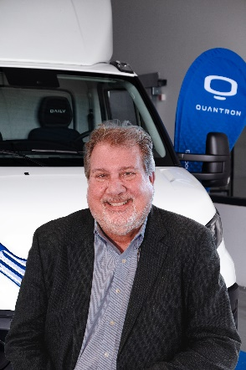 | Richard Haas, CEO Quantron USA, Inc.
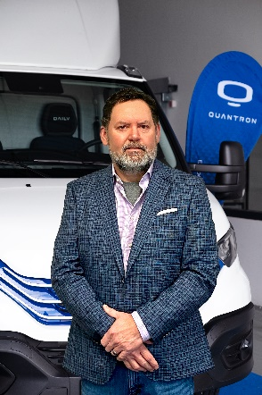 | Matt Pearson, COO Quantron USA, Inc.
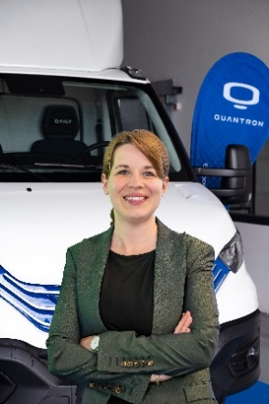 | Damaris Meyer, CFO Quantron USA, Inc.
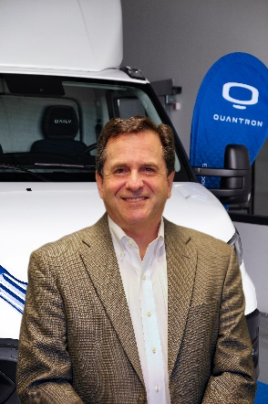 | Richard Ansell, Vice President Marketing/PR
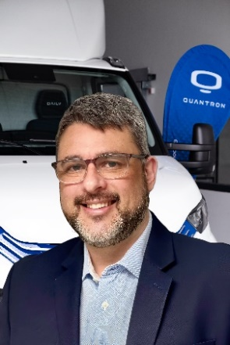 | Henrique Martins, Vice President of Homologation & Compliance Quantron USA, Inc.
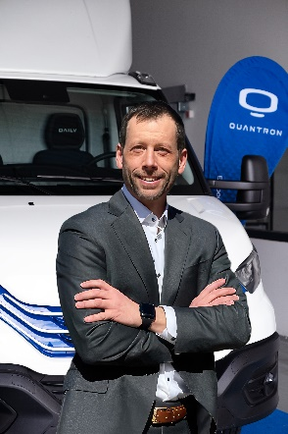 | Karl Plattenberger, Chief Engineer – Powertrain Integration Quantron USA, Inc.
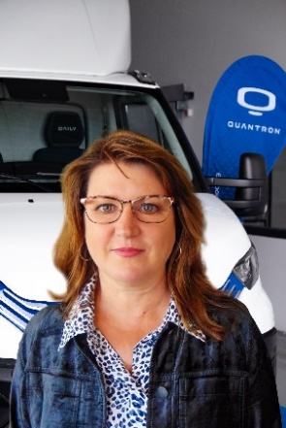 | Denise Vallis, Head of Program Management Quantron USA, Inc.
About Quantron AG
Quantron AG is a platform provider and specialist for sustainable mobility for people and goods; in particular for trucks, buses and vans with fully electric powertrains and H₂ fuel cell technology. As a high-tech spinoff of the renowned Haller KG, the German company from Augsburg in Bavaria combines over 140 years of commercial vehicle experience with state-of-the-art e-mobility know-how and positions itself globally as a partner to existing OEMs.
With the Quantron-as-a-Service Ecosystem (QaaS), QUANTRON offers an overall concept that covers all facets of the mobility value chain: QUANTRON INSIDE includes a wide range of both new vehicles and conversions for existing and used vehicles from diesel to battery and hydrogen electric powertrains using the highly innovative QUANTRON INSIDE technology. QUANTRON CUSTOMER SOLUTIONS ensures digital and physical aftersales solutions with a Europe-wide network of 700 service partners, as well as a service offering for maintenance, repair and spare parts, telematics and in-cloud solutions for remote diagnostics and fleet management. Customers receive individual solutions: rental, financing and leasing offers such as training courses and workshops at the QUANTRON Academy. In the future, QUANTRON ENERGY & POWER STATION will realize the production of green hydrogen and electricity as a platform. To this end, Quantron AG has joined forces with strong global partners. This Clean Transportation Alliance also forms an important building block for the supply of vehicles with the necessary green charging and H₂ refueling infrastructure.
QUANTRON stands for the core values Reliable, Energetic, Brave. The team of experts at the innovation driver for e-mobility is making a significant contribution to sustainable, environmentally friendly passenger and freight transport. You can find more information at www.quantron.net
Visit the Quantron AG on its social media channels on LinkedIn and YouTube.
Your contact Quantron AG:
Jörg Zwilling, Director Global Communication & Business Development, j.zwilling@quantron.net
Stephanie Miller, Marketing & Communications, press@quantron.net
Your contact Quantron USA, Inc.:
Richard Ansell, Vice President Marketing/PR Quantron USA, Inc., r.ansell@quantron.net

