PRESS RELEASE March 9th, 2023
VDA President Hildegard Müller visits QUANTRON and urges Berlin and Brussels to pursue an active location policy
- Hildegard Müller, President of the German Association of the Automotive Industry (VDA), visited Quantron AG, solution provider for sustainable passenger and freight transport, on 9th March
- Intensive exchange of views with Founder and Executive Chairman Andreas Haller, CEO Michael Perschke, Jorgo Chatzimarkakis, CEO of Hydrogen Europe, and Alexander Peters, Managing Partner of NEUMAN & ESSER, regarding the future of the transport industry and QUANTRON's pioneering role
- Ms. Müller gained deeper insights into the company and its approaches to building trendsetting 360-degree solutions
- Exemplary: Quantron-as-a-Service realises a 360-degree ecosystem solution that encompasses all sub-sectors of zero-emission mobility integrating hydrogen infrastructure from source to tank
- Holistic approach and Clean Transportation Alliance enables QUANTRON to move faster than traditional OEMs

On 9th March, Hildegard Müller, President of the German Association of the Automotive Industry (VDA), visited QUANTRON AG which is increasingly establishing itself as a forward thinker and enabler for sustainable passenger and freight transport. During her visit, she gained a deep insight into the Augsburg-based technology company and discussed the development of the German mobility industry together with the Executive Board. Jorgo Chatzimarkakis, CEO of Hydrogen Europe, and Alexander Peters, Managing Partner of NEUMAN & ESSER, also participated in the meeting via a video link.

VDA President Müller drew attention to the lack of infrastructure for battery and fuel cell-electric commercial vehicles in Europe and called for faster and far more decisive action on the part of policymakers: “In order for ambitious goals to actually be achieved, a sufficiently dense network of electric charging and hydrogen refueling stations for heavy commercial vehicles throughout Europe is a necessary prerequisite - in addition to a sufficient supply of vehicles to which we are committed. Currently, this is not even close to being in place. Without a sufficient publicly accessible charging and refueling network for heavy-duty vehicle classes in long-distance transport, it will be difficult to implement the targeted CO2 reduction goals for heavy-duty commercial vehicles”, said Müller.

With its Quantron-as-a-Service platform-based solution, Quantron AG not only provides zero-emission commercial vehicles but also integrates customer access to sustainable energy in the form of green hydrogen along with a suitable infrastructure. For this purpose, QUANTRON initiated the Clean Transportation Alliance together with NEUMAN & ESSER and other global partners which drives the expansion of hydrogen production and H2 refuelling stations, and is thus able to develop supply and demand for green hydrogen in parallel thereby lowering the entry barriers for customers to CO2-free transportation and logistics.

The meeting provided an opportunity to discuss the future of the transport industry as well as developing sustainable approaches to finding solutions. In this context, simpler and faster planning and approval procedures along with a secure supply of energy and raw materials are essential. Above all, VDA President Müller is calling for more speed and decisiveness from politicians. Otherwise, Germany and Europe as a whole would increasingly lose out internationally as business locations.

Müller emphasised: “Berlin and Brussels must realise competitiveness through an ambitious location policy: less bureaucracy, simpler and faster planning and approval procedures, a secure supply of energy and raw materials are just as necessary as a technology-open, market-based policy that unfettered companies and their innovations instead of slowing them down with regulations.”

In this context, Müller called for more speed and decisiveness from policymakers: "We must remain attractive as a location for investment, innovation and production. A technology-welcoming innovation policy under the guiding principle of climate protection is a basic condition for a joint success story."

Müller also pointed to the future-oriented field of the hydrogen economy: “Hydrogen is a key technology for achieving our climate targets, not only in Germany but also at a global level. Policymakers must now ensure the framework conditions are in place that will enable us to be a world leader in this field.”

Jorgo Chatzimarkakis: “The need for faster rollout of a clean technology infrastructure, such as hydrogen in mobility, is paramount if we are to achieve our climate goals in Europe. Early movers such as QUANTRON play an invaluable role in paving the way for a European-wide effort in zero emission mobility.”
Alexander Peters: “We can only be successful in achieving the goals of the energy transition, specifically in the transportation sector, if comprehensive decarbonisation solutions are implemented at an ambitious pace – through battery-electric as well as fuel cell and e-fuel-based mobility. We at NEUMAN & ESSER are open to all technologies. As a provider of hydrogen infrastructure solutions from hydrogen production to the hydrogen refuelling station, we have joined forces with QUANTRON as an FCEV OEM and provider of mobility solutions thereby giving access to a fully integrated system and lowering entry barriers to ensure a rapid ramp-up of hydrogen mobility.”
Andreas Haller, Founder and Executive Chairman of Quantron AG: “We were very delighted to welcome Ms. Müller and to discuss the future of the industry with her, Alexander Peters and Jorgo Chatzimarkakis. We share the view that the German automotive industry cannot wait for political measures to achieve the EU's CO2 limits for the transport sector. Instead, we need to work today on a viable picture of the future that includes all the necessary sectors. Since our inception, we have therefore focused on a holistic approach and developed our Quantron-as-a-Service ecosystem (QaaS) to enable the rapid ramp-up of zero-emission mobility in the transportation sector.”

Michael Perschke, CEO of Quantron AG, said, “Our goal is to create trend-setting and viable solutions by adapting and integrating more effective, future-oriented technologies. Many of the traditional OEMs are focusing on the development of zero-emission vehicles but this only addresses part of the challenge. The National Hydrogen Council estimates that at least 38,000 H2 trucks will have to be registered in Germany by 2030 in order to meet CO2 targets for road transport. Around 0.5 million tons of hydrogen will be needed to operate them. With our QaaS ecosystem, we want to address the future of mobility holistically, and are working in parallel to establish a nationwide H2 refueling and charging infrastructure to solve the chicken-and-egg problem. To accomplish this, QUANTRON is taking the path of partnerships and platform thinking.”

The exchange between Hildegard Müller, Jorgo Chatzimarkakis, Alexander Peters and the Executive Board of Quantron AG led to the realization that young, innovative companies like QUANTRON can also provide important impulses for shaping the future. During a test drive with the heavy-duty truck QUANTRON QHM FCEV, Hildegard Müller was able to personally experience that hydrogen-powered vehicles for emission-free transport are a reality already today.

Images (Please click on the image preview to download):
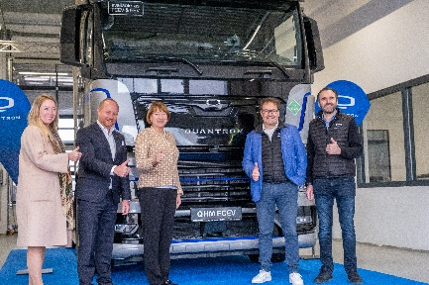 | From left: Miriam Gruß, Andreas Haller, Hildegard Müller, Michael Perschke, René Wollmann
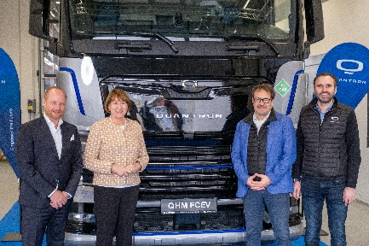 | From left: Andreas Haller, Hildegard Müller, Michael Perschke und René Wollmann
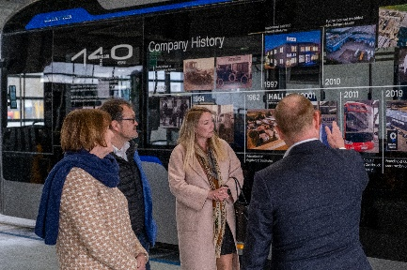 | Workshop tour at Quantron AG with Hildegard Müller
 | Hildegard Müller during a test drive with the QUANTRON QHM FCEV hydrogen truck (Image 1)
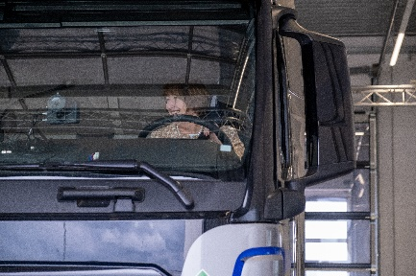 | Hildegard Müller during a test drive with the QUANTRON QHM FCEV hydrogen truck (Image 2)
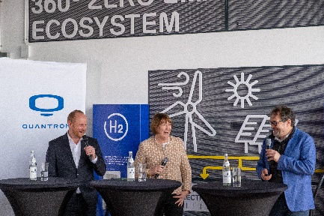 | Panel discussion at Quantron AG, from left: Andreas Haller, Hildegard Müller, Michael Perschke (Image 1)
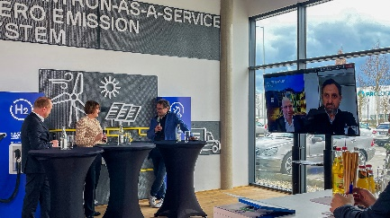 | Panel discussion at Quantron AG, from left: Andreas Haller, Hildegard Müller, Michael Perschke; online participants: Alexander Peters and Jorgo Chatzimarkakis (Image 2)

You can find the original images in low and high resolution here: Press releases from Quantron AG (https://www.quantron.net/en/q-news/press-releases/)
About Quantron AG
Quantron AG is a platform provider and specialist for sustainable mobility for people and goods; in particular for trucks, buses and vans with fully electric powertrains and H₂ fuel cell technology. As a high-tech spinoff of the renowned Haller KG, the German company from Augsburg in Bavaria combines over 140 years of commercial vehicle experience with state-of-the-art e-mobility know-how and positions itself globally as a partner to existing OEMs.
With the Quantron-as-a-Service Ecosystem (QaaS), QUANTRON offers an overall concept that covers all facets of the mobility value chain: QUANTRON INSIDE includes a wide range of both new vehicles and conversions for existing and used vehicles from diesel to battery and hydrogen electric powertrains using the highly innovative QUANTRON INSIDE technology. QUANTRON CUSTOMER SOLUTIONS ensures digital and physical aftersales solutions with a Europe-wide network of 700 service partners, as well as a service offering for maintenance, repair and spare parts, telematics and in-cloud solutions for remote diagnostics and fleet management. Customers receive individual solutions: rental, financing and leasing offers such as training courses and workshops at the QUANTRON Academy. In the future, QUANTRON ENERGY & POWER STATION will realize the production of green hydrogen and electricity as a platform. To this end, Quantron AG has joined forces with strong global partners. This Clean Transportation Alliance also forms an important building block for the supply of vehicles with the necessary green charging and H₂ refueling infrastructure.
QUANTRON stands for the core values Reliable, Energetic, Brave. The team of experts at the innovation driver for e-mobility is making a significant contribution to sustainable, environmentally friendly passenger and freight transport. You can find more information at www.quantron.net
Visit the Quantron AG on its social media channels on LinkedIn and YouTube.

About NEUMAN & ESSER
At NEUMAN & ESSER, long experience in gas compression and mechanical process engineering provides the basis for technologies required for a decarbonized society. We are enabling the energy transition and the circular economy as an OEM for: Piston and diaphragm compressors, Electrolyzers and reformer technologies, Grinding and classifying solutions. Family-owned for almost 200 years, today 1,400 employees are committed to bringing challenging projects to life around the world – from project feasibility evaluation, through engineering, construction, and commissioning to digitally supported 360° service during operation.
Your contact:
Jörg Zwilling, Director Global Communication & Business Development, j.zwilling@quantron.net
Stephanie Miller, Marketing & Communications Quantron AG, press@quantron.net

