PRESS RELEASE
2nd March 2023
QUANTRON hands over newly developed electric vehicle for Rhenus Home Delivery's innovative micro-depot concept
- Together with B. Göbel & Sohn GmbH, Quantron AG has developed a unique vehicle for Rhenus Home Delivery's innovative micro-depot concept
- Vehicle handover at the headquarters of QUANTRON AG in Augsburg
- The new QUANTRON QLI BEV 7-115 (7.2 t) is the ideal vehicle for inner-city distribution transport and has a special body design for facilitating fast loading and unloading
Technology company Quantron AG, which specialises in sustainable passenger and freight transport, together with the B. Göbel & Sohn GmbH, has handed over an innovative e-transporter with a lifting superstructure to the last-mile specialist Rhenus Home Delivery. The QUANTRON QLI BEV 7.2 t was specially developed for uncomplicated and emission-free deliveries from inner-city micro-depots directly to the end customer. QUANTRON will deliver a total of seven all-electric transporters with these special bodies to Rhenus Home Delivery.

Rhenus Home Delivery is the European market leader in 2-man handling of heavy bulk goods over the last mile. For end customer delivery, the company had been looking for partners who could supply them with transporters tailored to their micro-depot concept. In addition to the prerequisite of an emission-free drive, the requirement was also placed on the vehicles that they facilitated the quickest and most uncomplicated loading and unloading possible in order to optimise the delivery processes. The micro-depots serve as inner-city interim storage facilities for Rhenus Home Delivery. Starting from the local delivery depot, the swap bodies are bundled together and taken to the micro-depot overnight in order to reduce the number of individual journeys and relieve the morning rush hour.

Together with B. Göbel & Sohn GmbH, QUANTRON has developed such a unique vehicle. QUANTRON was responsible for the electrification of the vehicle in the project. The QUANTRON QLI BEV with a total weight of 7.2 tonnes and based on the Iveco Daily, adds a new weight class to the existing QUANTRON QLI range. With its low-noise and emission-free drive, it is ideal for inner-city deliveries over the last mile. B. Göbel & Sohn GmbH has taken on the integration of the electro-hydraulic scissor lifting table. This is able to quickly load and unload the special swap bodies for the micro depot and transport them safely.

Jonas von Frieling, Head of the Innovation Hub at Rhenus Home Delivery and Rhenus High Tech: "We at Rhenus Home Delivery decided on QUANTRON because with the start of the 'Micro-Depot Project', it became clear relatively quickly that we wanted to realise a vehicle that was not already available on the market. And, for this cooperation, we were looking for partners who wanted to go this way together with us.”
René Wollmann, CTO and appointed executive board member of Quantron AG: "We are extremely pleased that Rhenus Home Delivery selected us, together with Göbel, as the implementation partner for their idea. The first vehicle is already in the testing phase and we look forward to taking the next steps with Rhenus Home Delivery and Göbel in order to improve and further develop this concept in the sense of a co-creation.”
Images (click on image preview to download):
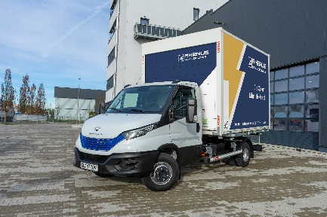 | The new QUANTRON QLI BEV 7-115 (7.2 t) with swap body
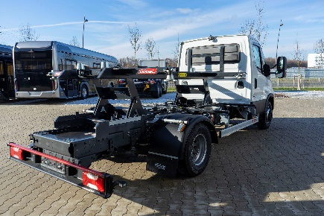 | The new QUANTRON QLI BEV 7-115 (7.2 t) with a special body design from Göbel & Sohn GmbH (Image 1)
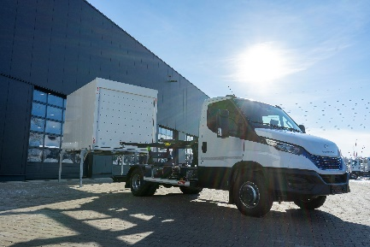 | The new QUANTRON QLI BEV 7-115 (7.2 t) with a special body design from Göbel & Sohn GmbH (Image 2)
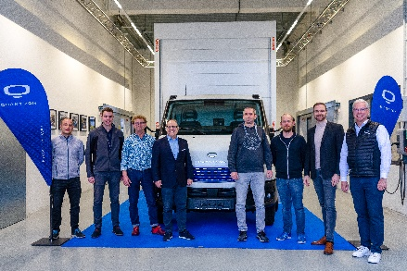 | Vehicle handover to Rhenus Home Delivery at the headquarters of QUANTRON AG in Augsburg

The original photo is available in both low and high resolutions here: Quantron AG press releases (https://www.quantron.net/q-news/pr-berichte/)
About Quantron AG
Quantron AG is a platform provider and specialist in sustainable mobility for people and goods; in particular, for trucks, buses and vans with all-electric drive trains and H₂fuel cell technology.. As a high-tech spin-off of the renowned Haller KG, the Augsburg/Bavaria-based company combines more than 140 years of commercial vehicle experience with the very latest e-mobility know-how, and positions itself globally as a partner to existing OEMs.
With the Quantron-as-a-Service Ecosystem (QaaS), QUANTRON offers an overall concept that includes all facets of the mobility value-added chain: QUANTRON INSIDE includes a wide range of new vehicles as well as conversions for existing and used vehicles from diesel to battery and hydrogen-electric drives with the highly innovative QUANTRON INSIDE technology. With a Europe-wide network of 700 service partners,QUANTRON CUSTOMER SOLUTIONS guarantees digital and physical after-sales solutions along with a range of services for maintenance, repairs and spare parts, telematics and in-cloud solutions for remote diagnosis and fleet management. Customers receive individual advice on, among other things, tailored charging and tank solutions, rental, financing and leasing offers. Training courses and workshops are also offered in the QUANTRON Academy. In the future, QUANTRON ENERGY will realise the production of green hydrogen and electricity as a platform. To this end, Quantron AG has teamed up with a number of strong global partners. At the same time, this Clean Transportation Alliance is also an important building block for the QUANTRON POWER STATION, the supply of vehicles with the necessary green charging and H2-tank infrastructure.
QUANTRON stands for the core values RELIABLE, ENERGETIC, BRAVE . The team of experts at the innovation driver for e-mobility is making a significant contribution to sustainable, environmentally friendly passenger and freight transport.
Visit Quantron AG on our social media channels onLinkedIn and YouTube. More informationen available at www.quantron.net

About the Rhenus Group
The Rhenus Group is one of the leading global logistics service providers with annual turnover of 7.0 billion euros. 37,500 employees work at 970 locations and develop innovative solutions along the entire supply chain. Whether it is transport, storage, customs clearance or value-added services: the family-owned company bundles its services in a wide range of business areas whereby the focus is always on the needs of the customers. Further information on sustainable logistics from Rhenus Home Delivery is available here.

Contact persons:
Jörg Zwilling, Director Global Communication & Business Development, j.zwilling@quantron.net
Stephanie Miller, Marketing & Communications Quantron AG, presse@quantron.net

