PRESS RELEASE 24th April 2023
Q-Days 2023: world premiere of the QUANTRON QHM FCEV AERO hydrogen-electric heavy-duty truck
- A highlight of this year's Q-Days is the QUANTRON QHM FCEV AERO hydrogen-electric heavy-duty truck with a specially developed exterior design of the driver's cab and optimized aerodynamic components for realising an even greater efficiency and range in long-distance transport
- The heavy hydrogen truck has a real range of up to 700km without limiting the payload and using a standard trailer. As a Scandinavia variant, even ranges of up to 1500 km are possible on the platform
- QUANTRON presents its plans to set up a nationwide hydrogen refuelling and charging infrastructure as part of the Clean Transportation Alliance partner network initiated by QUANTRON
- Joint venture with Goldstone Technologies Limited to develop a digital transaction platform for Quantron-as-a-Service (QaaS).
- Preview of the QUANTRON US Class 8 fuel cell truck at the ACT Expo in California on 2nd May 2023

For the second time, Quantron AG, a clean tech enterprise and specialist in sustainable passenger and goods transport, is organising the Q-Days from 21st to 28th April 2023 under the motto “#Readytodeliver”. At the in-house event, the company is presenting its market leading portfolio of emission-free transport solutions. In addition to zero-emission vehicles, this includes a range of digital and physical services, clean energy and corresponding infrastructure, bundled in the unique Quantron-as-a-Service (QaaS) offering.
Over 360 invited customers, investors, partners, specialist and technology media journalists from all over Europe, USA, Kingdom of Saudi Arabia and China are expected to attend the event.
Dr. Florian Herrmann, Head of the Bavarian State Chancellery and State Minister for Federal Affairs and Media, already attended the Q-Days on 21.4.2023 and had the opportunity to test the new truck in advance. He was enthusiastic and said: "QUANTRON is a Bavarian star that brings sustainable and innovative mobility to the road, electrically or with hydrogen. We are proud of this exemplary pioneering spirit that delivers solutions for ecological and economic transformation. Fuel cell technology is an important building block on the way to a CO₂ neutral future for Bavaria." Bavaria is investing over €700 million in hydrogen technologies, which will play a central role on the road to climate neutrality in 2040, especially in the transportation sector."
On this occasion, QUANTRON announced that an US investment bank will guide QUATRON’s B-financing round where 100-200 million euros is targeted to be raised.
World premiere of the hydrogen-electric driven QUANTRON QHM FCEV AERO
The premiere of the QUANTRON QHM FCEV AERO hydrogen-electric vehicle at the Q-Days 2023 is big news. Maximum efficiency and a range improvement of 10% are ensured by the specially developed Q-ENERGY management system and around 20% aerodynamic optimization was achieved by close cooperation between the QUANTRON design and R&D team under the motto "form follows function" for facilitating maximum performance. The 2 x 120 KW fuel cell system is provided by Ballard Power - an investor in QUANTRON.
The truck is designed for heavy long-distance transportation and is equipped with a tank capacity of around 54 kg of hydrogen and thus achieves a range of around 700 km. The special feature is that the hydrogen tank is completely integrated into the frame structure within the wheelbase of 3900mm - in compliance with all legal requirements and without any compromises being made concerning dimensions and usability. Standard trailers can be used without restrictions. QUANTRON is the only supplier who currently offers a truck tractor with fuel cell technology without any restriction (the so-called "backpack") on usability. The QHM FCEV is also offered in a range-extended version for use in Norway with a range of up to1,500 km, with a tank capacity of up to 116 kg.
Looking ahead at another world premiere: QUANTRON's first US Class 8 truck for the American market
Q-Days visitors will also get a glimpse of the ACT Expo trade show in Anaheim, California, where the first hydrogen-powered QUANTRON US Class 8 truck will be presented as a prototype on 2nd May 2023 – with a best-in-class tank capacity of up to 100 kg.
Strategic partnerships: Clean Transportation Alliance
In addition, QUANTRON will be providing insights into its plans for the upcoming years at the Q-Days 2023. One focus is on the consistent and systematic expansion of the Clean Transportation Alliance partner network. This unique network of partners will facilitate the Quantron-as-a-Service (QaaS) range of services. QaaS is a 360° service that encompasses all facets of the mobility value chain. Apart from emission-free vehicles and the technology itself (QUANTRON INSIDE), this includes digital and physical solutions such as insurance, fleet management, after-sales and roadside assistance (QUANTRON CUSTOMER SOLUTIONS) as well as the corresponding energy infrastructure (QUANTRON ENERGY & POWER STATIONS).
Norwegian Hydrogen AS and Westgass Hydrogen AS, two producers and suppliers of green hydrogen and hydrogen filling stations in Scandinavia, have recently joined the Clean Transportation Alliance.
Michael Perschke, CEO of Quantron AG says: “We are very pleased that our Clean Transportation Alliance is continuing to grow and with it the Quantron-as-a-Service offering. The discussions confirm our technology leadership in trucks with fuel cell technology in terms of performance, payload and range and, above all, the everyday suitability for operation with standard trailers. In addition, we now also offer the secure supply of green hydrogen with various partners. This allows logistics and transport companies to make the technology transition to a CO₂-free long-distance solution without restricting their vehicle & route planning.”
Presentation of the first development stage of the digital platform which will form the backbone of Quantron-as-a-Service in the future
In order to expand the digital offering of QaaS, QUANTRON has signed an agreement with Goldstone Technologies Limited (GTL) to establish a joint venture. The digital platform will be jointly developed, enabling transaction processes to be efficiently orchestrated in the background. Furthermore, QaaS customers will be in a position to use the platform's user interface to record the performance parameters of their vehicles such as hydrogen consumption, kilometres driven or CO₂ emissions. The joint venture will be launched with branches in Augsburg and Hyderabad/India. A further branch office in the USA is to follow in 2023.
Positive start to the event
Andreas Haller, founder and CEO of Quantron AG, is very satisfied with the start of Q-Days 2023: "Since last year, QUANTRON has grown internationally with new branches in Switzerland, USA and a general importer for Spain. With Petromin, we have been able to obtain a contractual commitment with a reliable sales partner in Saudi Arabia. The Q-Days are a good opportunity for us to demonstrate our progress to our customers and partners in a clear and, above all, tangible way. The feedback from our visitors so far has been extremely positive especially after test-driving our product portfolio.”

Images (click on image preview to download):
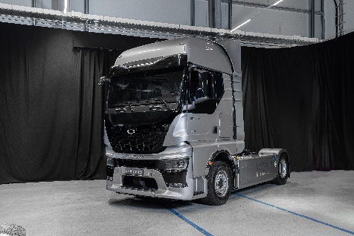 | QUANTRON QHM FCEV AERO hydrogen-electric heavy-duty truck (Image 1)
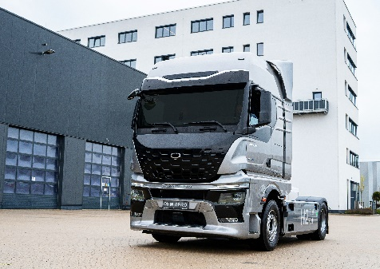 | QUANTRON QHM FCEV AERO hydrogen-electric heavy-duty truck (Image 2)
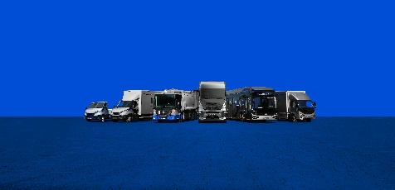 | QUANTRON Portfolio
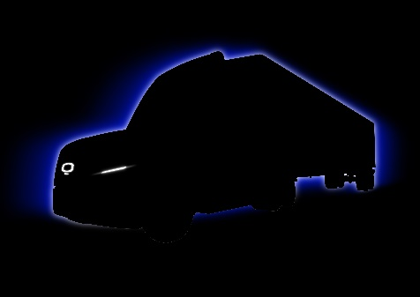 | QUANTRON Class 8 US Truck
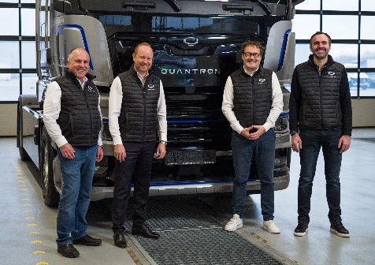 | QUANTRON Executive Board  from left: Herbert Robel (CHRO), Andreas Haller (Founder and Executive Chairman), Michael Perschke (CEO) and René Wollmann (CTO)

The original photos are available in both low and high resolutions here: Quantron AG press releases (https://www.quantron.net/q-news/pr-berichte/)
About Quantron AG
Quantron AG is a platform provider and specialist in sustainable mobility for people and goods; in particular, for trucks, buses and vans with all-electric drive trains and H2 fuel cell technology. As a high-tech spin-off of the renowned Haller KG, the Augsburg/Bavaria-based company combines more than 140 years of commercial vehicle experience with the very latest e-mobility know-how, and positions itself globally as a partner to existing OEMs.
With the Quantron-as-a-Service Ecosystem (QaaS), QUANTRON offers an overall concept that includes all facets of the mobility value-added chain: QUANTRON INSIDE includes a wide range of new vehicles as well as conversions for existing and used vehicles from diesel to battery and hydrogen-electric drives with the highly innovative QUANTRON INSIDE technology. With a Europe-wide network of 700 service partners, QUANTRON CUSTOMER SOLUTIONS provides digital and physical after-sales solutions along with a range of services for maintenance, repairs and spare parts, telematics and in-cloud solutions for remote diagnosis and fleet management. Customers receive individual advice on, among other things, tailored charging and tank solutions, rental, financing and leasing offers. Training courses and workshops are also offered in the QUANTRON Academy. In future, QUANTRON ENERGY & POWER STATIONS will realise the production of green hydrogen and electricity as a platform. To this end, Quantron AG has teamed up with a number of strong global partners. At the same time, this Clean Transportation Alliance is also an important building block for supplying vehicles with the required green charging and H2 tank infrastructure.
QUANTRON stands for the core values RELIABLE, ENERGETIC, BRAVE. The team of experts at the innovation driver for e-mobility is making a significant contribution to sustainable, environmentally friendly passenger and freight transport.
Visit Quantron AG on our social media channels oi LinkedIn and YouTube. More information is available at www.quantron.net

Contact persons:

Jörg Zwilling, Director Global Communications & Business Development, j.zwilling@quantron.net

Stephanie Miller, Marketing & Communications Quantron AG, press@quantron.net

