PRESS RELEASE
17th April 2023
QUANTRON successfully implements internationalisation strategy and confirms 2023 forecast after a strong first quarter
- QUANTRON confirms turnover guidance of 45-60 million euros in 2023 with orders in three world regions - Europe, Middle East and USA
- QUANTRON announces a well-filled sales pipeline with sales potential of over 165 vehicles in Q1 2023
- Positive governmental subvention decisions totalling around 70 million euros for QUANTRON customers in Germany and contractually secured order volume of 23 million euros
- Upcoming world premiere of the hydrogen-powered QUANTRON US Class 8 truck as a prototype for the first time at the ACT Expo in May 2023 in California
- Customer pilot of the first battery-electric truck in the Kingdom of Saudi Arabia (KSA)

Quantron AG, specialist for sustainable passenger and goods transport, has now presented its business figures for the first quarter of 2023 as well as further strategic partnerships designed to ensure the global growth of the company.
There is an increasing demand for emission-free mobility solutions in both the German and international markets. In the first quarter of 2023, Quantron AG was able to realise a sales potential for 2023 of 165 emission-free commercial vehicles for the transport of people and goods.
Significant increase in volume of offers compared to the previous year
In Q1 2023, QUANTRON was able to already exceed the volume of offers placed in the entire year 2022 (about 1000 units) recording around 1200 units.
In the first quarter of 2023, QUANTRON booked a contractually secured order volume of around 23 million euros.

Significant uptake of positive subvention approvals expected
In the same period, QUANTRON customers in Germany received positive subvention approvals of around 70 million euros for enabling decarbonisation of their fleets with zero-emission vehicles.
In the first quarter of this year, QUANTRON also expanded its Clean Transportation Alliance to include two new partners: Norwegian Hydrogen AS and Westgass Hydrogen AS. QUANTRON has concluded strategic partnerships with both companies for the expansion of the hydrogen infrastructure in the Scandinavian countries (Norway, Iceland, Sweden, Finland and Denmark). This strengthens and rounds off the Quantron-as-a-Service solution.
QUANTRON relies on internationalisation and has successfully implemented the delivery of the first battery-electric truck in the Kingdom of Saudi Arabia through its partner Electromin (a Petromin Corporation company). Since March 2023, Ecotruck Services, which is headquartered in Zaragoza, has been part of Quantron AG´s extended sales network acting as a general importer for the Spanish market. In addition, the American subsidiary Quantron USA, Inc. will be presenting its first hydrogen-powered QUANTRON US Class 8 truck as a prototype at the ACT Expo in Anaheim, California which begins on 2nd May 2023.
In order to implement its ambitious growth plans, QUANTRON has hired experts in recent months from various industries representing a total of 15 different nationalities. The company has increased its headcount to 130 from around 90 in April 2022 and plans to hire an additional 20 experts which will be spread across its three offices by the end of 2023.
"The positive response together with the strong growth of QUANTRON show that our emission-free solutions are in demand from customers and partners worldwide," says Michael Perschke, CEO of QUANTRON. “Almost 70 million euros are now available to our customers in the form of approved governmental subsidies in Germany. We are now generating revenue directly as well as with partners in three world regions – Europe, Middle East and USA.”
Andreas Haller, Founder and Executive Chairman of Quantron AG adds: “Leading vehicle fleet customers are increasingly becoming aware of QUANTRON, in particular regarding our fuel cell products. QUANTRON is currently on the move as a consolidator and is expanding its technology leadership especially in the area of 44 t heavy-duty trucks. The Quantron-as-a-Service option with strong hydrogen partners is currently one of our unique selling points and this will be further expanded throughout Europe.”
Images (click on image preview to download):
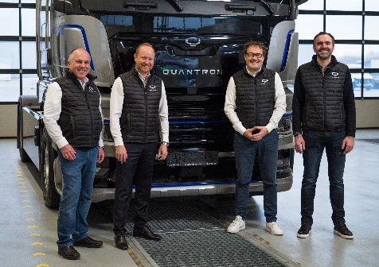 | QUANTRON Executive Board;  from left: Herbert Robel (CHRO), Andreas Haller (Founder and Executive Chairman), Michael Perschke (CEO) and René Wollmann (CTO)
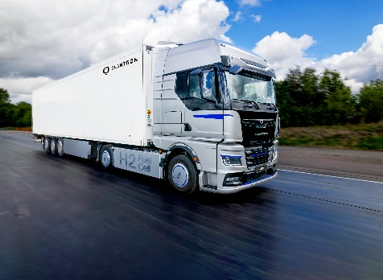 | Hydrogen-electric heavy-duty truck QUANTRON QHM FCEV
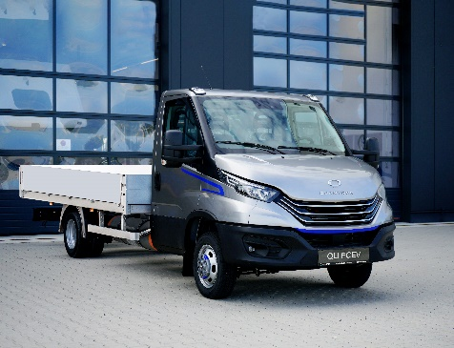 | Hydrogen-electric light transporter QLI FCEV

The original photos are available in both low and high resolutions here: Quantron AG press releases (https://www.quantron.net/q-news/pr-berichte/)

About Quantron AG
Quantron AG is a platform provider and specialist in sustainable mobility for people and goods; in particular ,for trucks, buses and vans with all-electric drive trains and H₂fuel cell technology. As a high-tech spin-off of the renowned Haller KG, the Augsburg/Bavaria-based company combines more than 140 years of commercial vehicle experience with the very latest e-mobility know-how, and positions itself globally as a partner to existing OEMs.
With the Quantron-as-a-Service Ecosystem (QaaS), QUANTRON offers an overall concept that includes all facets of the mobility value-added chain: QUANTRON INSIDE includes a wide range of new vehicles as well as conversions for existing and used vehicles from diesel to battery and hydrogen-electric drives with the highly innovative QUANTRON INSIDE technology. With a Europe-wide network of 700 service partners,QUANTRON CUSTOMER SOLUTIONS guarantees digital and physical after-sales solutions along with a range of services for maintenance, repairs and spare parts, telematics and in-cloud solutions for remote diagnosis and fleet management. Customers receive individual advice on, among other things, tailored charging and tank solutions, rental, financing and leasing offers. Training courses and workshops are also offered in the QUANTRON Academy. In future, QUANTRON ENERGY & POWER STATIONS will realise the production of green hydrogen and electricity as a platform. To this end, Quantron AG has teamed up with a number of strong global partners. At the same time, this Clean Transportation Alliance is also an important building block for supplying vehicles with the required green charging and H2 tank infrastructure.
QUANTRON stands for the core values RELIABLE, ENERGETIC, BRAVE . The team of experts at the innovation driver for e-mobility is making a significant contribution to sustainable, environmentally friendly passenger and freight transport.
Visit Quantron AG on our social media channels onLinkedIn and YouTube. More informationen available at www.quantron.net

Contact persons:
Jörg Zwilling, Director Global Communication & Business Development, j.zwilling@quantron.net
Stephanie Miller, Marketing & Communications Quantron AG, press@quantron.net

