PRESS RELEASE April 3rd, 2023
QUANTRON and Norwegian Hydrogen AS join forces to get hydrogen trucks on Nordic roads
- Quantron AG and Norwegian Hydrogen AS join forces and conclude a five year strategic collaboration
- The aim is to deploy hydrogen powered heavy-duty trucks in the Nordics (Norway, Iceland, Sweden, Finland, Denmark)
- Norwegian Hydrogen AS joins the Clean Transportation Alliance of QUANTRON as a preferred partner, enabling the Quantron-as-a-Service (QaaS) Ecosystem in the Nordics by supplying green hydrogen via its Hydrogen Refuelling Stations
- Clean Transportation Alliance ecosystem offers everything needed to operate a zero-emission hydrogen fleet from a single source
Quantron AG, a leading provider of emission-free solutions for sustainable passenger and freight transport, and Norwegian Hydrogen AS, a producer of green hydrogen and operator of hydrogen refueling stations, have announced a five-year strategic collaboration to promote hydrogen-powered heavy-duty trucks in the Nordic region. The partnership aims to accelerate the transition towards zero-emission logistics in the Nordics, which include Norway, Iceland, Sweden, Finland, and Denmark.
QUANTRON is an early mover to introduce the latest generation of hydrogen trucks to the Nordic market. The heavy-duty truck QUANTRON QHM FCEV offers a range of up to 1.500 km depending on the customer need, making it ideal for long-haul transportation.
Norwegian Hydrogen joins the Clean Transportation Alliance launched by QUANTRON and will be the preferred hydrogen supplier for QUANTRON in the Scandinavian countries, supplying green hydrogen through its production facilities. The H2 refueling stations there will be operated by the newly founded subsidiary VIREON AS. This enables QUANTRON customers to benefit from the comprehensive Quantron-as-a-Service (QaaS) offering, which ranges from vehicle procurement and the corresponding infrastructure to the supply of green hydrogen.
Michael Perschke, CEO of QUANTRON: “QUANTRON is in the process of setting a new standard in emission-free transport of people and goods. Our goal is to offer comprehensive solutions that not only include the vehicles themselves, but also energy deliveries and the necessary infrastructure. In Norwegian Hydrogen, we have found an excellent partner to achieve our ambitions in the Nordic market.”
Jens Berge, CEO of Norwegian Hydrogen AS: “Norwegian Hydrogen has established a dedicated subsidiary to build a network of hydrogen refueling stations along major transportation corridors across the Nordic region, and the agreement with QUANTRON represents a substantial contribution to our ambitious growth strategy. It is also a great recognition to be selected as a strategic partner by such an innovative and leading company as QUANTRON. We are also very excited to join QUANTRON’s Clean Transportation Alliance as a preferred supplier and enabler of the QaaS solution in the Nordics.”

Images (Please click on the image preview to download):
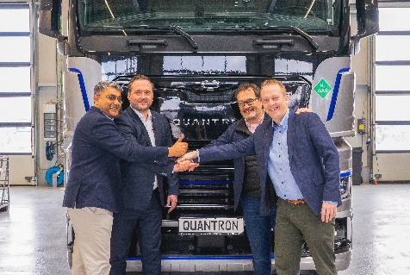 | From left: Anil Reddi (Director Quantron-as-a-Service), Jens Berge (CEO Norwegian Hydrogen AS), Michael Perschke (CEO Quantron AG), Per Øyvind Voie (Managing Director, VIREON AS)
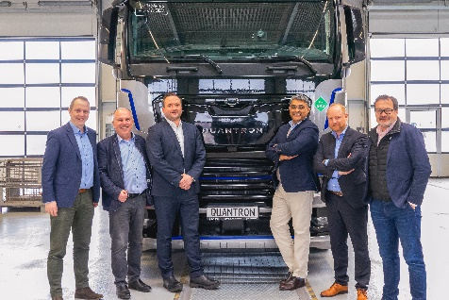 | From left: Per Øyvind Voie (Managing Director, VIREON AS), Herbert Robel (CHRO, Interim CFO Quantron AG), Jens Berge (CEO Norwegian Hydrogen AS), Anil Reddi (Director Quantron-as-a-Service), Andreas Haller (Founder and Executive Chairman Quantron AG), Michael Perschke (CEO Quantron AG)
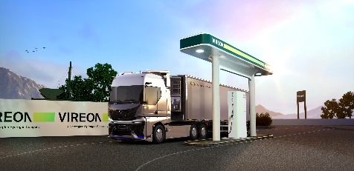 | Hydrogen truck at VIREON refueling station
You can find the original images in low and high resolution here: Press releases from Quantron AG (https://www.quantron.net/en/q-news/press-releases/)
About Quantron AG
Quantron AG is a platform provider and specialist for sustainable mobility for people and goods; in particular for trucks, buses and vans with fully electric powertrains and H₂ fuel cell technology. As a high-tech spinoff of the renowned Haller KG, the German company from Augsburg in Bavaria combines over 140 years of commercial vehicle experience with state-of-the-art e-mobility know-how and positions itself globally as a partner to existing OEMs.
With the Quantron-as-a-Service Ecosystem (QaaS), QUANTRON offers an overall concept that covers all facets of the mobility value chain: QUANTRON INSIDE includes a wide range of both new vehicles and conversions for existing and used vehicles from diesel to battery and hydrogen electric powertrains using the highly innovative QUANTRON INSIDE technology. QUANTRON CUSTOMER SOLUTIONS ensures digital and physical aftersales solutions with a Europe-wide network of 700 service partners, as well as a service offering for maintenance, repair and spare parts, telematics and in-cloud solutions for remote diagnostics and fleet management. Customers receive individual solutions: rental, financing and leasing offers such as training courses and workshops at the QUANTRON Academy. In the future, QUANTRON ENERGY & POWER STATION will realize the production of green hydrogen and electricity as a platform. To this end, Quantron AG has joined forces with strong global partners. This Clean Transportation Alliance also forms an important building block for the supply of vehicles with the necessary green charging and H₂ refueling infrastructure.
QUANTRON stands for the core values Reliable, Energetic, Brave. The team of experts at the innovation driver for e-mobility is making a significant contribution to sustainable, environmentally friendly passenger and freight transport. You can find more information at www.quantron.net
Visit the Quantron AG on its social media channels on LinkedIn and YouTube.

About Norwegian Hydrogen AS
Norwegian Hydrogen AS will build and operate an effective network of production sites and distribution systems for hydrogen, tailored to meet the future requirements for zero-emission fuels in a wide range of mobility sectors and industrial segments. The company is supported by a group of strong industrial owners, such as Flakk Group, Hexagon Purus, Hofseth International, Tafjord, and Mitsui & Co., Ltd. Norwegian Hydrogen’s head office is in Ålesund, Norway, and they also have offices in Oslo, Narvik, Helsinki, Copenhagen and Stockholm.

About VIREON AS
Vireon aims to be the leading hydrogen refueler in the Nordics for heavy-duty trucks. Founded in 2023 as a subsidiary of Norwegian Hydrogen AS, the company is already engaged in building heavy-duty hydrogen refueling stations across Norway, Sweden, Denmark, and Finland.
Backed by strong owners with high ambitions, and with a highly dedicated team with diverse backgrounds, we work to enable zero emissions for trucks and other heavy-duty applications. Our growth strategy includes both organic expansion and mergers and acquisitions, and we actively seek partnerships to strengthen our position and accelerate the green energy transition towards zero emissions.

Your contact:
Jörg Zwilling, Director Global Communications & Business Development, j.zwilling@quantron.net
Stephanie Miller, Marketing & Communications Quantron AG, press@quantron.net

