PRESS RELEASE April 27th, 2023
QUANTRON and Stifel Europe Bank AG sign agreement to support next round of capital raise
- Quantron AG and Stifel Europe Bank AG have signed a contract which aims to secure additional capital for QUANTRON's B-financing round.
- Stifel will act as exclusive financial adviser for the B-Round for Equity and will also support the Growth Capital needs of Quantron AG
- STIFEL will provide its entire platform capabilities and it is planned to secure European as well as US Investors with focus on strategic and impact investors with a total capital raise target between 100-200 Mill. Euro
Quantron AG, a Clean Tech company and specialist in sustainable passenger and goods transport has appointed Stifel Europe Bank AG, the leading mid-market investment bank dedicated to energy transition,. as the exclusive advisor for QUANTRON’s B-financing round.
The investment banking agreement is designed to secure additional capital and establish strategic partnerships for QUANTRON's ambitious growth plans. Stifels role will be to assist QUANTRON in placing equity, equity-linked and/or debt securities and arranging financing. Stifel may also act as an exclusive financial adviser for any acquisition or disposal of equity securities, assets or businesses related to QUANTRON.
"Stifel, with its extensive experience in transatlantic energy transition and commitment to sustainable investments, is the perfect partner to support us for our B-financing round" said Michael Perschke, CEO of Quantron AG. “We will work especially on our global growth plan, including the expansion of our new subsidiary in the US. What finally convinced us was STIFEL’s Senior Management Commitment, sector expertise and global presence.”
“We are very excited to work with QUANTRON on their B-financing round – with our dedicated energy transition team in Europe, led by Alex Boyce and Govinder Ubhi, who have a specific focus on next generation powertrain technologies”, said Natalie Seebacher, Managing Director Stifel Europe Bank AG. “We see QUANTRON as a unique example to work across the entire value chain from hydrogen production to commercial vehicle end users. We will be leveraging our entire global platform and capabilities to secure capital in the optimal structure for QUANTRON. Our role is to serve as trusted advisor and work with QUANTRON to execute their growth ambitions in a rapidly evolving market.”

Images (Please click on the image preview to download):
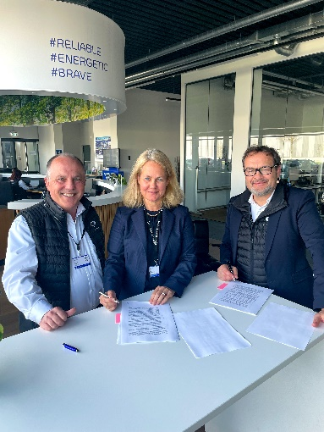 | Contract signing, from left: Herbert Robel (CHRO & Co-Founder Quantron AG), Natalie Seebacher (Managing Director Stifel Europe Bank AG), Michael Perschke (CEO Quantron AG)

You can find the original images in low and high resolution here: Press releases from Quantron AG (https://www.quantron.net/en/q-news/press-releases/)
About Quantron AG
Quantron AG is a platform provider and specialist for sustainable mobility for people and goods; in particular for trucks, buses and vans with fully electric powertrains and H₂ fuel cell technology. As a high-tech spinoff of the renowned Haller KG, the German company from Augsburg in Bavaria combines over 140 years of commercial vehicle experience with state-of-the-art e-mobility know-how and positions itself globally as a partner to existing OEMs.
With the Quantron-as-a-Service Ecosystem (QaaS), QUANTRON offers an overall concept that covers all facets of the mobility value chain: QUANTRON INSIDE includes a wide range of both new vehicles and conversions for existing and used vehicles from diesel to battery and hydrogen electric powertrains using the highly innovative QUANTRON INSIDE technology. QUANTRON CUSTOMER SOLUTIONS ensures digital and physical aftersales solutions with a Europe-wide network of 700 service partners, as well as a service offering for maintenance, repair and spare parts, telematics and in-cloud solutions for remote diagnostics and fleet management. Customers receive individual solutions: rental, financing and leasing offers such as training courses and workshops at the QUANTRON Academy. In the future, QUANTRON ENERGY & POWER STATION will realize the production of green hydrogen and electricity as a platform. To this end, Quantron AG has joined forces with strong global partners. This Clean Transportation Alliance also forms an important building block for the supply of vehicles with the necessary green charging and H₂ refueling infrastructure.
QUANTRON stands for the core values Reliable, Energetic, Brave. The team of experts at the innovation driver for e-mobility is making a significant contribution to sustainable, environmentally friendly passenger and freight transport. You can find more information at www.quantron.net
Visit the Quantron AG on its social media channels on LinkedIn and YouTube.
Your contact:
Jörg Zwilling, Director Global Communications & Business Development, j.zwilling@quantron.net
Stephanie Miller, Marketing & Communications Quantron AG, press@quantron.net

